How to Donate Online on Behalf of Club Members
(For Club Members: President, Club Foundation Chair, Membership Chair, Executive Secretary/Director, Secretary & Treasurer)

Step 1: Log in to your My Rotary account – www.rotary.org/myrotary.
Step 2: Choose what fund your club members would like to support (e.g., Annual Fund is the default selection and selected in the image below).
Step 3: Place a check mark by “This donation is from my club or its members.”

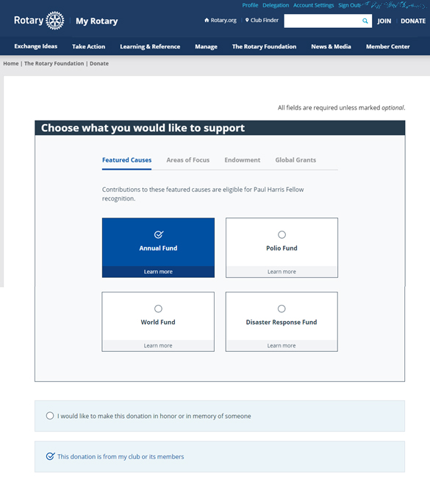

Step 4: Select the box “Donate from members.”
Step 5: Your members and their donor IDs will be populated. Enter the contribution amount for each member. Enter $0 if no contribution amount.
Step 6: Please confirm all information is correct before submitting the online multi-donor feature.

If you have any questions, please contact the Rotary Support Center at rotarysupportcenter@rotary.org or 1-866-9Rotary.

