APPENDIX F: Sample Letter to Submit with VSC / Criminal (FBI) Background Check



[today’s DATE]
To whom it may concern,

Rotary International District 7040 requires a Vulnerable Sector Check (Canada wording) / Criminal (FBI) Background Check (USA wording) for Volunteers for [your name and DOB here] who is going to be volunteering and interacting with vulnerable persons and youth during this 2025-2026 Rotary year.
[add additional description of duties if desired]

Thank you for your cooperation.

Yours in Rotary,
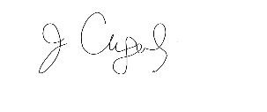
Julie Cugalj,
District 7040 Youth Protection Officer
Area Governor, Rotary District 7040 2019-2021, 2024-2025

