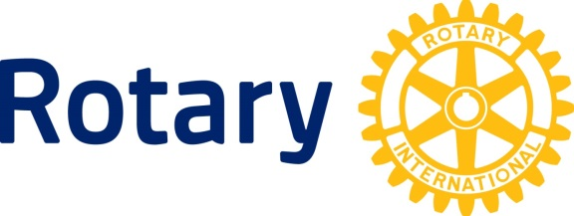
DISTRICT 9370

23 February 2014

Dear Club President/Club Secretary

I wish to advise you that the District has in place a Public Liability Policy that covers our District and it’s membership (Clubs) during and for all activities undertaken for Rotary business. I summarise hereto the cover provided by the policy and the procedure for ensuring that your Club be indemnified against any claim made against it in the event of an occurrence. The policy comes into play when a third party, or a member, has suffered bodily injury and or material damage through the negligence of any one of the insured bodies mentioned hereunder , who owe a duty of care and after a claim has been lodged. In this case the Insurer would pick up the costs and conduct the legal case if there was one.

Insured bodies include:
- Rotary District 9370 (KZN/Eastern Cape/Free State & Lesotho)
- Rotary Clubs
- Rotary Anns Clubs
- Rotary Inner Wheel Clubs
- All District Officers
- Rotaract Clubs
- Interact Clubs
- EarlyAct Clubs
- Vocational Training Teams
- Ambassadorial Scholars
- Youth Exchange students
- Anyone else engaged in Rotary business..

Area of cover – within Southern Africa

Types of cover:

- (1) PUBLIC LIABILITY SECTION

- This section will cover all Clubs against claims made against them for:
  - Death or Injury to third party persons
  - Accidential damage to third party property
subject to a maximum claim of R1m per incident with the first R 1000 payable by the insured. An additional cover of up to R30m has been secured in the event of a catastrophic claim.

  - Food and drink extension
Where Clubs supply food and drink at events – subject to a maximum claim of R1m per incident with the first R 1000 payable by the insured

- Motor Contingent liability
This section will cover all Rotarians against third party liability claims whilst driving their own vehicles on RI business where they are not otherwise insured.
NB: There will be no excess payable

Rotary District 9370…Insurance Cover

- (2) EQUIPMENT – Business all risk cover of District equipment and Club property

Business all risks cover is provided under this section for all property belonging to the District or any Rotary Club in the District subject to a maximum limit of R15 000 per Club and a total sum insured of R300 000. The excess payable in case of a claim is 10% of claim with a minimum of R500 payable.

- (3) MONEY

Cash < R 10 000 whilst any Rotary Club is involved in a fund raising event. For any increase in limit an additional premium will be required. The excess payable in case of a claim is 10% of claim with a minimum of R500 payable.

Please note that if your Club is involved in any public activity (e.g. a fun-run, cycle race, fete, etc) then your Club may seek public liability cover under this policy at no cost.

Should you have any queries or require any clarity then please contact me.

Warm regards

Natty Moodley

Copied to: DG/DGE/DGN/ACs/AGs/District Chairs/Finance Committee

Natty Moodley - District Treasurer
P O Box 56587, Chatsworth, Durban, 4030
Telephone 031 4095125 Cell 0837015951 Email rotary@nattymoodley.co.za

