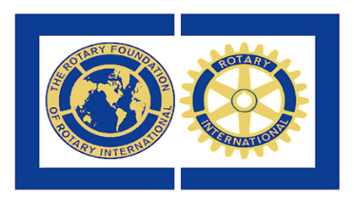
DONATING TO
THE ROTARY FOUNDATION

Please find below the various ways in which you may donate to The Rotary Foundation. In every case your money is very well used and meets a need in someone’s life.

Paul Harris Fellow : Making a donation of $1000 to Annual Programs Fund (World Fund).
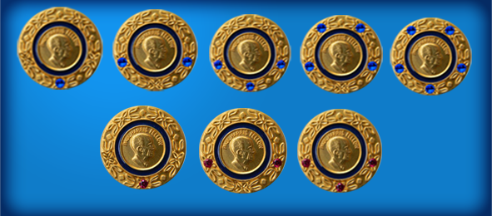
Sapphire 1 = 2nd PHF
Sapphire 2 = 3rd PHF
Sapphire 3 = 4th PHF
Sapphire 4 = 5th PHF
Sapphire 5= 6th PHF
Ruby 1 = 7th PHF
Ruby 2 = 8th PHF
Ruby 3 = 9th PHF
The 10th PHF makes you a Major Donor (see below).

Paul Harris Society members make a donation of $1000 annually

Sustaining Members make a lesser donation of at least $100 annually and are recognised as Paul Harris Fellows each time $1000 is reached.
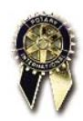
Benefactor : Making a donation of $1000 to the Endowment Fund.
This money is not used but the interest on it is used every year

Major Donor : Donations to the Endowment Fund
Major Donor Bequest Society
Level 1 : $10 000 donation.
Level 2 : $25 000* donation
Level 3 : $50 000* donation
Level 4 : $100 000* donation
Level 5 : $250 000_{*+} donation
Level 6 : $500 000*+ donation
Level 7 : $1 000 000*+
*Qualifies for a customised named fund + Qualifies for Arch Klumph Society membership
Arch Klumph Society members have their photographs in the Arch Klumph Gallery in Evanston (Posthumously for Bequest Society members)

Major donations may be made by bequest. Then members belong to the Bequest Society. Bequests may also be by way of Life Insurance, Marketable Securities, Real Estate, Charitable Trusts or Annuities.

Donation and bequests in local currency are at the exchange rate of the day
Further information may be had from PDG Trevor Long,
Endowment/Major Gift Adviser, Zone 20A (South).
tlong@intekom.co.za Tel +27-41-586 4620 041-586 4620
3 Waterford, Mitchell Street, South End, Port Elizabeth, 6001

