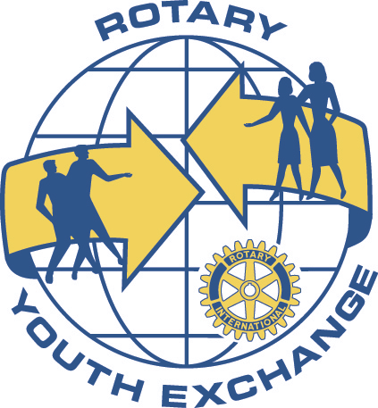
Rotary International
District 9370
Youth Exchange Committee
August 2013

Dear President,
We send you greetings from your District Youth Exchange committee, as you enter your exciting year as President. We wish you success with your endeavors.
Youth Exchange is an exciting project which can be easily handled by Rotary Clubs. The two options are the Short Term programme and the Long Term programme.
The Short Term programme requires minimal Club involvement as the inbound student is hosted by the family of the outbound. The Club is required to select suitable candidates and submit these to District for interviewing and selection
The Long Term programme requires the club to select a suitable candidate and accept an inbound student for the twelve month exchange period. Hosting can be successfully undertaken by non- Rotarians, including the parents, friends and family of the candidate. Once selected by the Club, prospective students are required to attend the district selection process.
Attached is our Survey Form which we ask you to complete and return at your earliest convenience. We require this information to plan our program ahead.
Promotional brochures are available on the District web-page, or contact us and we will mail these to you.
Members of this committee are very happy to engage with you and your members to discuss any aspects of the programs.
Looking forward to hearing from you.
Sincerely in Rotary,
Gussie
Gussie & Hilary Augustus (Chair, Secretary)
aug@iafrica.com, P.O. Box 20209, Durban North, 4016.
Tel 031 579 2850, Fax 086 694 6677, Cell: 0825560299

