Er

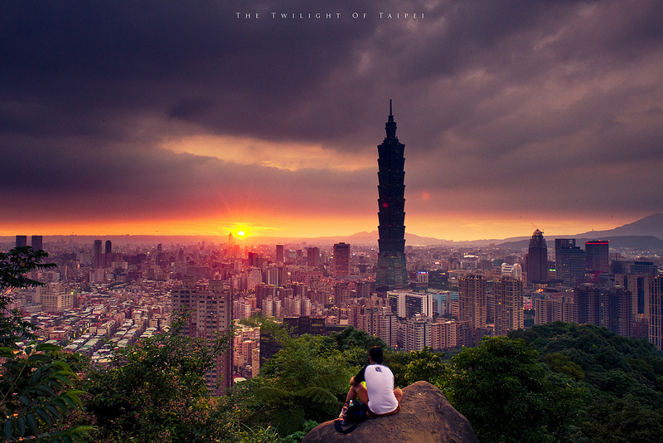

Rotary Taiwan Odyssey
01 – 13 June 2026
Day by day Itinerary
Costs $5650 (Land Only)
Singles supplement $2050

Day 1. Monday 01 June 2026 Taipei X/X/D

After arrive at Taipei Airport, transfer to hotel. At 17:00, we all meet at the lobby for briefing and follow by a welcome dinner.

Please note, checking in time for hotels in Taiwan, is after 15:00.

Caesar Hotel Sinban 4* Add:

Day 2. Tuesday 02 June 2026 Taipei B/X/D

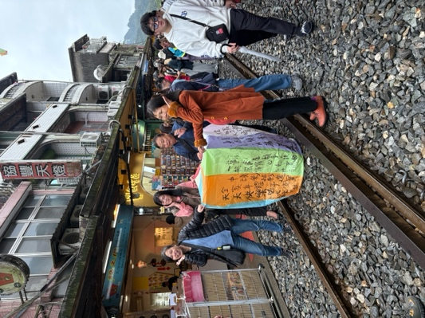
Today, after breakfast, we travel to the hillside villages of Jinguashi and Chiufen. Both villages were once gold mining centres. The gold has since gone, but the quaint old villages of closely-packed houses clinging to steep mountainsides continue to offer enchanting, fascinating glimpses into Taiwan’s Japanese colonial past.

We will have opportunities to go to Ruifang and have a Sky lantern experience, where we can write good-wishes on the Lantern before releasing it into the sky.

Hotel: Caesar Hotel Sinban 4*

Day 3. Wednesday 03 June 2026 Taipei B/L/X
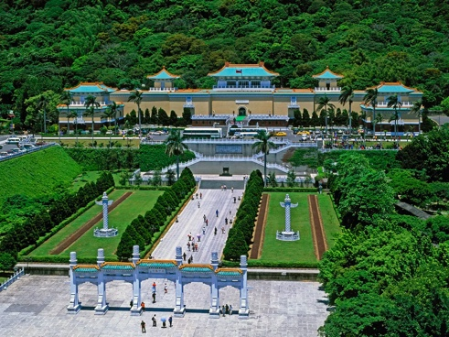
Today, we embark on a full-day tour of Taipei. We start with a visit to the he National Revolutionary Martyrs' Shrine, follow by explore the National Palace Museum – home to the world's largest and finest collection of Chinese art, spanning 5,000 years of Chinese history.

In the afternoon, we visit the Chiang Kai-shek Memorial Hall, built in 1980 to commemorate former Taiwan President General Chiang Kai-shek. In the evening, we will visit Taipei 101 – incl. observatory deck, Dihwa street, Raohe night market,and if time permit, we can visit Tsiyao temple. As well as drive Pass the President Hall
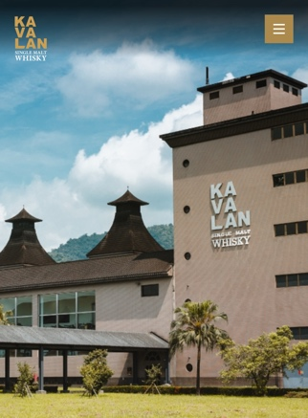
Hotel: Caesar Hotel Sinban 4*

Day 4. Thursday 04 June 2026 Yilan B/L/X
Morning transfer to Yilan. Kavalan whisky factory. National Center for traditional of art
This morning, we head off for Yilan. En route we will visit the Kavalan Whisky factory – a world renown whisky maker. Follow by a visit to Lanyang museum and Yilan's National Centre for Traditional Arts, established in 2002 to promote and preserve Taiwan's aboriginal culture and arts.

Hotel: Wellspring by Silks Jiaoxi 4*

Day 5. Friday 05 June 2026 Taitung B/X/D

Today, we will drive along the East Coast, taking in the breath-takingly beautiful routes that trace along the Pacific Ocean. On the way, we stop at Dulan and learn about the legend surrounding the 'Terrace of the Three Immortals' at Sansiantai. After lunch, we travel to our hotel in Taitung. On arrival, we can look forward to a relaxing hot spring bath in the 5-star hotel. This area of Taitung County is blessed with natural hot spring water. The Spa Complex offers both in-room and outdoor Jacuzzi, and spa. Please remember to bring your swimsuit and a cap (or you can purchase easily at hotel) to experience this wonderful local specialty. We stay three nights here.

Hotel: Hoya Chihpen 4* or similar

Day 6. Saturday 06 June 2026 Taitung B/L/D

After breakfast, we visit the Taiwan National Natural History Museum, to learn about the aboriginal history and culture. Afternoon visit Chishang, rice field and taste Bento box.

Hotel: Hoya Chihpen 4* or similar

Day 7. Sunday 07 June 2026 Taitung B/L/X
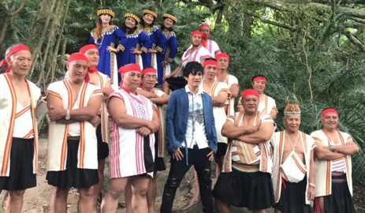

A full day forest tour with indigenous BBQ lunch, and a visit to the Forest Culture Museum. Today we will experience Avatar’s Hometown where the Bunoung tribe lives. In this precious forest museum, there is a tree which has been dubbed “The Walking Tree”. Please be sure to wear comfortable walking shoes. We will go for a wonder in the pristine and tranquil forest, experience the harmony of nature and learn about the aboriginal culture and life style, we will enjoy a day busking in nature’s Oxygen Bar. The Director Aliman’s philosophy is to coexist with nature harmoniously and lean from it.
http://www.forestculturemuseum.com.tw/ (https://youtu.be/1H4uzWREvRA)

Hotel: Hoya Chihpen 4* or similar

Day 8. Monday 08 June 2026 Kaohsiung B/X/D

Morning transfer to Kaohsiung, Taiwan's second largest city and the largest industrial harbor. It’s also the second busiest port in Asia. On arrival we first visit the “Dago Fort” – the Former British Consulate at sunset.

We will take a see some specular buildings in Kaohsiung city e.g. the Music Center, Kaohsiung Expo etc.

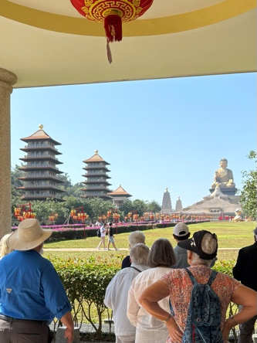
Late afternoon visit Cijing island. Include boat ride. In the evening, we will have opportunity to sample Taiwanese desserts and snacks at the Liuho Night Market, and stroll along the famous Love River, which is renowned for its cafes and romantic atmosphere.

Hotel: Grand Hi Lai KHH 5* or similar

Day 9. Tuesday 09 June 2026 Tainan B/L/D

Today we drive to Tainan, the ancient imperial capital. En-route we visit Fu Guang Shan – headquarter of Nan Tien Temple in Wollongong. In Tainan we will tour Fort Provintia, Anping Castle and the Fujian-style Koxinga Shrine, and learn about the Dutch history of the island,
Hotel: The Place, Tainan 4*

Day 10. Wednesday 10 June 2026 Sun Moon Lake B/X/D
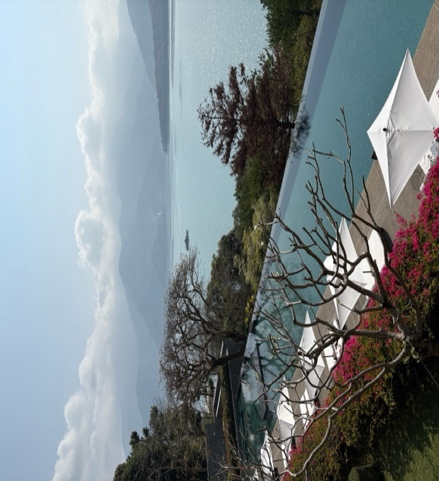
This morning, we will be transferred to the beautiful resort of Sun Moon Lake, on route we’ll visit: National Palace Museum – south branch. In the late afternoon, arrive in Sun Moon Lake. The name derives from the shape of the lake: the northern part is in the shape of the sun, while the southern part resembles a crescent moon.

Tonight, we stay at one of the top 50 resorts in the world - "Lalu". It was designed by award-winning Australian Architect Kerry Hill. The hotel overlooks Taiwan's largest lake, with an impressive mountain backdrop, it was the place where Chiang Kai-shek entertained his overseas dignitaries. The original guesthouse was painstakingly relocated, brick by brick, into the Garden of Lalu and is now a museum commemorating Chiang Kai-Shek’s era.

Don’t miss visiting this museum if you are interested in contemporary Chinese History. We stay two nights at Lalu.

Hotel: Lalu, Deluxe room, Sun Moon Lake, 142 Zhongxing Rd, Yuchi Township, Nantou County, Taiwan 555
Tel: +886 4 9285 5311

Day 11. Thursday 11 June 2026 Sun Moon Lake B/L/X
Today, we take a cruise around the Sun Moon Lake and visit the Holy Monk Shrine, which was dedicated to the Buddhist monk Xuanzang, who led an epic journey from China to India in 629. He returned sixteen years later, with hundreds of scriptures and scrolls, and had a profound influence on the spread of Buddhism throughout China. After lunch, we have leisure time.

Hotel: Lalu Deluxe room

Day 12. Friday 12June 2026 Hsinchu B/L/D

After breakfast, we farewell Lalu and head for Taipei, on way we can visit to Hsinchu city & pass by Hsinchu Science Center - the place where they make the silicon chip – Taiwan’s Silicon Valley.
And visit Hsinchu City God temple, and the temple market, a taste of Hakka food.
If time permit, we will visit Cihu and pay our respect to generalissimo Chiang Kai-Shek’s Mausoleum.

Tonight, we will have a farewell dinner to celebrate the end of tour. Later, we take Taiwan’s High Speed Rail & return to Taipei.

Hotel: Caesar Hotel Sinban 4*

Day 13. Saturday 13 June 2026 Taipei B/L/X

Our program finishes after breakfast, just in time for Rotary International Convention.

**Please note that all locations will be visited, the order of the days may vary depending on weather.**

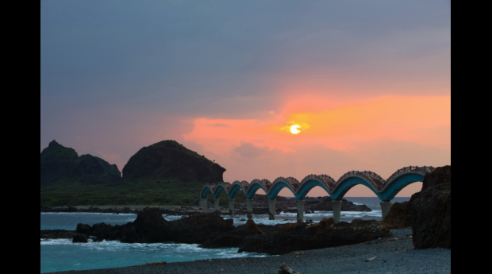



TA Licence 2TA 5109
Telephone: 1300 888 225
Email: info@odysseytravel.com.au
Website: www.odysseytraveller.com
Last edited: 13 October 2025

