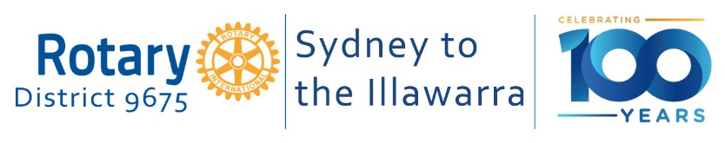

D9675 EnviroClub Awards

Application Form – Bronze Award
A Bronze Award is the first of three levels of recognition of your club’s environmental achievements. The District 9675 Environment & Sustainability Committee will review your application on the basis of criteria at the appropriate level for the Award. The Committee will then make a recommendation to the District Governor who will make the final decision as to whether your club receives this level of Award. Refer to the EnviroClub Awards Information Pack for further details about requirements and assessment criteria.

Please complete all sections below. Where appropriate, attach any additional information or evidence (for example photos, screen shots, promotional/advertising materials) to support your application.

Rotary Club Name

Rotary Year

Club Environment Officer | Name:  Email address:
Club Environment Committee formed | YES  NO
Name of Club President
Date of Application

Summarise the Club’s submission for a BRONZE Award below.
- Current environmental project/s undertaken by the Club.

2. Planned environmental projects.

Email completed application forms to Brendan O’Keeffe at brendan@cscadvisory.com at any time, but before June 1 for presentation at the District Changeover function.

For official use only

Date application received

Application approved | YES  NO  Date
Committee’s comments / recommendations
Date approved by District Governor

Date Award presented to the Club

