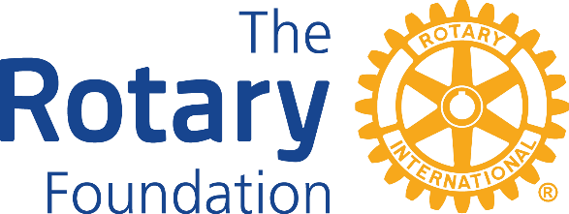

DISTRICT 9980 DISTRICT GRANT APPLICATION 2018-2019
This form should be fully completed and returned to the District Grants Administrator (full details at the bottom of the form) no later than JULY 31st 2018.
- Name of project:

- Club(s) involved:
  - Rotary Club of
  - Rotary Club of
  - Rotary Club of

- Project Description:

- Project expected commencement date: ________/_________/________

- Project expected completion date: ________/_________/________

- Areas of Focus: (please circle): Promoting Peace Fighting Disease Providing Clean Water
Saving Mothers & Children Supporting Education Growing Local Economies

- Rotarians responsible for project and reporting to district:

h. Funds to be provided by participating club(s): |  |  |  | NZ$
i. | Project budget: (Attach separate sheet if necessary)
 | Principal items to be Purchased |  |  | Value
 |  |  |  | $
 |  |  |  | $
 |  |  |  | $
 |  |  |  | $
 |  | Total project cost |  | $
j. Funds requested from District: |  |  |  | $
Note: Single-Club projects are eligible for a dollar-for-dollar match from the District of up to $2,000.
Multi-Club projects are eligible for up to $5,000 dollar for dollar. Item H above should detail how much the Club(s) is/are contributing to the project; Item I the full project costs, and Item J the amount requested from District.

k. Contact person:
Name:
Rotary Club of
Address:

Phone:
Email:

Signature………………………………………………………. Date………………………………
Please return this form to the District Grants Administrator:  Joan Kiernan (Queenstown Club)  P O Box 1436  Queenstown 9348  Phone 021 356 265 or work/home 03 441 3091  Email joan. kiernan@queenstown.net | General Foundation enquiries can be addressed to the District Foundation Chair:  Trish Boyle  Email macboyle@xtra.co.nz  Phone 03 217 9982 or 027 333 1339

