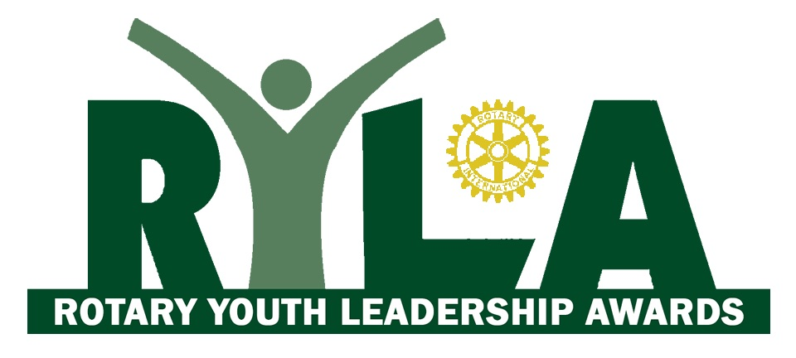
2018 Hosted by:
Friday 2nd - Tuesday 6th February
at Waihola, South Otago

APPLICATION FORM – closes 20th December 2017
Candidate please complete sections 1 to 8.
Sponsoring Rotary Club to complete section 9.
This form can be either printed or completed electronically.

1. PERSONAL DETAILS
(To be eligible, you must be over 18 years of age and have not reached your 27th birthday by 1st February 2018)
Surname
Given Name
Preferred Name
Address
Town / City
Phone / Mobile
Email
Date of Birth
Sex (M/F)
T-Shirt Size (S/M/L/XL)

2. EMERGENCY CONTACT

Contact Name
Relationship
Address
Town / City
Phone / Mobile
Email

3. OCCUPATION
(Please be sure to advise your employer of any leave required in February 2018 if successful with this application.)
Current employer
Position held
Period of employment

4. HEALTH
(For the safety of all candidates, information in this section must be disclosed to the 2018 RYLA Committee and third party providers relevant to the programme on a confidential basis.)
Health Issues / Allergies
Current Medication
Dietary Requirements
Any other information
important to disclose.

5. CURRENT/MOST RECENT EDUCATION

School/Tech/University
Year
Level Attained
Special Awards

6. RECREATIONAL INTERESTS & INVOLVEMENT

Sporting

Organisations / Clubs

Hobbies

7. QUESTIONS

Briefly state THREE reasons why you would like to attend RYLA

What are the FOUR benefits you hope to personally gain from attending RYLA?

8. DECLARATION

(NOTE: If this form is submitted electronically, the sponsoring Rotary Club must print out this page and have it physically signed by the applicant during their interview.)

I, _________________________________ being the Applicant,

- Understand that I will be required to abide by the Code of Conduct and adhere to all the requirements and instructions of the director and staff of RYLA during my participation in the programme and that in the event of my failure to do so in a reasonable manner I may be returned to my home by the first available transport, with any additional costs so incurred being paid by myself, parents or guardian.
- Understand that RYLA 2018 is held in a camp environment and that I will be required to share a single sex dormitory with others.
- In accordance with the Privacy Act, agree to my name and contact details being used on a list of awardees for RYLA follow-up and administration purposes.

Signed: ______________________ Date: ______________________

9. NOMINATING ROTARY CLUB

The Rotary Club of _____________________________ recommends this Applicant be selected for the RYLA 2018 Programme.
(NOTE: Final selection of candidates remains with Rotary Club of Balclutha RYLA Committee.)

Rotarian Name
Signed
Date
Mobile
Phone
Email
Position in Club

COMPLETED FORMS
emailed to: ryla2018waihola@outlook.com
or posted to: RYLA 2018
Balclutha Rotary Club
PO Box 143
Balclutha 9240

Applications close 20th December 2017.

RYLA participants are nominated by their local Rotary Clubs, which cover all expenses associated with the programme.

The fee per attendee is $675.
The early registration fee is $650 for applications received by 30th November 2017.

Please make cheques payable to: The Rotary Club of Balclutha Charitable Trust
or direct credit via internet banking to: 02-0918-0014510-00
In the reference please be sure to include “RYLA 2018” and your Rotary Club’s name and note the date and reference number of the transaction on the application form.

Payment details:
- Cheque for $____________ enclosed
- Internet banking – amount $___________, date paid ___/____/2017
Reference used _______________________________________

RYLA 2018 - CODE OF CONDUCT
Awardees shall treat the camp buildings and facilities, and the environs, with courtesy and respect and abide by camp-site rules. Any facilities visited shall be treated similarly.
Awardees should treat each other and the Rotarians working in the programme with courtesy and respect.
Awardees are expected to take full part in the programme and attend all sessions.
No smoking, alcohol or drugs allowed on the camp property.

Administration of the Code
Any breaches of the Code of Conduct will be acted upon immediately.
The Camp Mum and Dad and the Duty Rotarian will deal with any minor breaches of the Code of Conduct.
The RYLA Management Committee will deal with any major breach of the Code of Conduct. This committee will include: the RYLA Chairperson (or nominee), the Duty Rotarian, Camp Mum and Dad.
The Awardee involved will have the right to be heard, and to have representation.
It is expected that a major breach of the Code of Conduct will result in the Awardee being sent home.

