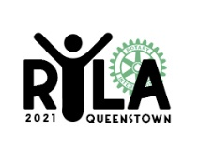 COMPULSORY EQUIPMENT LIST

Please ensure all items are clearly NAMED. The RYLA 2021 Committee or Lakeland Park Camp accept no responsibility for any loss or damage that may occur while you are on the course.

General use throughout the week:

Pillow and sleeping bag

Single fitted sheet

2 Towels

Personal toiletries

A small personal first aid kit with pain relief and plasters

Any personal medication can be put in a separate plastic bag (the Camp Nurse can look after these for you or help refrigerate if required)

Swimming togs and beach towel

Casual comfortable clothing for 6 days

Sports clothing for daily exercise (may get wet or dirty)

Casual footwear for day to day, walking and sporting use

Formal / semi-formal wear for one social evening (Award Gala Dinner Event)

Sunhat and Sunscreen

Camera if you wish

Musical Instruments if you wish

Photo ID

Laptop and mobile phone optional

Please also Bring: Non-perishable food item/s (can or packet) for a charity grocery hamper 😊

DO NOT BRING:

Anything Valuable

Alcohol or Drugs

Extra Outdoor Equipment:

Waterproof Jacket (over pants optional)

Polar Fleece over layer

1 thermal layer

Beanie and woolen socks (optional)

Drink Bottle

Head torch (preferable) or standard torch
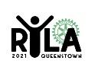District 9980

