WHAT IS RYLA?
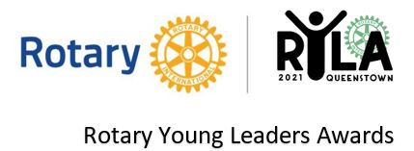

Rotary District 9980 RYLA is a five-day residential high energy programme designed to develop young leaders between the ages of 20 and 29. District 9980 encompasses from Timaru to Southland and includes Central Otago and Fiordland.
Originating in 1959 in Queensland, Australia, RYLA was officially adopted by Rotary International (RI) in 1971. This exciting programme engages Rotary clubs and districts around the world to help the next generation of leaders expand their skills.
The RYLA programme recognises, encourages and educates current and future leaders by offering them this intensive leadership experience. The programme demonstrates Rotary's commitment to developing leaders.
And this spirit extends even beyond the Rotary club. RYLA has substantial goodwill within the wider community and each year attracts cooperation from community and cultural organisations, business, and civic and national leaders. Each supporter understands the long-term benefits our young leaders gain from their RYLA experience.
RYLA is an invaluable programme that brings together individuals to harness creativity, diversity, inspiration, energy, and leadership to cultivate personal growth, challenge limits and empower long-lasting meaningful change. While on the programme you will engage in seminars, activities, group discussions and interactions with other like-minded young leaders like yourself, from all walks of life and for many, this is life changing. You will also make valuable vocational contacts and new friends.
More than 25,000 young adults graduate from RYLA courses each year around the world. It helps to develop self-confidence and a wide range of personal skills such as planning, personal organisation, public speaking and helps participants to understand the requirements of many aspects of personal leadership, community, and business.
At RYLA you can expect to specifically cover:
Self - Who am I? How can I be the best I can be?
Work - What is expected? How can I develop leadership skills to get ahead?
Community - What is Community? Which groups do I identify with? How can I make a difference?
Leadership - Aspirations: What do I want to achieve? How will I accomplish my goals?

Aim: To empower young individuals to create positive growth within themselves and their communities through harnessing their leadership potential.
Values: Harnessing diversity and utilising strengths in others | Tolerance and understanding uniqueness | Developing self-leadership | Inspiring courage

