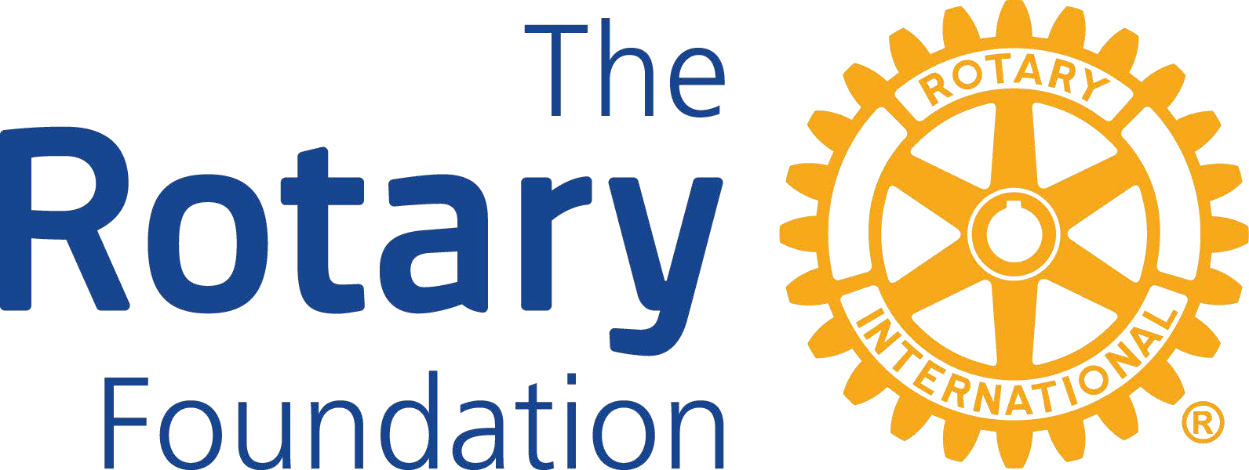
District and Global Grants
District 5495 club qualification requirements for District Designated Funds in 2026-27
Clubs submitting applications for District Grants or Global Grants in 2024-25 must be qualified by the district to receive District Designated Funds (DDF). District 5495 has established requirements in addition to those established by The Rotary Foundation. To be eligible to receive funding, a Rotary Club in District 5495 must complete these requirements:

  - Agree to implement and sign the Rotary Foundation Memorandum of Understanding for clubs. The MOU requires, among other things, that the club has established a financial management plan for administration of grant funds. Note: A club financial plan template is available on the District website which can adopted or adapted by the club.

  - A separate bank account required for all Global Grant funds. A separated bank account is not required for District Grants. However, separate accounting of Rotary Foundation funds is mandatory in all cases.

  - Appoint a Club Rotary Foundation Chair to a 3-year term.

  - Have at least two members attend the District Foundation Grants Seminar annually. It is highly recommended that the President-Elect and Club Rotary Foundation Chair attend. Note: The Club can send as many participants as desired.

  - Be current on its RI and District dues, and in good standing with the District, Rotary International, and The Rotary Foundation.

  - Be current on all required tax returns for the Rotary Club and any associated Club Foundation.

  - Have established and reported an Annual giving goal to the District Foundation Chair for the current year and for the next year – this is reported online through Rotary Club Central.

  - Have contributed to the Rotary Foundation Annual Giving Fund in the previous year or the current year.

  - Be current on all Rotary Foundation Grant reports.

