Flags of the World D 9510

Reference | Country | Flag
1 | Rotary International | 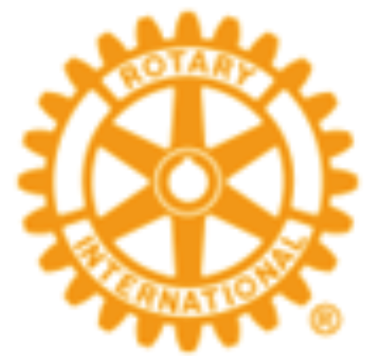
2 | United Nations | 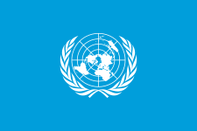
3 | Australia | 
4 | Belgium | 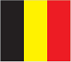
5 | France | 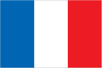
6 | Bahamas | 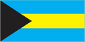
7 | New Zealand | 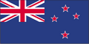
8 | Equador | 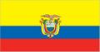
9 | Taiwan | 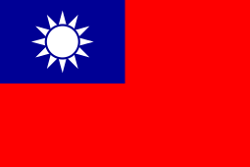
10 | Singapore | 
11 | Germany | 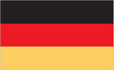
12 | Finland | 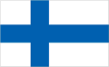
13 | Myanmar | 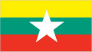
14 | Israel | 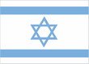
15 | Mexico | 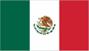
16 | Philippines | 
17 | Argentina | 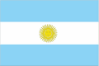
18 | Norway | 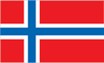
19 | Nationalist China
20 | Switzerland | 
21 | Indonesia | 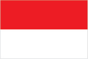
22 | Portugal | 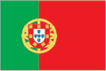
23 | Peru | 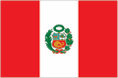
24 | Honduras | 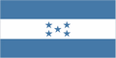
25 | Chile | 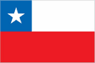
26 | South Africa | 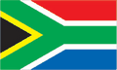
27 | Brazil | 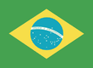
28 | Uraguay | 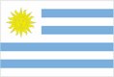
29 | Spain | 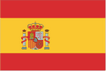
30 | Ireland | 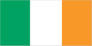
31 | Netherlands | 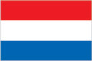
32 | Iceland | 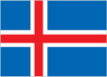
33 | New Guinea | 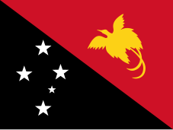
34 | Sweden | 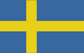
35 | Japan | 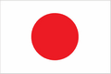
36 | Denmark | 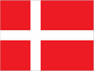
37 | Greece | 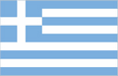
38 | Ireland
39 | United Kingdom | 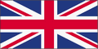
40 | Bangladesh | 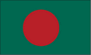
41 | Malaysia | 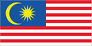
42 | India | 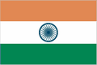
43 | Thailand | 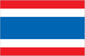
44 | Italy | 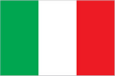
45 | Korea - South | 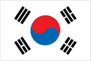
46 | Austria | 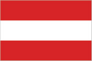
47 | Canada | 
48 | Victoria | 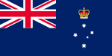
49 | Fiji | 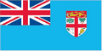
50 | Morocco | 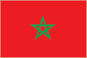
51 | Pakistan | 
52 | USA | 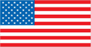
53 | Malta | 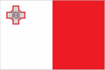
54 | South Australia | 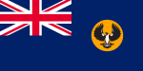
55 | Vanautu | 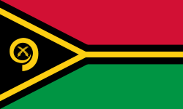
56 | New South Wales | 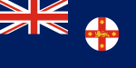
57 | Queensland | 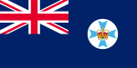
58 | Nigeria | 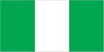
59 | Turkie | 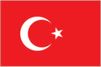
60 | Ethiopia | 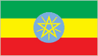
61 | Solomon Islands | 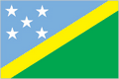
62 | Timor Leste | 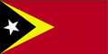
63 | Poland | 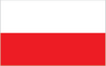
64 | Vietnam | 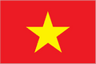
65 | Nauru | 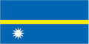
66 | Maldives | 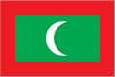
67 | Nepal | 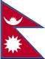
68 | Sri Lanka | 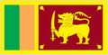
69 | Aboriginal | 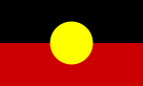
Spares / Loose

 | Vietnam
 | United Nations
 | Ireland
 | Canada
 | USA
 | Ukraine | 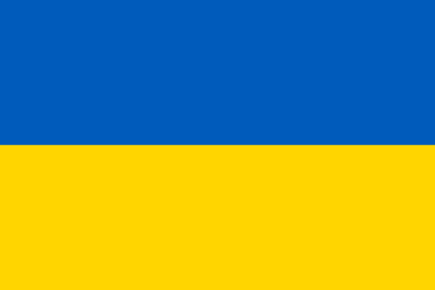
 | Italy
 | Maldives
 | Australia (3 flags)
 | Torres Strait | 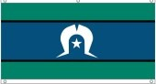
Ordem e Progresso
Brazil
Miscellaneous

 | Table cloth – 100 Years of Rotary

Phil
Feb 2025

