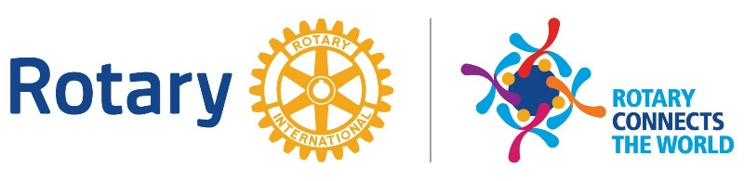

Rotary District 7470 Conference
May 7 – 10, 2020 – Hyatt Place
Inner Harbor Baltimore

