District Governor John Shockley
Governor’s Email
July 11, 2022

THIS EMAIL IS BEING SENT TO THE ENTIRE ROTARY DISTRICT

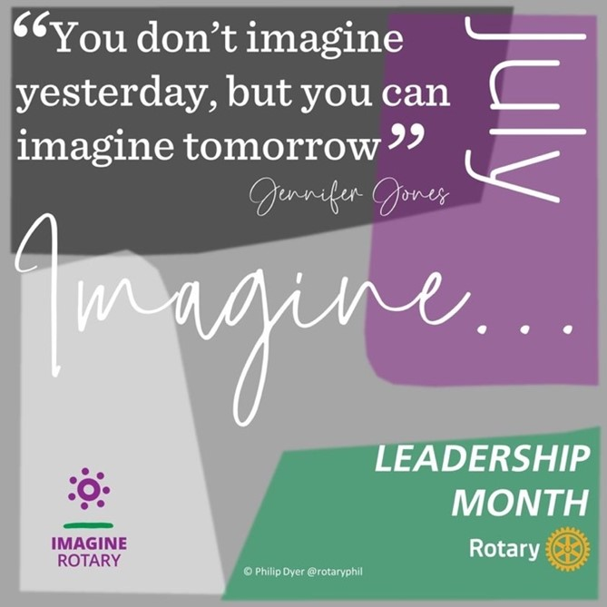

Happy Monday Rotarians!

July is Leadership Month in Rotary. Let’s take a moment to thank all our past, current, and future leaders for their commitment to making Rotary great.

Great leaders oftentimes start with great training. And, the Rotary Learning Center offers great training for all Club and District officer and committee positions as well as general Rotary and Foundation knowledge. Attached you will find a Learning Center course catalog. Best part: All courses are free for all Rotarians! …. You can find your next great course at www.Rotary.org.

DISTRICT GRANTS DEADLINE IS JULY 15 – NO EXCEPTIONS
Applications for District Grants for the 2022-23 Rotary year are due at midnight on July 15. No late applications will be accepted. Submit your application today in the member area of the District website at www.NJRotary.org. Need help or have questions? Please email District Grants Chair Pamela Singh at pamelarsingh@gmail.com.

PLAN YOUR GOVERNOR’S VISITS NOW
I am available to come to your Club for service projects, fundraisers, installations, inductions, or other special events. It’s the responsibility of each Club to schedule their own visit with me. Please email me at johndg2223@aol.com to schedule your visit.

LIKE US ON FACEBOOK
Did you know that the District has a Facebook page? We surely do. We’d like all Facebook using Rotarians to “like” the page to stay connected with us. CLICK HERE to “like” our District’s page today.

DISTRICT GOVERNOR 2025-26 NOMINATIONS
Clubs may nominate District Governor candidates for the 2025-26 Rotary Year now thru September 30. Past Presidents who will have been Rotarians for 7 years by July 1, 2025 are eligible to be nominated by their own Clubs. I’ve appointed PDG Ray Freaney as the Nominating Committee Chair. If you have any questions about the nomination or selection process or would like to submit a nomination, please email PDG Ray at rayfreaney@gmail.com.

Annually at the beginning of the new Rotary year all Rotary Members receive a request to review and update member profiles in the Club, District and Rotary International databases. All District Rotarians will receive an automated request later this week. This request will list current information contained in our District database and ask you to update your information. Please pay particular attention to phone numbers, birth dates and mailing addresses. Rotary’s privacy policy keeps your information secure and confidential. For more information, please contact PDG Barry Kroll at barrykroll@aol.com.

DISTRICT PUBLIC IMAGE COMMITTEE BOOST:
Watch this space for help and encouragement with Public Image

Today’s topic: A New Rotary Year!
Our new Presidential Rotary theme for 2022-23 is Imagine Rotary!
Be sure to update your club’s website and social media with the official theme materials. You can download them HERE.

For more Public Image information, or if you would like to join the Public Image Committee, email District Public Image Chair Dorothy Huey at hueynews@optonline.net

That’s all for this week.

John

John Shockley
District Governor, 2022-23
Rotary International District 7475
C: 732-522-6178
E: JohnDG2223@Aol.com

