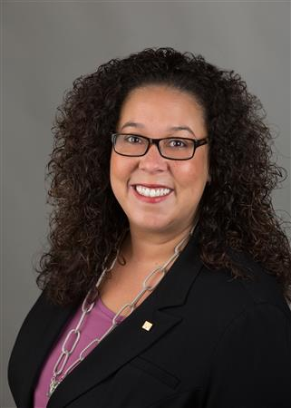

District Governor Shelby Rhodes
Weekly Newsletter
April 11, 2022

THIS EMAIL IS BEING SENT TO ALL DISTRICT 7475 ROTARIANS.

Happy Monday Rotarians!

It’s a busy time of year in Rotary with a lot going on. Last week, I visited with The Skylands, Newark, Morristown, Madison, and West Orange Rotary Clubs. I presented four District grant checks and had a great time at The Skylands planning our 75th Anniversary brunch.

Speaking about District grants, this Friday (April 15) is not only Tax Day but it’s also the District Grant report due date. No report by April 15 = no reimbursement. If you need any help or have a question, please contact Grants Chair Pamela Singh by email at pamelarsingh@gmail.com. Or, call her at Home 908-226-1463 or Cell phone 908-202-6608. If you did not do the project, please let her know so we can reassign the funds.

TRF MOMENT:
WHAT’S ROTARY DIRECT GIVING?
Rotary Direct Giving is a program that’s a fast and easy way to support Rotarian projects locally and around the globe. You can schedule monthly, quarterly, or annual donations automatically using your credit card. Sign-up HERE today to make impact.

TRAINING & LEADERSHIP DEVELOPMENT:
Training Rotarian leaders has been a major focus this year in our District. We have several training programs available for all Clubs. Here’s a partial list:

- Member Engagement
- Building a Vibrant Club
- Membership is everyone’s job
- What The Rotary Foundation can do for your Club
- Rotary’s Learning Center
- ClubRunner – From Basics to Advanced Concepts
- Public Image Workshop including social media
- Show me the money – Fundraising in a Post-Covid world

To learn more or schedule training in your Club on these amazing topics, please contact the District Chief of Staff Mark Hartmann at Mark@HartmannRhodes.com.

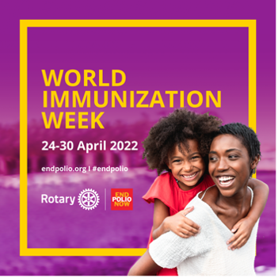

JOIN WITH ROTARY TO PROMOTE THE POWER OF VACCINES TO PROTECT CHILDREN + SAVE LIVES.
During World Immunization Week, April 24-30, let’s advocate for polio eradication and well-being of our communities.

The Global Polio Eradication Initiative estimates that the polio vaccine has saved more than 20 million children around the world from paralysis. We need to continue vaccinating children against polio, because if the poliovirus circulates anywhere, it is a threat everywhere.

Here’s how you can support Rotary’s efforts during World Immunization Week:
- Use the World Immunization Week Toolkit for graphics and sample posts to share on social media with the hashtags #EndPolio and #VaccinesWork.
- Donate to PolioPlus to help Rotary and our partners deliver polio vaccines to vulnerable children. Or start an online fundraiser using Raise for Rotary and share it with your friends, colleagues, and family members. All contributions will be matched 2-to-1 by the Bill & Melinda Gates Foundation.
Attached you will find the World Immunization Week Toolkit.

OUR FOOD TRUCK FESTIVAL NEEDS YOUR SUPPORT
CLUBS: Please consider becoming a Sponsor for the District Food Truck fundraiser on April 30th at the Central Jersey Regional Airport. (See details below.) Most clubs recognize their outgoing President, a dedicated member or community leader with a Paul Harris Fellow each Rotary Year. For a $1,000 sponsorship, you get the full 1,000 Paul Harris points and 10 Food Truck Festival tickets too! It’s a deal you simply can’t refuse.
This event replaces the annual Eat, Drink and Share fundraiser which was cancelled last fall due to Covid-19 concerns. If your club had budgeted funds for Eat, Drink & Share, please allocate them into this alternative event. Also, come and have fun! See your friends from other clubs while enjoying Jersey’s best empanadas.
CLUBS NEWS - WHAT’S UP AROUND THE DISTRICT
CLICK HERE to access this week’s article. How does your Club get featured next week? Simply email your news to Rotary7475news@gmail.com. Our deadline is every Friday around 5 pm.

DISTRICT RAFFLE TICKETS – CLUBS ORDER TICKETS TODAY!
The District Raffle benefits YOUR Club. Tickets are $20 each with about half (less ordinary expenses & fees) going to YOUR Rotary Club’s charitable endeavors. This year raffle winners will be picked on Monday, May 16 District Training Assembly at the Park Avenue Club in Florham Park. (Note: The tickets say “Thursday, May 16”. This is incorrect. It’s Monday, May 16.) Clubs can CLICK HERE to place a ticket order. AND, please don’t wait until the last minute to get your tickets and monies mailed back in to the District Foundation. Tickets and money (not cash) due by May 5.

APRIL EVENTS
APRIL 22-24, 2022 – ANNUAL DISTRICT 7475 CONFERENCE – Details, agenda, and registration information are available on the district website, CLICK HERE for details. For more information, contact 2022 District Conference Chair Mike “Dutch” Minor at mminor@onevera.com.

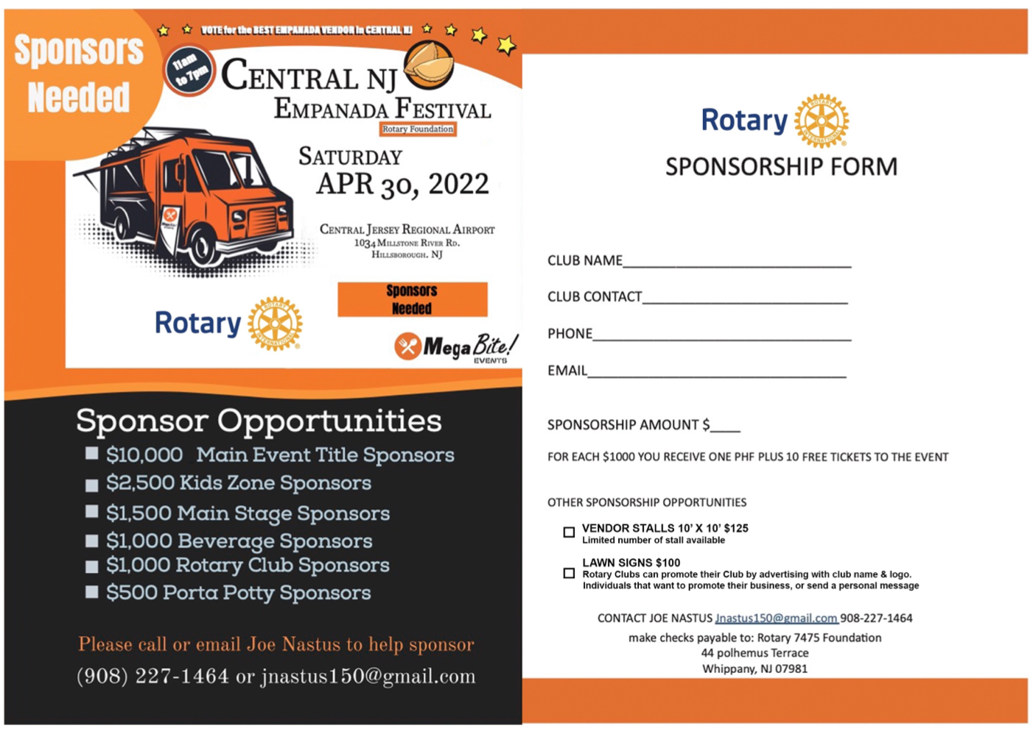

Saturday, April 30 – Rotary Empanadas & Food Truck Festival supporting The Rotary Foundation Annual Fund – We’re looking for Clubs to be sponsors for this Annual Fund fundraiser which will be held from 11 am to 7 pm at Central Jersey Airport in Manville (Somerset County.) For a $1,000 sponsorship, Clubs will get a Paul Harris Fellow plus 10 event tickets. Sponsorship form is attached. We need your support at this event to reach our fundraising goals. For more information, email event Chair Joe Nastus at jnastus150@gmail.com.

MAY & JUNE EVENTS
Tuesday, May 3 at 6 pm – District Leadership Meeting – This meeting will be held at the Park Avenue Club in Florham Park. We’ll focus on Vibrant Clubs. This session is for all District Leaders, Club Presidents, and Presidents-Elect. Tickets are $20 each which includes dinner and drinks. Advance purchased required. Please CLICK HERE to purchase your ticket. For more information, email me at Shelby@HartmannRhodes.com.

Monday, May 16 – 2022 District Training Assembly – Presidents-Elect, Secretaries-Elect, Treasurers-Elect, Foundation Chairs-Elect and Membership Chairs-elect will take over the Park Avenue Club in Florham Park for training. Tickets are now available for purchase. CLICK HERE to buy your ticket today. IF YOUR CLUB WANTS TO RECEIVE A DISTRICT GRANT NEXT ROTARY YEAR (2022-23), THE CLUB PRESIDENT AND FOUNDATION CHAIR MUST ATTEND THE DISTRICT TRAINING ASSEMBLY. For more information, email DGE John Shockley at johndg2223@aol.com.



JUNE 10-12, 2022 Rotary Youth Leadership Award (aka “RYLA”) – REGISTRATION NOW OPEN – Click HERE to register. Please email PDG Barry Kroll at barrykroll@aol.com with your questions.

June 30, 2022 – District 7475 Banner Exchange – Come as I pass the District Banner & Gavel to John Shockley of the Branchburg Rotary Club. We’ll end this year where we started – the Park Avenue Club in Florham Park. Save the date. More details to follow. For more information, email DGE John Shockley at johndg2223@aol.com.

That’s all for this week!

Be well + stay safe as we Serve to Change Lives together!



Shelby Rhodes
Rotary District Governor 2021-22
Rotary International District 7475
E: Shelby@HartmannRhodes.com
C: 973-945-9494

