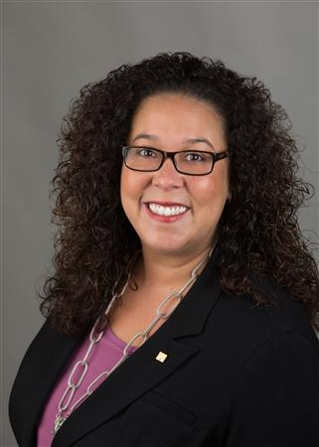

District Governor Shelby Rhodes
Weekly Newsletter
June 13, 2022

THIS EMAIL IS BEING SENT TO ALL DISTRICT ROTARIANS.

Happy Monday Rotarians!

With just 17 days left in the Rotary year, I’d like to devote this week’s weekly email to your charity – THE ROTARY FOUNDATION.

Why now?

First, our District Foundation Recognition Dinner is this Wednesday, June 15. We’ll recognize our District’s Clubs and Rotarians for their amazing generosity. Our dinner – including a cocktail reception and plated dinner both with open bar – will be held at the Park Avenue Club. Tickets must be purchased in advance HERE. This event is open to all Rotarians and their partners/guests. I hope to see many of you at the event.

Secondly, we are short in our fundraising goals. How short? Well, we are $5,863 away from our Annual Fund-Share goal and $10,065 from our PolioPlus goal.

I am fairly certain we will reach our Annual Fund-Share goal with promises from various Clubs and Rotarians, but our PolioPlus goal is whole another story. We still have 27 clubs - yes 27 clubs - where no members or the Club have given a single dollar to END POLIO NOW.

Polio eradication is very close with just a handful of cases this year. But that doesn’t mean we can forget the promise Rotary made to the children of the world. Rotary is the only organization dedicated to global polio eradication. Please consider a donation today END POLIO NOW by clicking HERE or using the attached donation form.

HOW SHOULD OUR CLUB ALLOCATE FUNDRAISING DOLLARS?
I have many members asking me about Club and Rotarian giving to The Rotary Foundation. So, I am going to take a moment to explain how we should think about giving. Simply put:

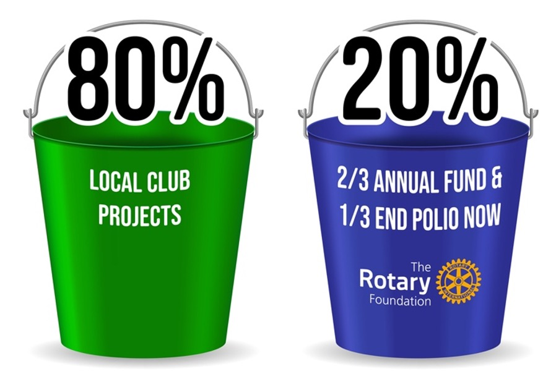

If a Club raises $100, then $80 would go to local Club projects while ~$13.20 would go to the Annual Fund-Share and ~$6.80 to PolioPlus.

Every Club should plan each year to give a minimum of $1,000 to the Annual Fund-Share and each Rotarian is asked to give $100 (that’s just 28-cents per day). Why? This will continue to feed the engine of District Designated Funds (aka “DDF”) to provide District and Global grants.

Here’s the math:
~1,800 members each giving $100 per year is ~$180,000
77 Rotary Clubs each giving $1,000 per year is $77,000

That’s ~$257,000 per year which will feed grants for our District Clubs to continue doing projects locally and around the globe. And, where members can’t afford $100 each then Clubs should work to fill-in this gap from Club fundraising dollars.

As for Polio: ~1,800 members each giving is ~$90,000. This amount will be matched 2:1 by the Gates Foundation which becomes ~$270,000.

PLEASE REMEMBER: If you are a Rotarian, then The Rotary Foundation is your charity.

CLUB NEWS:
CLICK HERE to read this week’s Club news which include a 5k Kolor Run, the Jean Harris Award Honoree and $113,000 awarded by one Rotary Club this year. … Want to have your news featured? Email rotary7475news@gmail.com by Friday at 5 pm.

END HUNGER IS BACK – FOOD DISTRIBUTION ON JUNE 25

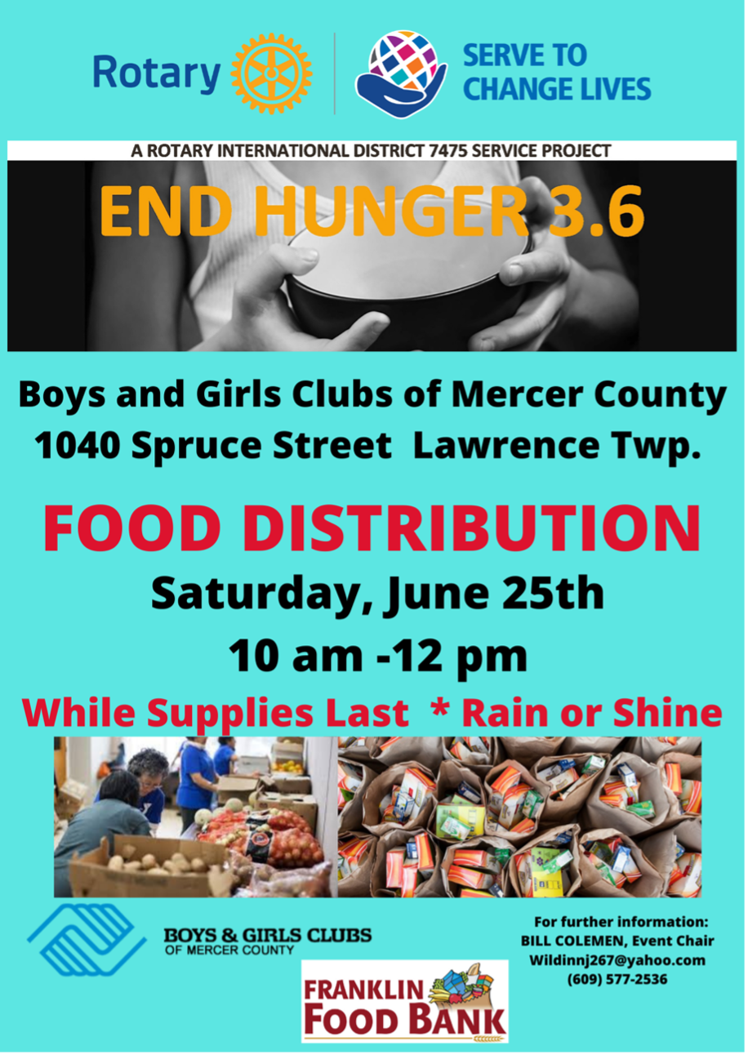

2022-23 CHANGING OF THE GUARD/INSTALLATION OF OFFICERS:
Clubs will start installing their 2022-23 club officers real soon. If you’d like a member of the leadership team to be part of your special day, please contact District Chief of Staff Mark Hartmann at 973-296-9507 (call/text) or Mark@HartmannRhodes.com to make arrangements.

LAST CALL – ROTARY FOUNDATION RECOGNITION DINNER – Wednesday, June 15, 2022 – All District 7475 clubs and Rotarians and partners are invited to the Park Avenue Club in Florham Park for a special evening as we recognize our Rotary Foundation donors. Past TRF Trustee Chair PDG Brenda Cressey will be our keynote speaker. ALL ROTARIANS ARE INVITED TO ATTEND. Cocktail reception followed by a plated dinner and drinks are included. Tickets are $75 each. CLICK HERE

WE’LL END WHERE WE STARTED THIS ROTARY YEAR:
June 30, 2022 – District 7475 Banner Exchange – Come as I pass the District Banner & Gavel to District Governor-Elect John Shockley. We’ll end this year where we started – the Park Avenue Club in Florham Park. ALL ROTARIANS ARE INVITED TO ATTEND. Dinner and drinks included. Tickets are $75 each. CLICK HERE today to get your ticket. For more information, email DGE John Shockley at johndg2223@aol.com.

That’s all for this week! … Thank you for your time in reading this email and your generosity to The Rotary Foundation.

Be well + stay safe as we Serve to Change Lives together!



Shelby Rhodes
Rotary District Governor 2021-22
Rotary International District 7475
E: Shelby@HartmannRhodes.com
C: 973-945-9494

