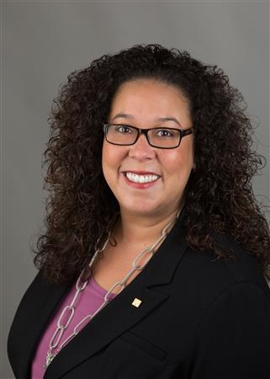
District Governor Shelby Rhodes
Weekly Newsletter
November 1, 2021

THIS EMAIL IS BEING SENT TO ALL DISTRICT 7475 ROTARIANS.

Happy Monday Rotarians!

Each November we focus on The Rotary Foundation. Why? It’s Rotary's Foundation for doing good around the world.

We do good in these 7 areas of focus:

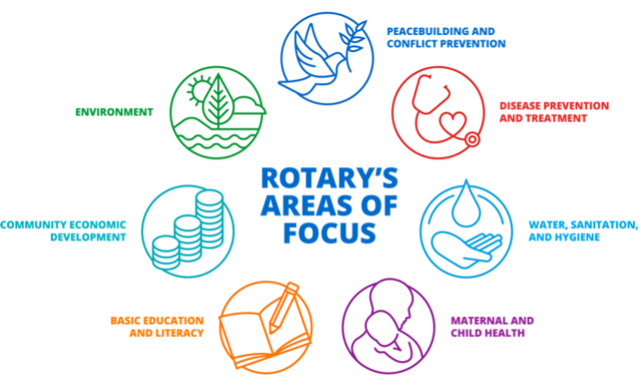

If you are a Rotarian, then The Rotary Foundation is your charity.

We ask all Rotarians to donate $100 or more to the Annual Fund online today at www.Rotary.org/give (Thank you for all those who have already donated this Rotary Year to the Annual Fund!)

MEMBER INCENTIVE PROGRAM:
Win $100.00! … Every new member of Rotary has a Rotary Sponsor who is generally someone in the Club where the new member joins. Each month new member sponsors will be entered into a drawing and one sponsor will be selected to win a $100.00 incentive check. View incentive program HERE.

WHAT’S UP IN CLUBS AROUND THE DISTRICT:
CLICK HERE to access this week’s article on the District website. How does your Club get featured next week? Simply email your news to Rotary7475news@gmail.com. Our deadline is every Friday around 5 pm.

NOW’S THE TIME TO ELECT YOUR 2022-23 CLUB OFFICERS AND REPORT SAME IN CLUBRUNNER AND IN ROTARY.ORG BY DECEMBER 31. It is very important Clubs enter this data by December 31 so targeted communications can be directed to the correct 2022-23 officers.

CLUBRUNNER – NEED HELP??
If you are the person responsible in your Club for maintaining your Club’s website or entering/editing member information or setting up events or syncing and comparing membership between district and Rotary International or anything else ClubRunner related you can have a 45-minute private lesson on how to use ClubRunner via Zoom. There is no cost for this service. There will be 4 sessions available per week. Contact Barry Kroll, District Webmaster at barrykroll@aol.com to set up your appointment.

DISTRICT GOVERNOR VISITS:
Please work directly with District Chief of Staff Mark Hartmann. He can be reached at 1-973-296-9507 (cell/text) or Mark@HartmannRhodes.com.

UPCOMING EVENTS:

Tuesday, Wednesday & Thursday, November 2 – 4 at 7 pm – Virtual Zone Summit – Hear from your Rotary Leaders at our 2021 Zones 28 & 32 Summit. It’s free to attend. Click HERE to register.

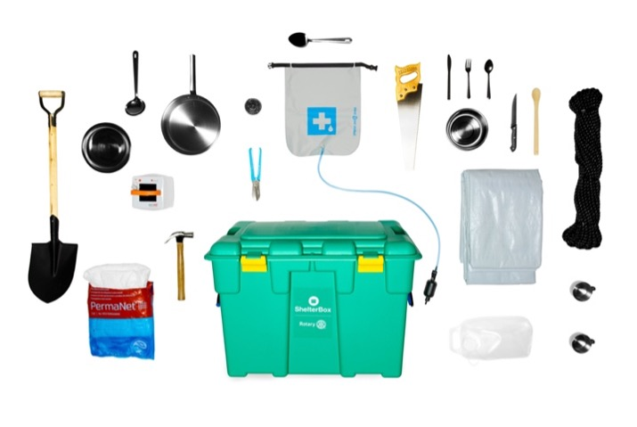
Thursday, November 4 at 8 pm - An Evening to Experience ShelterBox - Each year, ShelterBox holds a benefit highlighting the lifesaving work the generous support of our donors has enabled. We hope you will join us for an hour of inspiration as we share exclusive updates from ShelterBox Response Team members on our current response efforts. Whether you are new to ShelterBox or a long-time supporter, the Evening to Experience ShelterBox is an hour of inspiration, hope, and stories that personify “Service Above Self”. You will hear from families whose lives were transformed after receiving ShelterBox aid. This event is held online and is free to attend. Register online HERE.

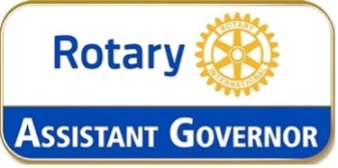

Monday, November 8 at 7 pm – Assistant Governor’s Meeting – This online meeting is for Assistant Governor’s and select invited District Leaders. Advance registration required. Sign-up online HERE.

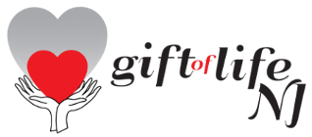

Thursday, November 18 at 7 pm – Gift of Life of New Jersey Annual Meeting – Gift of Life’s mission is to save the lives of children by providing resources to treat congenital heart defects. Children are brought to the United States for surgery plus overseas missions to train foreign surgeons and bring them needed equipment through Gift of Life’s efforts. Come learn about the organization’s efforts during the pandemic year. If your Club would like to present its annual contribution to Gift of Life at the virtual meeting, please contact PDG Jim Allison, Gift of Life NJ Chair, by email at JRA188@aol.com so he can add your Club’s name to the agenda. This session is online via Zoom. Advance registration required. Please sign-up here.

Tuesday, January 11 at 6 pm – District Leadership Meeting – Save the date District Officers, Executives, Leaders and Club Presidents for this in-person meeting. More details to follow as we get closer to the event.

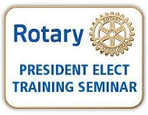

SAVE THE DATE! - PRESIDENT ELECT TRAINING SEMINAR (aka “PETS”)
PETS is in-person this Rotary year! … PETS will be held at the Marriott in Hanover, NJ on March 24-26. PETS training is MANDATORY for all Presidents-Elect, even if you are currently a President with a 2-year term or were President in the past. Plus, we’ll have two online Pre-PETS sessions on March 1 and March 8. Please save these dates now and future information will be sent out.

That’s all for this week!

Be well + stay safe as we Serve to Change Lives together!
Shelby

Shelby Rhodes
Rotary District Governor 2021-22
Rotary International District 7475
E: Shelby@HartmannRhodes.com
C: 973-945-9494

Need to meet with Shelby? Click here to schedule a time.
Need to meet with Mark & Shelby? Click here to schedule a time.

