HOW TO ACCESS ROTARY
CLUB CENTRAL

Go to My Rotary and select Sign In or Register. Or go to www.rotary.org/ClubCentral. You will be prompted to sign in/register if you haven’t already done so.
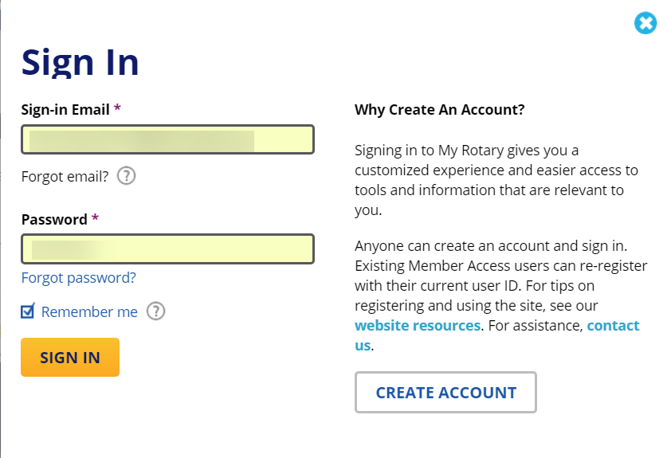
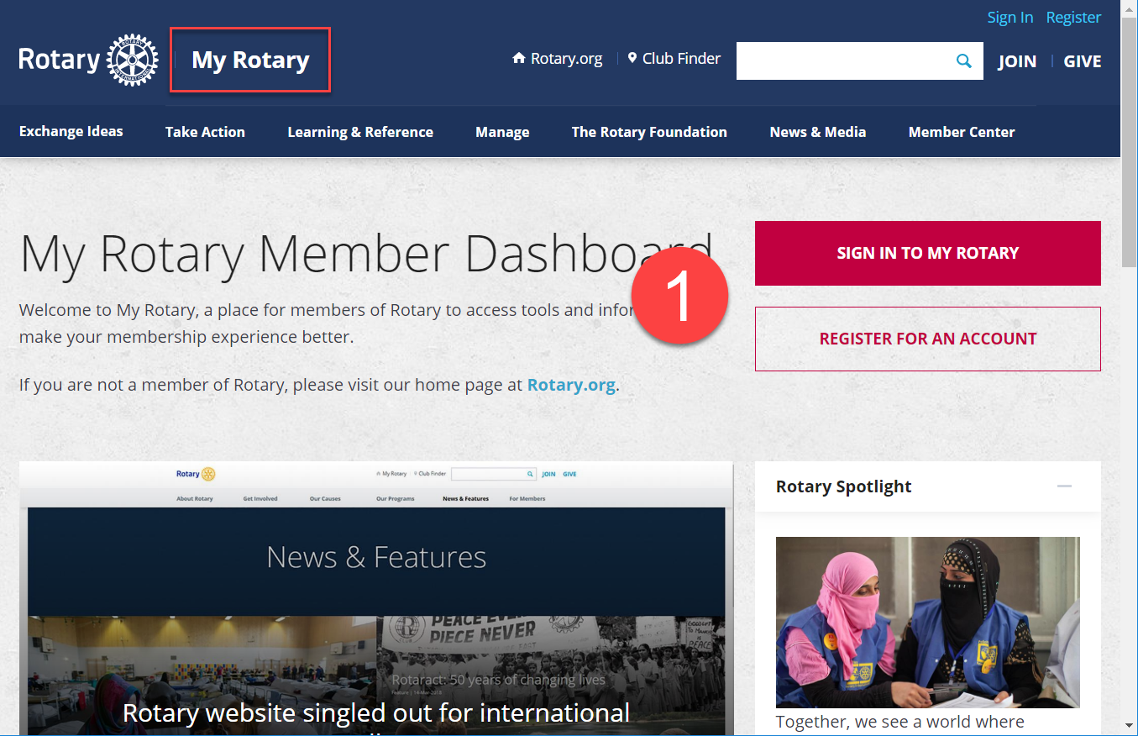

If you haven’t already registered, click “Create Account” - you’ll enter your name and email address and receive a confirming email from Rotary.org with a link to complete your registration. You’ll then be able to sign-in.
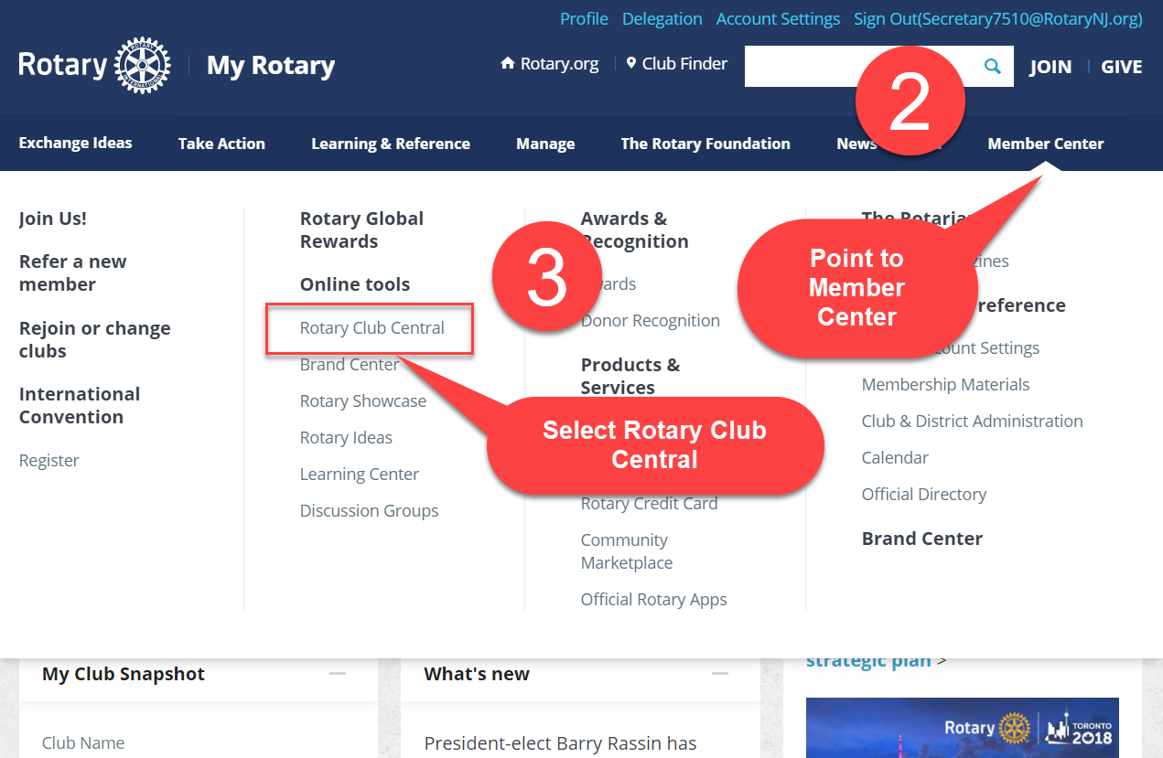

What is Rotary Club Central?
Rotary Club Central is a tool that enables clubs to set goals and track achievements from year to year.
Who can edit and view club records?
Club leaders - the incoming, current and past president; the club secretary, treasurer, and executive secretary (if used); the Foundation chair; and the membership chair - can enter and edit goals and achievements for their year in office.
What will this guide cover?
The guide will show step-by-step procedures for entering club goals and will show how to enter achievements.
- The goals should be entered before the new officers begin their year of service.
- The achievements can be entered at any time throughout the year of service as goals are accomplished.

Goal-setting basics
The guide will show step-by-step procedures for entering club goals and will show how to enter achievements.
When you reach Rotary Club Central, your screen looks like this, your club’s Dashboard. The graphic images show your club’s trends in membership and in projects.
You can also click on the tabs such as Global, My Zone, My District to see trends across all of Rotary, in your district’s Zone, in your District itself, etc.

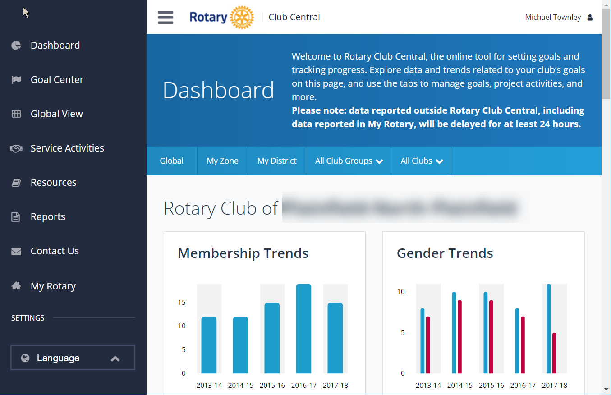

The left side menu contains the various links for action items.
- Dashboard - the welcome screen with your club’s trends displayed
- Goal Center - the screen where you enter Membership and Engagement; Foundation Giving; Service; Young Leaders; Public Image; Rotary Citation.
- Global View - shows all clubs' collective progress toward each goal worldwide and across your zone, district, and club group.
- Service Activities - As you work to meet your club's service goals, Rotary Club Central helps you track your projects and activities, record contributions and volunteer participation, and review project data.
- Resources - “How to” pdfs for using this website that you can download and share.
- Reports - a number of reports on membership, foundation giving, etc.

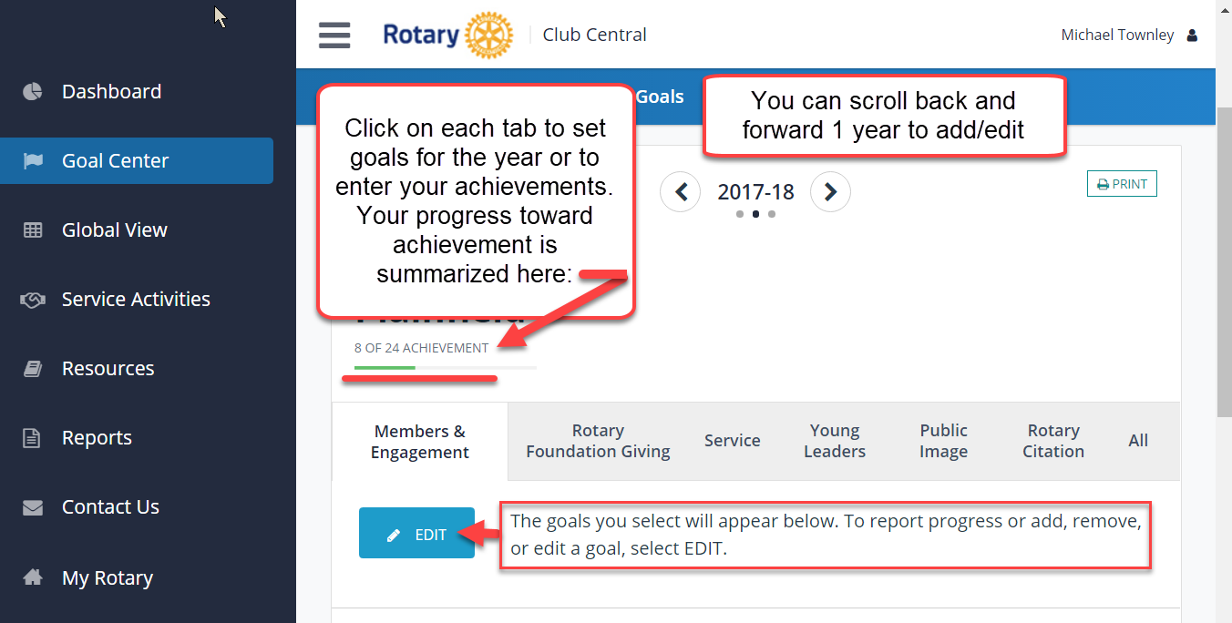

Membership and Engagement: After clicking “Edit,” you can enter your goals or your achievement numbers. You can also see a graphic display for each category.
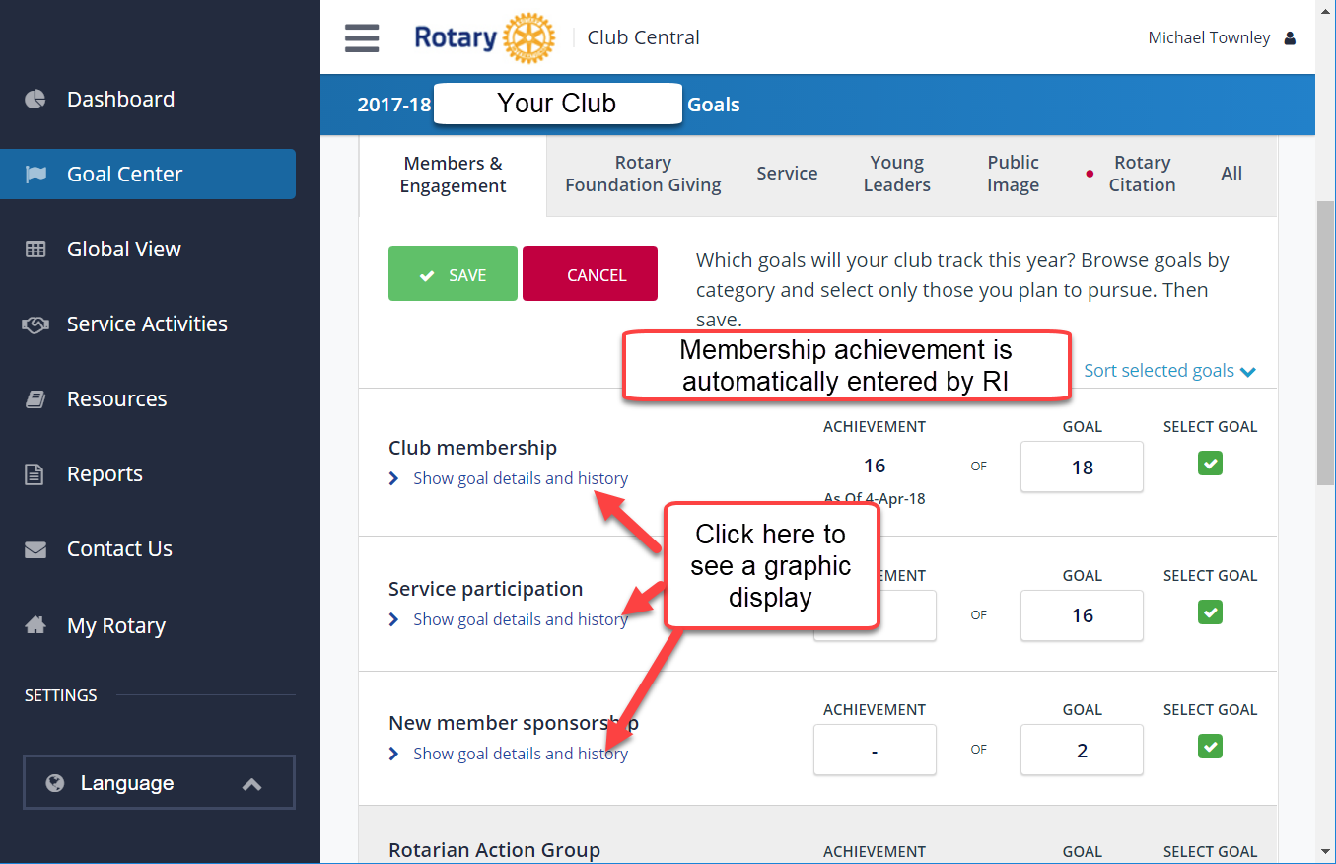
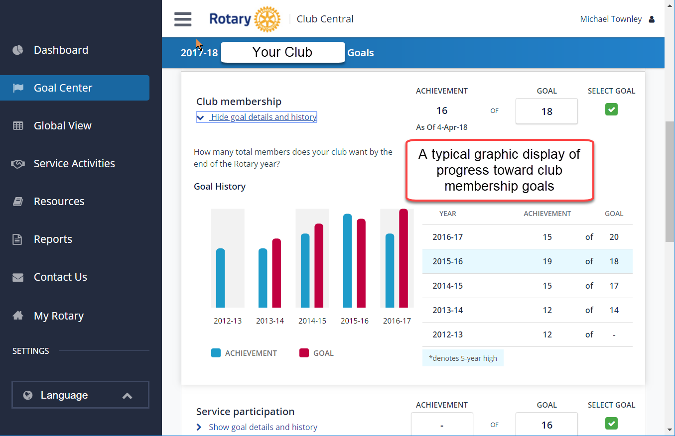

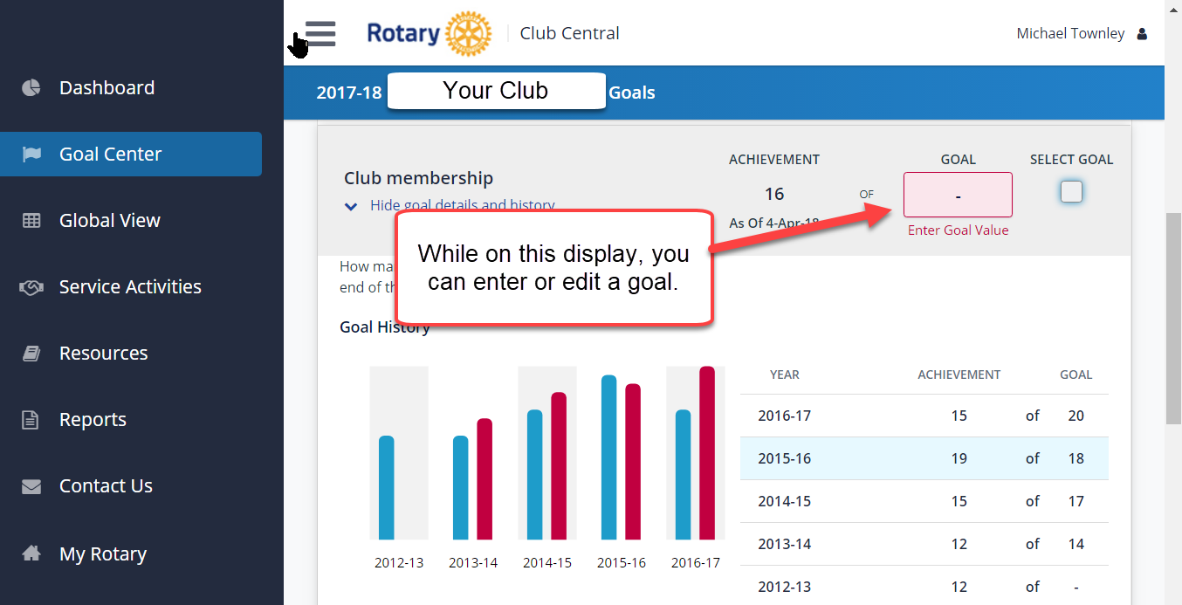

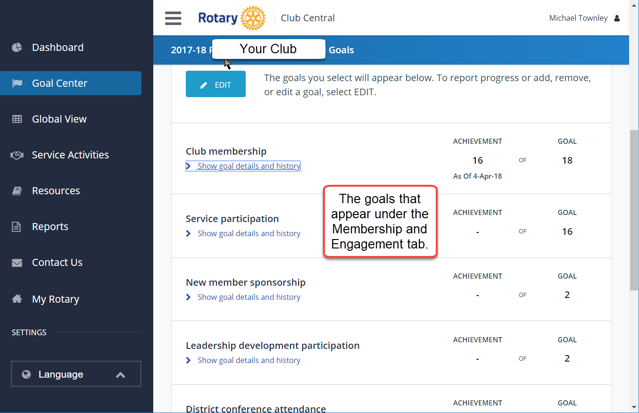

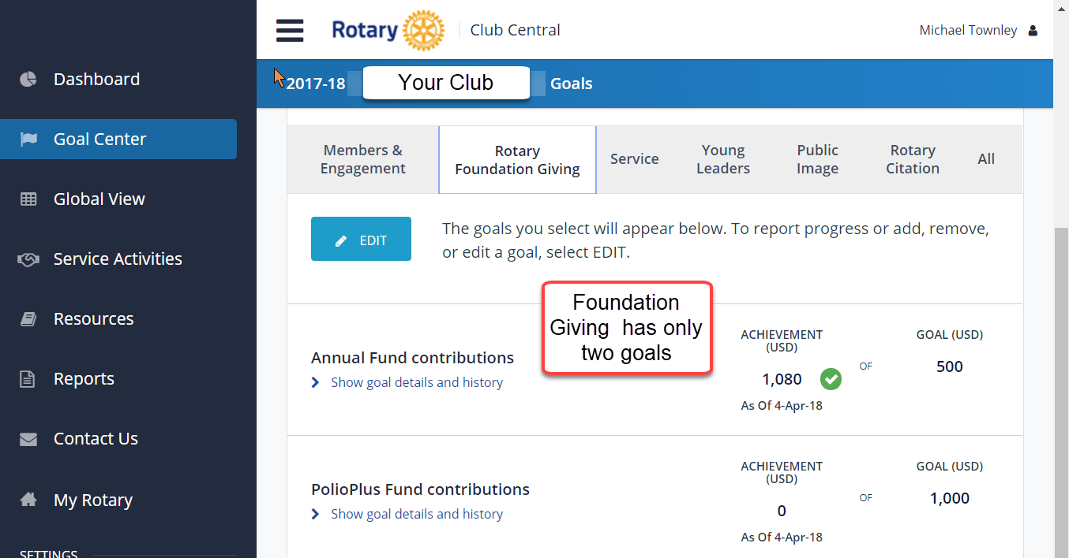
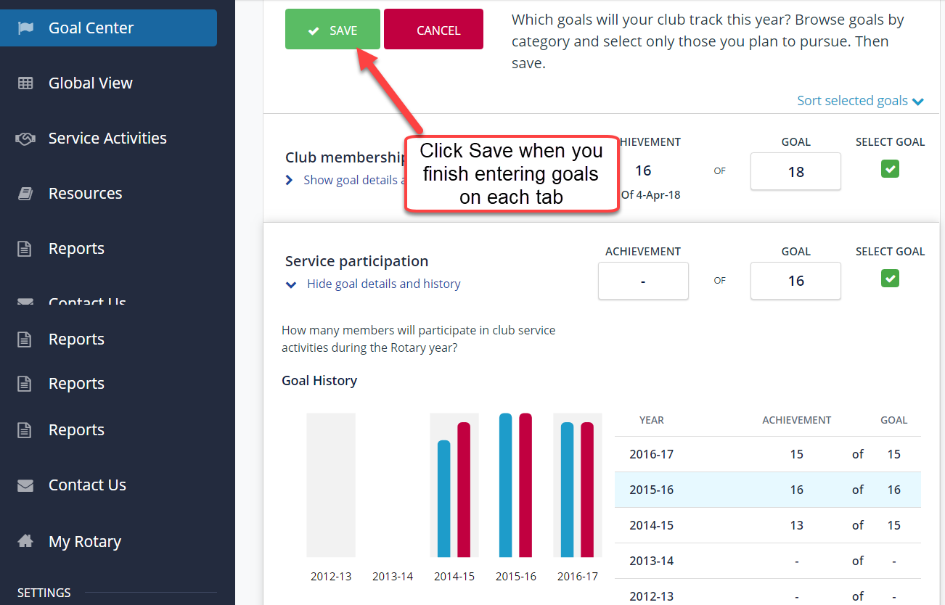

After you complete entering goals for Membership and Engagement, you can continue on to the other tabs: Rotary Foundation Giving, Service, Young Leaders, Public Image, and Rotary Citation.
Some of these tabs have only one or two goals.
Again, be sure to save your work before you stop. You can return and enter more data at any time.

[See next page for Service Activities]

Service Activities is another major component of your club’s goals and achievements. As shown below, you have the option to “Add New Service Project” or “Repeat Past Service Project.” This is especially helpful when your club has regular, annual service projects.

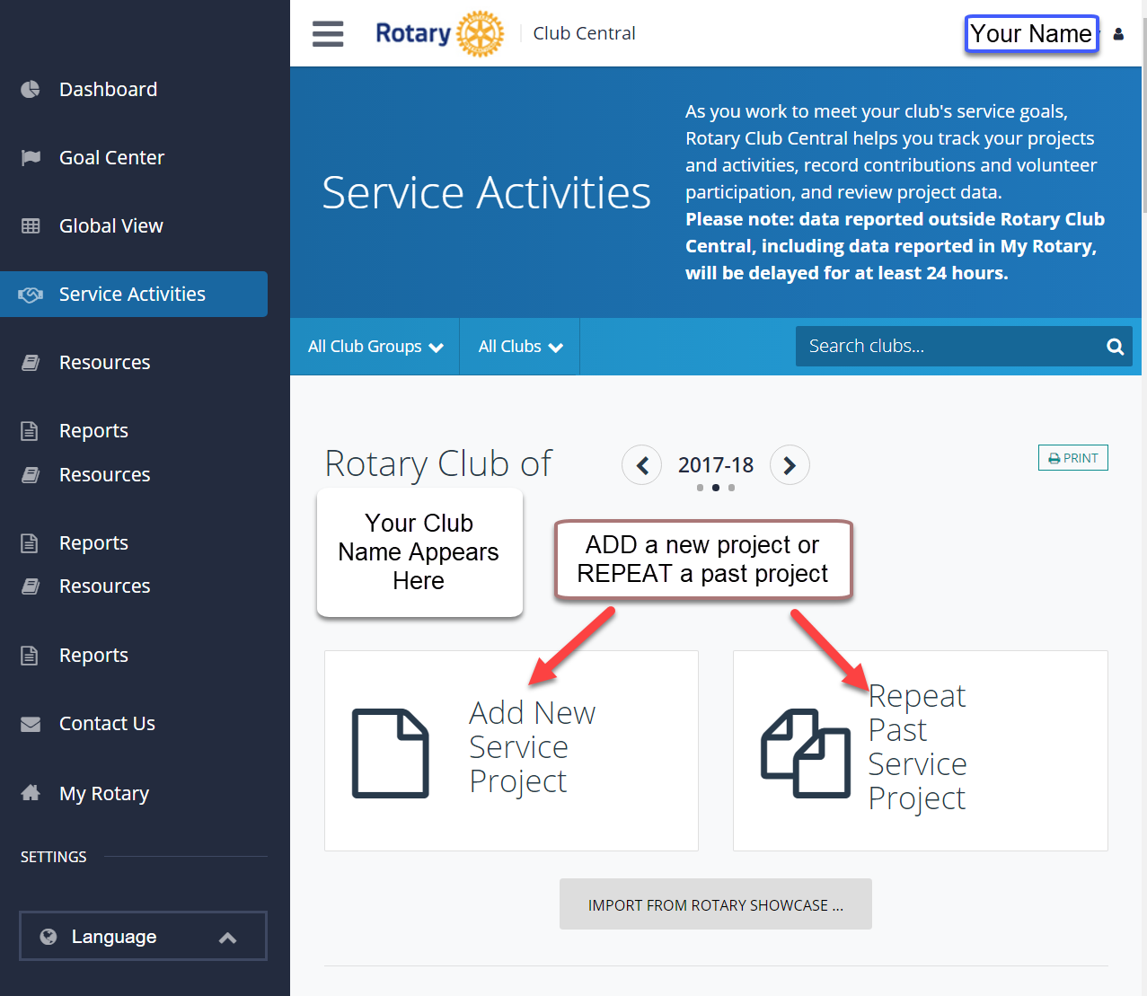

Adding a new project :
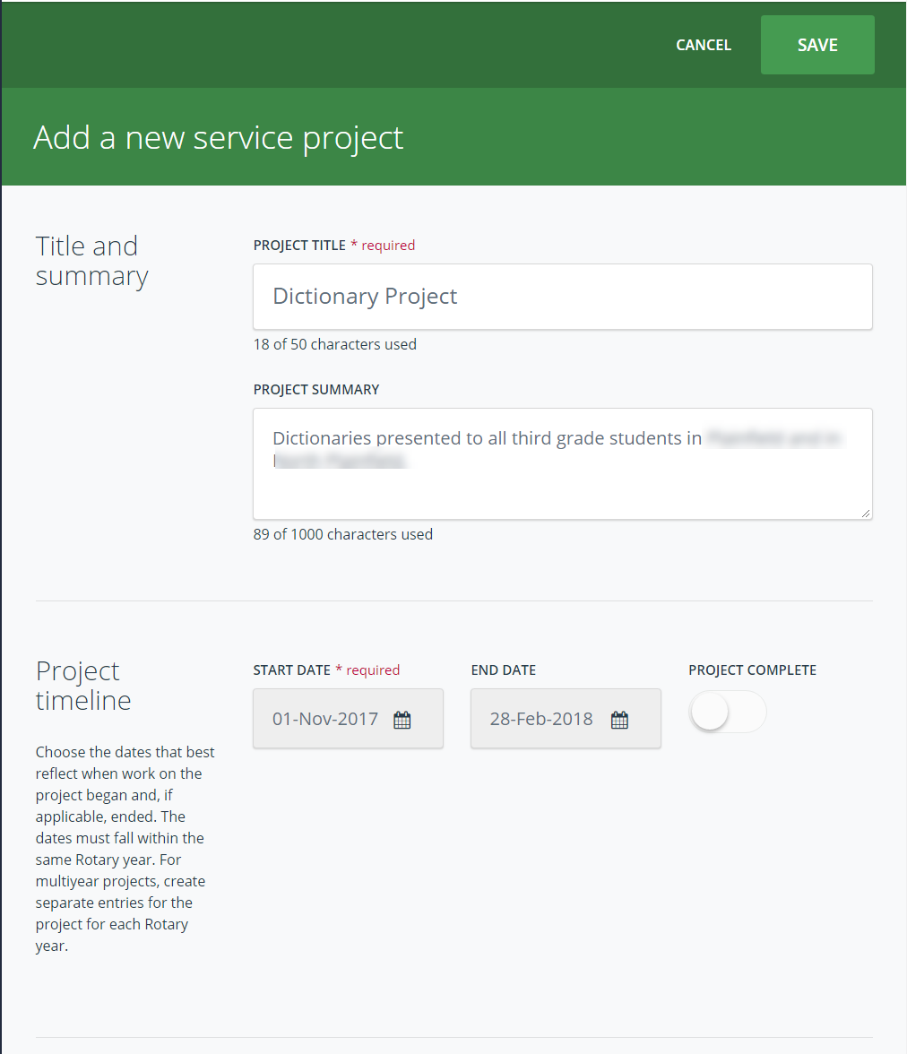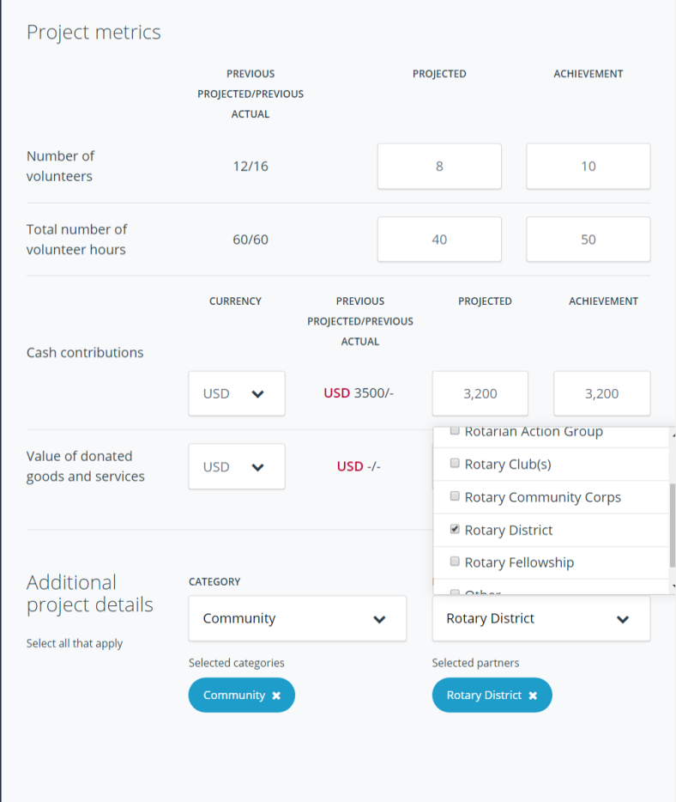

Repeat a Past Service Project:
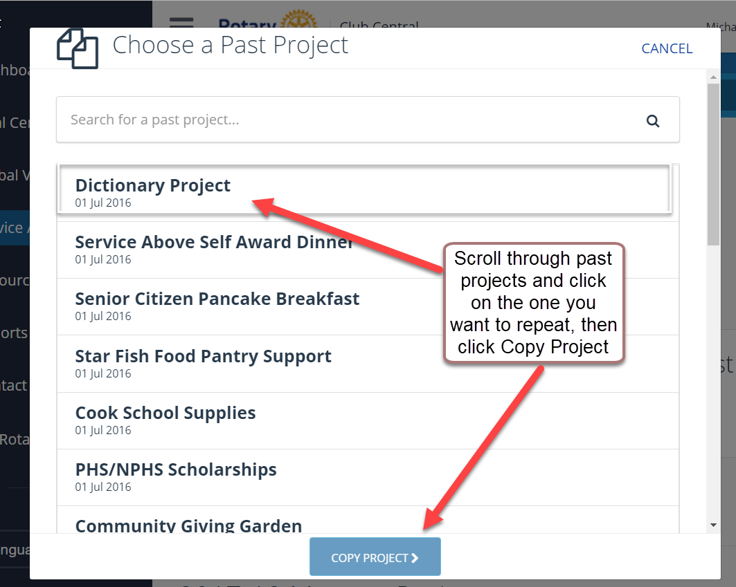
Scroll down on the “Service Activities” page an you will see a listing of any projects that you have already entered, with Completed Projects on the left and Current Projects on the right.
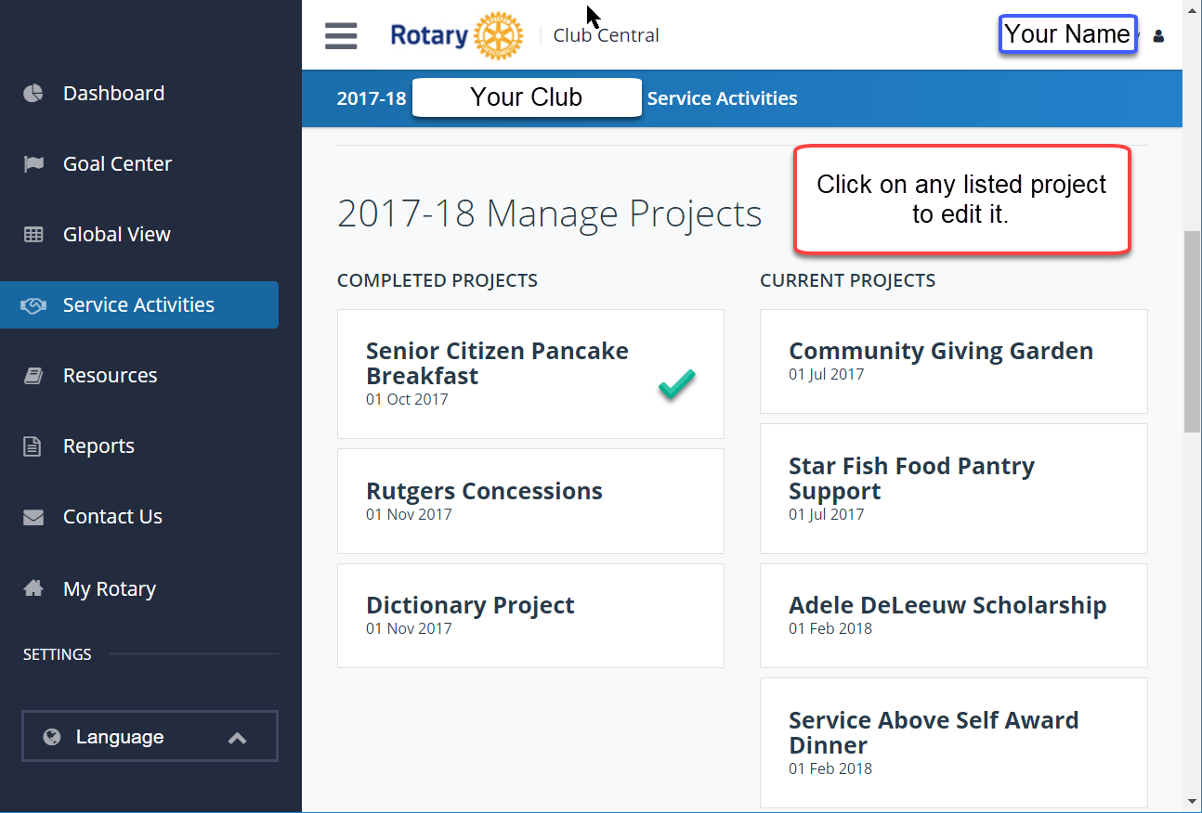
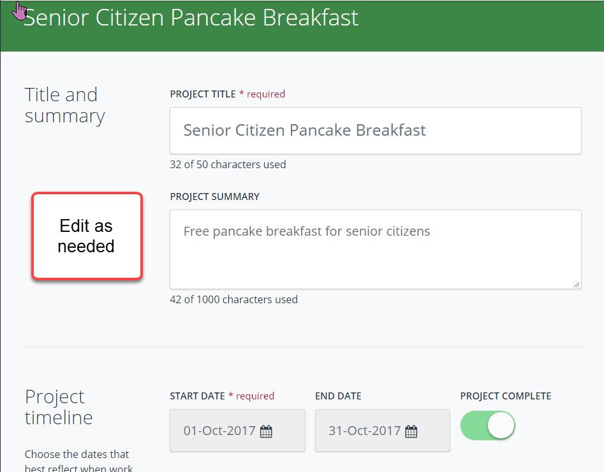
Resources: this menu item has resources for General use of the Rotary Club Central site (shown below), plus additional resources for each of the tab sections: Membership and Engagement; Foundation Giving; Service; Young Leaders; Public Image; Rotary Citation.
Some of the resources are identified as pdfs, while others are links to web pages on Rotary.org or related websites.

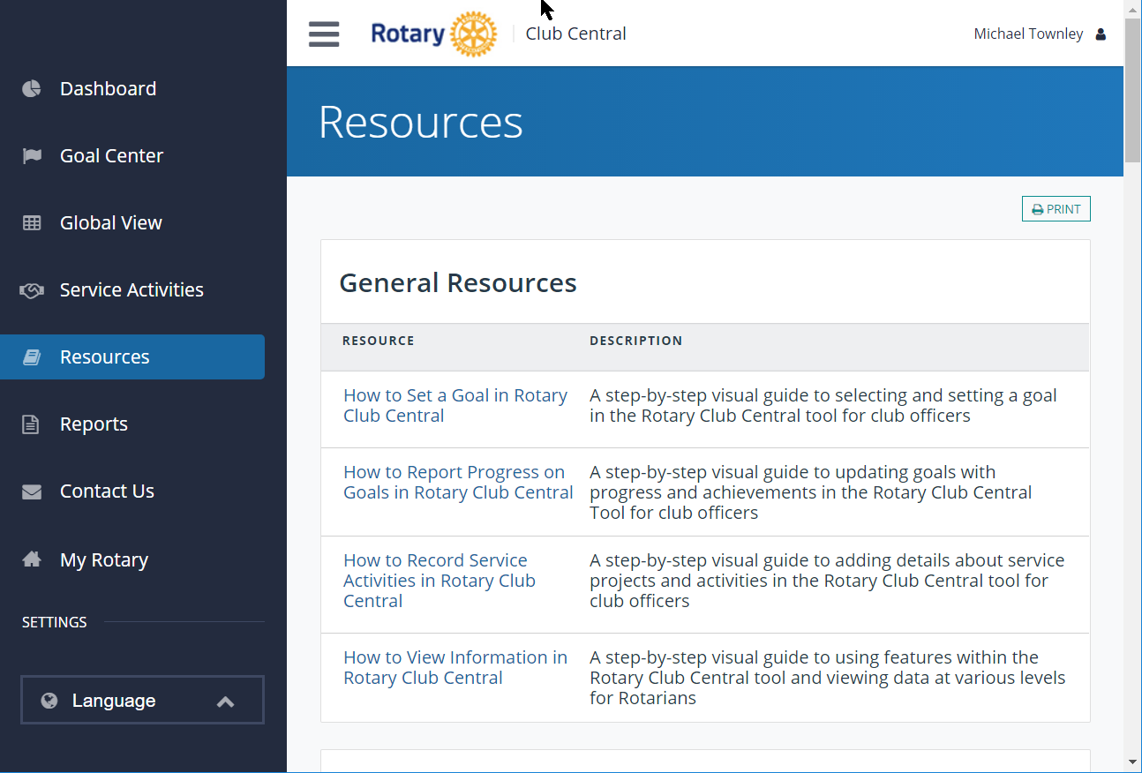

Reports: These reports are generated on demand at the Rotary.org website. Please be patient as it may take a little while to load the reports.

[See following page for graphics]

Three categories of reports as shown below:
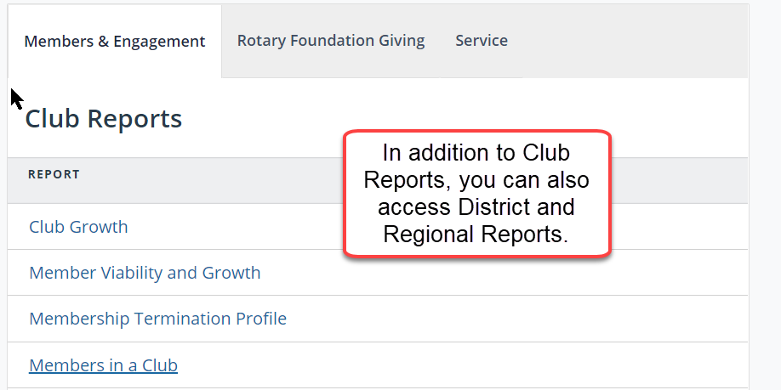

The Rotary Foundation Giving reports include Club Recognition Summary, useful in quickly seeing how your members are doing in the Annual Fund Giving or their Polio Plus donations:
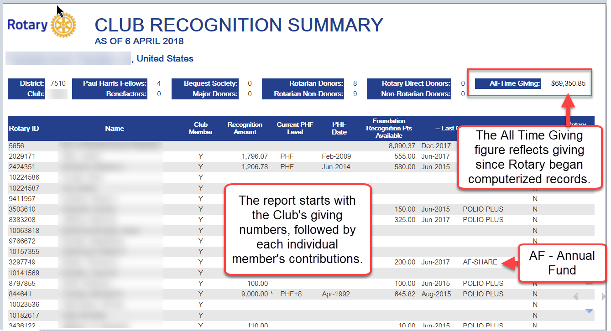

One of the Service reports is the Listing of Club Sponsored Organizations - Interact Clubs and Rotaract Clubs that are sponsored by your own club.
If you select this report and it does not show any active clubs but you know your clubs are active, the most likely reason for this is that their data has not been filed each year with Rotary.org.
There is a link in the report to facilitate entering that data and updating those clubs so they get out of the “Suspended” category.
The example below shows an “Active” club sponsored by the Rotary Club of Plainfield-North Plainfield and a “Suspended” club.
The “Suspended” club has not been active since the school was unable to provide an adviser.
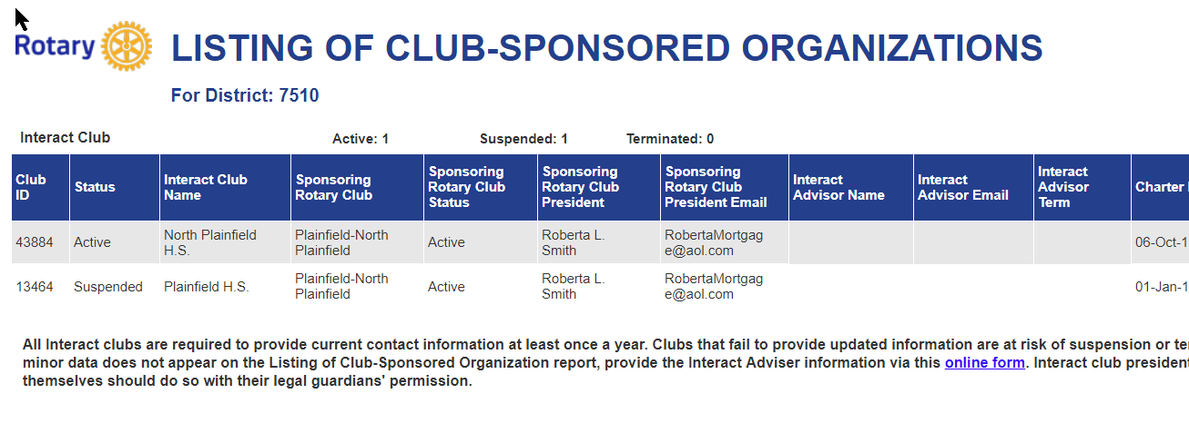
[End of graphics]

Conclusion: Rotary Club Central provides a convenient way to enter your club’s goals and track your club’s progress toward achieving those goals on a year-by-year basis. This is useful to your own club leadership and to your district’s leadership as they help assess the life of a club.
Club officers should work together to determine the goals for the year and then enter those goals in Rotary Club Central.
To do this, club officers should register on Rotary.org so that they can access My Rotary and the many tools available there, including Rotary Club Central.
If you need assistance using Rotary Club Central, please go to the Resources menu item and download the pdfs available there in the General section. They are very helpful.
Further assistance is available from your district leadership.

Rotary District 7510 Contact: District Secretary Michael Townley - secretary7510@rotarynj.org
Rotary District 7470 Contact: District Webmaster Barry Kroll - barrykroll@aol.com

