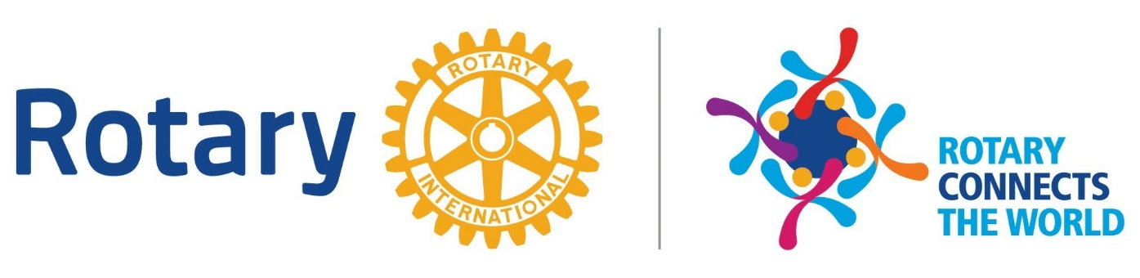

Frequently Asked Questions

What is RLI (Rotary Leadership Institute)?
The world of Rotary is much bigger than just your club and district, and there are numerous Rotary resources designed to give Rotarians access to tools, services, expertise and ideas that will help them deliver needed services and support to their communities. One of those resources is the Rotary Leadership Institute (RLI).

RLI is a series of three fast-paced, interactive, one-day courses offered to increase a Rotarians’ base of knowledge in Rotary and strengthen their personal volunteer and leadership skills. The courses are facilitated by trained Rotary leaders in each district and are fun, topical, and geared toward active Rotarians who want to be more effective leaders in their clubs. The Rotary Leadership Institute was established in 1992 and today almost 400 districts around the world have RLI programs. For more information, visit the RLI website at www.rlinea.org

What will I learn?
You will find a treasure trove of Rotary information and knowledge in the RLI courses, such as: How to create and carry out service projects, how to attract and retain members, how The Rotary Foundation works, how to publicize what your club is doing, how to strategically plan for your club’s future, and perhaps best of all, what kind of leader you are and how to become a better volunteer leader, in Rotary and other organizations.

How long are the classes and what is the cost?
There are three full-day classes in the curriculum, titled Part I, Part II and Part III, and each Part consists of six segments or modules. Each district sets the times and places for its RLI sessions; typically, classes are held on Saturdays and will begin at 7:30 am with breakfast and end at 3:30 pm. A participant must complete all three Parts, preferably in sequence, to graduate from the Institute.

The cost for Rotary Leadership Institute is $75.00 for in person classes, $25.00 for virtual classes. This fee covers the costs of course materials, hot breakfast and lunch, coffee breaks, etc. Often times your club may pay part or all of your RLI tuition. You should ask your club president if assistance is provided.

Who are the faculty?
Faculty members (“facilitators”) are carefully selected by District leaders for their breadth of Rotary knowledge and experience, their facilitation abilities, and their communications skills. They are present or past District leaders, past club presidents and others with experience in special areas of Rotary. All facilitators have completed specified RLI training and are certified by Rotary Leadership Institute Northeast.

How is the material presented?
RLI training provides you with interactive and collaborative learning sessions while you explore issues and discuss potential solutions with your fellow club and district Rotarians. Course methods include discussion groups, group challenges, and problem-solving sessions. Everyone participates and Rotarians learn from each other. A course notebook containing the topics and notes for each session, course outlines, agendas, faculty listings and more are provided to each student.

Generally, classes are limited to between 15 and 20 participants for each Part so there will be vigorous discussion and exchanges of ideas. However, the class size varies by District and will be displayed on the Rotary Leadership Institute Northeast registration page when you sign up.

Must I complete all three Parts in one Rotary Year?
No. If you cannot complete all three Parts in one Rotary Year, you can finish later. You can basically work at your own pace. You should complete the three Parts in sequence, if possible; however, occasionally participants may be scheduled out of sequence so as to create larger classes for more interactive sessions and better small group discussions.

How do I sign up?
Go to the RLI Website, www.rlinea.org and select the more information next to the site of your choice. Generally, all three Parts – I, II and III – are offered on the same day, so you should select the Part that you’re eligible for on that date. Tuition may be paid online at the time of registration by credit card

Should I attend RLI even if I don’t plan to be a club officer?
Yes! You will pick up new ideas and gain invaluable Rotary knowledge and acquire leadership skills and awareness that will make you more effective as a member of your club and a member of the global Rotary community. When you graduate from RLI, you will have a much broader and more informed perspective of how to help your club address and solve your community’s needs. You will learn about new Rotary resources and build new relationships and friendships. You will meet Rotarians from around your District who, like you, want to do more and accomplish more in Rotary, whether as a club officer, committee chair, or member.

Best of all, RLI will inspire you to want to do more!

