Please use this sample proclamation as a template to work with your Mayor or other government officials to pass a resolution to commemorate Rotary Has Heart Day on Feb. 14, 2016, and to publicize Rotary’s accomplishments. Please remove text box and insert date information at the bottom of this page. Available for download from www.rizones33-34.org

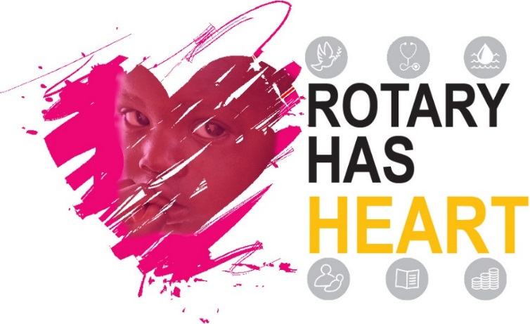

Rotary Has Heart Proclamation

WHEREAS, Rotary International, founded February 23, 1905 in Chicago, Illinois USA, is the world’s first and one of the largest non-profit service organizations; and

WHEREAS, there are over 1.2 million Rotary club members comprised of professional, business, and community leaders in over 34,823 clubs in 206 countries and geographic areas; and

WHEREAS, the Rotary motto “Service Above Self” inspires members to provide humanitarian service, encourage high ethical standards, and promote good will and peace in the world; and

WHEREAS, local clubs are encouraged to participate in a Community Service Project centered around Rotary International’s six areas of service (basic education and literacy, economic and community development, disease prevention and treatment, peace and conflict prevention/resolution, water and sanitation, maternal and child health); and

WHEREAS, Rotary is committed to adopting projects to help do good in the world; and
[our Rotary Club’s name] is one of approximately 1600 clubs throughout eight states and the District of Columbia in the United States and 20 countries of the Caribbean with more than 67,500 members sponsoring a project in the first quarter of the year 2016, finding Valentine’s Day 2016 directly in the middle of this time, to satisfy a need in its community thus “Doing Good In the World

Therefore, I __________________________________ [Mayor] of the[Municipality] of _________________, do hereby proclaim February 14 2016 as Rotary Has Heart Day in ___________________________ [Municipality], and encourage all citizens to join me and Rotary International and the Rotary Club of [our club’s name] in making sure this project is given proper recognition.

