**COMING BACK STRONGER:**

**Building Individual and Community Resilience Through Strong Volunteers**

**The Rotary R2 Resilience Program**



**Table of Contents**

**The Story of Coming Back Stronger: Why do we need it? ……………………………. 2**

**The Situation ……………………………………………………………………………………………… 3**

**Intended Outcome: Who might we support? ……………………………………….…….. 4**

**Our Collaboration ……………………………………………………………………………….……… 5**

**Implementation: Helping volunteers remain resilient during – and after – the pandemic ……………………………………………………………………………………..……… 6**

**Organizational Structure ……………………………………………………………………………. 9**

**Evaluation and Reporting ………………………………………………………………………….. 10**

**Sustainability …………………………………………………………………………………………….. 10**

**Appendix**

**What is Resilience? ………………………………………………………………………….. 11**

**About Community Development ……………………………………………………… 13**

**Rotary’s Capacity …………………………………………………………….………………. 14**

**The Story of Coming Back Stronger …. Why do we need it?**

The president of the local Rotary club in a small community in Ontario is struggling to help her fellow Rotarians adjust to the changes wrought by Covid19. Local businesses have closed. People have moved away. They’re used to gathering together to respond to community challenges and to help. The disease prevents them from doing so. Worse, their personal lives have been turned upside down. They’ve been forcibly disconnected from family, friends and neighbours. The reassurance of a hug or a gentle touch is being denied them. Their sense of self, mental health and well being are being challenged in unexpected ways.

As a volunteer in another community said recently, “We don’t know what to do!”

Versions of this story are being repeated over and over across North America. It is true that the pandemic has disproportionally harmed marginalized individuals and groups. But the pandemic has had another impact not often considered and less often discussed. Thousands upon thousands of the volunteers for whom a major life purpose is to help the most vulnerable and disenfranchised, are unable to do so. Fundraisers have been cancelled, community spaces closed, sports leagues put on hiatus, self help groups made silent. For people committed to serving others, such activities represent a major life purpose, for others they provide a critical connection to their community and a cure for their loneliness, indeed for some they can be the only reason for getting out of bed in the morning.

Rotarians and their allies have had their purpose interrupted, their sense of stability and well being challenged. They too must find a way past the pandemic.

If we want volunteers well prepared to build individual and community resilience, we need to ensure their own resilience is strengthened. Thus, it is critical that we provide them with the resilience training and skill development that will strengthen their mental health and leave them better equipped to do the heavy, heavy lifting we all need to do to help others.

As you read this overview, please keep this in mind:

* To best help others, we must first help ourselves and,
* Together, we will come back stronger.

**The Situation**

COVID disproportionately impacts mental health and wellbeing of people marginalized by society. We will ‘unleash’ the power of Rotary, United Way, Community Foundations and volunteers from other groups on a targeted campaign of partnership building with those most harmed by the pandemic and provide tools and training to help strengthen their resilience - their capacity to solve their own problems so they may ‘come back stronger’.

Research done in partnership with the Canadian Mental Health Association in May 2020 shows that mental health consequences of COVID can be described as the fourth wave of the pandemic and are projected to result in the greatest and most enduring health footprint. Some 50% of Canadians felt their mental health had worsened during the pandemic, indicating high levels of worry and anxiety. The following month, Statistics Canada reported only 54% of Canadians identified their mental health as “very good” or “excellent” in 2020, compared to 68% two years earlier. And that was almost six months ago… the situation has not likely gotten better!

The economic value of this initiative is significant – pre-COVID, the President and CEO of the Mental Health Commission of Canada stated that mental health costs the Canadian economy $50 billion/year – that’s $1400 for every one of us. Her data indicate that 60% of Canadians have, or know someone who has experienced a mental illness. Both numbers have increased, the challenge has multiplied and we can’t be naïve about the effort required to turn things around.

The toll of the pandemic is not distributed equally. Mental health and resilience are profoundly shaped by everyday conditions in which we live, exacerbated by months of physical distancing, growing job loss, economic uncertainty, housing and food insecurity, child care challenges or school closures. Many are attempting to balance far too much, and it is taking a toll. Deterioration in mental health is more pronounced in specific disadvantaged groups: people with a pre-existing mental health condition, racialized groups, those with a disability and people living in poverty. And for these, food insecurity and fear of domestic violence have become more pronounced.

Governments and public institutions alone cannot adequately address this challenge. As one UBC researcher said, even if only 10% of the population suffer long term mental health effects as a result of the pandemic, that is almost 4 million people needing help from an already overwhelmed system. Organizations like Rotary and the United Way and our partners must step forward and begin reaching out to affected groups to help improve their capacity to solve their own problems. We must help build their resilience.

The underlying issue of resilience in relation to mental health is not being adequately addressed. More resilient communities are better able to address and solve their own problems, more likely to have an equitable share in societies benefits and more likely to become stronger social and economic contributors to society over all. Our goal is to enable Rotary, United Way and other volunteers to strengthen their connections with disadvantaged communities to collaboratively build everyone’s resilience so we can all participate in the journey of coming back stronger.

But to do so effectively, we must start by ensuring the mental health of Rotary, United Way and other volunteers. As the old saying goes, “to help others, first help yourself.” Thousands of volunteers for whom a major life purpose is to help the most disenfranchised, are unable to do so. Fundraisers have been cancelled, community spaces closed, sports leagues put on hiatus, self help groups made silent. “What do we do now?” Volunteers across the country struggle with this question. News reports describe a crisis of lost identity, depression and disengagement of people once actively involved, who now feel lost, isolated and at heightened risk of mental and physical health issues. For people committed to serving others, volunteer activities represent a significant part of their lives and a critical connection to their community. Volunteers’ resilience must be strengthened so their mental health and wellbeing recover and they can in turn support improved resilience of vulnerable individuals and their communities. It’s been a double hit. We must address recovery for both groups.

We have the tools and program to help them recover. We have the skilled team to deliver it. We have the national network to scale it across the country and later to the US. And we have the plan to make it replicable and sustainable while leveraging the power of our partners to reach the volunteers and persons who need help to recover. We envision a highly visible national effort, to build resilience, strengthen communities and help them come back stronger.

**Note: A more detailed description of resilience can be found in the appendix.**

**Intended Outcome: Who might we support?**

We envision delivering the premier North American initiative that builds individual and community resilience through strong volunteers and that it will become a unique and iconic brand.

We have engaged with Dr. Michael Ungar and his team at The Resilience Research Centre (RRC), Dalhousie University, to provide professional expertise, training, evaluation and support for this project. RRC conducts large multisite research and evaluation projects to broaden our understanding of culturally embedded protective factors and processes (i.e., resilience) of relevance to young people, their families and communities around the world. Since founding the RRC in 2002, Dr. Ungar has held over ten million dollars in research funding and conducted more than a dozen large-scale longitudinal evaluations in a dozen countries on five continents. Projects have included a six year five-country study of the pathways young people ages 13-21 navigate when needing services like counseling, educational support, and child protection.

**Outcome**: Resilient people + Resilient communities = Stronger Rebound and Recovery.

Simply, highly motivated and specially trained teams of volunteers, organized in **community clusters**, will engage with, support and build resilience in disadvantaged communities across Canada and into the US. The first phase of activity will begin in Atlantic Canada, then roll out across Canada and later into the US.

We can’t predict what our lives will be like as we adjust to the changes wrought by the pandemic. Research, however, indicates that our ability to rebound is profoundly affected by our **ruggedness** (our ability to cope with and respond to dynamic, changing environments) and **resourcefulness** (our ability to negotiate for the sources of support we need to move forward). Most importantly, the science of resilience says that the more rugged and resourceful we are, the better able we are to cope with crises and shape a stronger future.

Our focus is to ensure volunteers can sustain their own mental health so they can then be effective helpers with others. Volunteers initially include Rotarians and participants in programs of the United Way and Community Foundations of Atlantic Canada. The project is highly scalable and replicable across communities and groups in Canada and then into the US, where Rotary has a large presence.

Each **cluster** (clusters are described in a following section) of volunteers must be free to identify which communities most disadvantaged by the pandemic they’ll focus on. While we cannot presuppose which specific communities they will choose to serve, given the interest already expressed across Canada, may include those who experience racial inequality in Nova Scotia, the Sudanese Canadian community in Calgary, disadvantaged youth in central Ontario and persons with mental health issues in a number of communities.

**Our Collaboration**

This initiative is an innovative approach to responding to individual and community needs, with an existing intervention that will be adapted to each population’s needs and scaled across Canada.

The Resilience Research Center (RRC) at Dalhousie University will provide professional expertise and training required to implement this project. Two partners have joined Rotary to form a unique collaboration with aligned missions to create a powerful force to begin this initiative in Atlantic Canada and then expand nationally with other partners.

***United Way Halifax*** brings people together, including donors, volunteers and partners, to create lasting social change. They do so by investing leadership, time and funds towards critical community-based programming, partnerships, and sector capacity-building, and by doing all they can to bring their voice and influence on issues that matter most. In perfect alignment with this, the ***Community Foundation of Nova Scotia***’s mission is to build strong, vibrant, and diverse communities throughout Nova Scotia by enabling and inspiring effective philanthropy. They provide the knowledge and support for communities, charities, and citizens to realize their individual potential and collective possibilities. Through the establishment of funds, scholarships, and awards, they help build the financial assets that fuel change and growth. Not surprisingly, the two organizations collaborate on various efforts.

**Implementation: Helping volunteers remain resilient during – and after - the pandemic**

**A Powerful, Innovative, Far Reaching Collaboration**: Individuals and communities, will create a network of skilled resource clusters to enhance individual, and community resilience across Canada (and later the US). Each cluster comprises a trained cadre of volunteer Rotarians, partners and other allies who work with their community to build a response to COVID’s effects.

Through Dr. Ungar and his team, we will deliver training informed by two decades of research in more than a dozen low, middle- and high-income countries. RRC has developed an intervention called R2 Resilience (R2 = enhancements in **R**uggedness and **R**esources) that will be customized for our clusters. Unlike other resilience programs, R2 builds the capacity of participants to not only develop psychological strength, but also provides tools to help people change the world around them to make their social environments more socially just and better resourced. Recovery is accelerated, sustained and equitable. These resilience factors are explained as interacting parts of a whole systems approach to enhancing wellbeing in stressed environments, with each rugged quality potentially affecting access to resources and vice versa.

The Figure below shows interactions between 16 resilience factors selected as critical to resilience for public safety workers in Ontario.

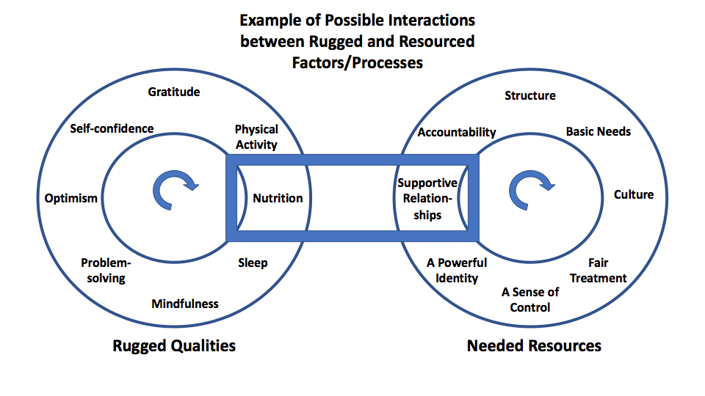

The Rotary R2 Resilience program will roll out in phases:

* Volunteers in clusters receive tools required for psychological and social sustainability through dynamic online curriculum (establish Leadership Core, contract Project Manager, identify community development experts, establish evaluation criteria and methodology); Initial training on resilience and community development to Atlantic Canadian Rotarians, project partners, community allies
* Volunteers identify populations at risk because of COVID with which to focus their efforts. R2 Resilience program materials will be adapted for use by volunteers with each population. Activate first clusters in Atlantic Canada (then in Southern, Eastern and Northern Ontario, Alberta)
* Once showing promise, other partners will repeat this process and launch their own R2 Resilience programs, adapting and adding new materials as needed with support of the RRC evaluation and training team. In each case, clusters of volunteers will take a long-term community development approach, helping both themselves (as volunteers needing support during particularly stressful and demanding times) and those who need support in their communities to become more resilient and navigate their way to the resources required to come back stronger after this crisis. Community development training is part of the R2 training program.

Specifically, volunteers who assist vulnerable populations will build on the work of the RRC to offer:

**Support and Training**: Assist individuals, organizations and businesses to complete their own recovery plans.

**Navigation**: Connect individuals with urgent needs with relevant professional expertise and services.

**Learning**: Monitor and evaluate progress as we discover the most promising practices when it comes to building the resilience of volunteers and the resilience of their communities, businesses, and institutions.

R2 is contextualized for each population and community, selecting the most critical rugged qualities and social resources to build resilience. To begin contextualization for this project, we completed a series of regional online consultations in July with 40 volunteers to identify core components of the R2 Resilience Program.

Versions of R2 have been implemented with health care leaders in Ontario, youth with anxiety disorders in South-east Asia, traumatized and racially marginalized families in Memphis, and school children in Halifax. This tailored implementation expands the work to include adult volunteers and to further validate the R2 Resilience program as a best-practice. Each implementation contextualizes the intervention while building on the rigorous scientific basis for resilience. To tailor the intervention, R2 implementation experts have met senior management teams and those responsible for the health and wellbeing of volunteers in our partner organizations to ensure the program is adapted to specific challenges and opportunities volunteers experience during the pandemic.

For this initiative, we have already:

***Explored general and specific risks***faced by individuals in each service setting. Whether those are related to psychological trauma or breaking social isolation, the R2 approach ensures that the program responds to the most pressing local issues.

***Identified the right* *audience***for the program. We have begun creation of content aimed at individuals and groups of volunteers seeking to build their resilience, as well as those holding positions of responsibility for others.

***Formatted the program*** to ensure it fits each organizational setting and the time and resources each has to build resilience. The R2 team will turn the core curriculum into workshops and online resources that can range from a series of short interactive seminars delivered face-to-face to day-long events, webinars, websites and apps, depending on what each partner needs. The program can be delivered in different mediums, such as face-to-face coaching, group workshops, or online, and may be facilitated by an R2 expert, an internally trained trainer, or self-directed.

***Delphi Process to identify the range of resilience factors that are right for each group of volunteers****.* Different partners mobilize volunteers who need different protective factors. R2 provides just the right amount of content, matched to each local setting, to support individual and organizational transformation. This is done by providing a quick response needs assessment and then selection and contextualisation of the science of resilience. Most core content is ready to implement but is adapted to ensure volunteers receive relevant content.

***Make the training materials easily accessible to ensure the program is scalable and sustainable****.* As a result of this contextualization and training process, we will provide valuable training/support for Rotarians and partners’ volunteers as the program is scaled across Canada and into the US.

**This is no “help line”**! We do not intend to sit by our phones waiting for people to call. This is an active process of community development and engagement; a deliberative process of reaching out, relationship building and planning with the people most affected by the pandemic.

We are proud volunteers and this project is about volunteering in the best possible way. While we will need to resource the talent of some knowledge experts, our focus is to strengthen, educate, engage and inspire individual Rotarians, project partners and community members, increasing their capacity for service well into the future. This is about community at a fundamental level, stripped of hyperbole and jargon. It is person to person giving, acting, caring and supporting.

**Organizational Structure**

To ensure openness, transparency and complete accountability and to value partnerships and respect our collaborative approach, we will build a flexible and dynamic organizational structure. We anticipate a ‘flat’ structure comprised of a network of independent groups organized around communities and/or communities of interest as shown below.

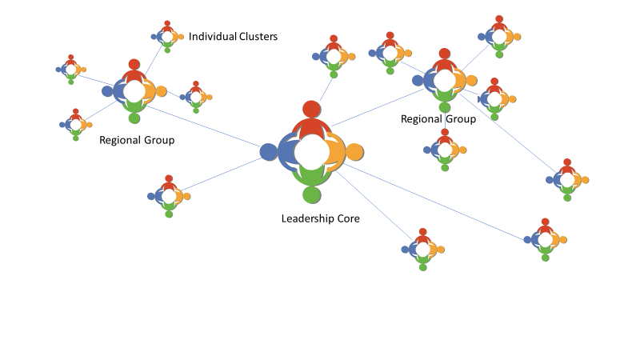

Overall project responsibility will rest with a central Leadership Core tasked to provide project direction, administrative oversight and overall accountability. Membership of the core will consist of one representative of each partner and ally, and to which contractors and employees will report.

Depending on the needs of a particular community or region, direct engagement will take place either through Individual Clusters that report directly to the leadership core or Regional Groups as shown above. In the case of regional groups, clusters might report to the leadership core through the regional group. For example, one of our interested partners is a group of some 45 Rotary clubs that have already established a “Healthy Communities” initiative. In cases such as this, it makes best sense to provide support through them. In another example, a well-established partnership of Rotary, United Way and the City of Calgary might be best positioned to manage community activities.

**Evaluation and Reporting**

The R2 experts will support the design of an evaluation to measure outcomes. Through R2’s affiliation with the evaluation experts at the Resilience Research Centre, the impact of R2 will be assessed. These evaluations can range from brief and minimally intrusive to far larger, multisite longitudinal studies of outcomes depending on what each organizations capacity to support evaluation. At a minimum, we will conduct an outcome evaluation of the initial program implementation with Rotary volunteers and a process evaluation of the implementation and scaling up process. Typically, evaluations occur at regular intervals (e.g., on first day of training, and 3 and 6 months after the training ends). Evaluation staff at the Resilience Research Centre will compile and analyse the data, produce a report on the findings and make recommendations for further tailored implementation of the R2 program.

We will share best practices and case studies through a website that will be maintained through the duration of the project, and perhaps longer. We will also use available technology (Microsoft Teams, Slack, or others) to facilitate knowledge sharing and reporting within the project and across clusters. The RRC is also very motivated to publish in peer-reviewed academic journals results of these trials to ensure that R2 becomes recognized as an international best practice for building resilience.

**Sustainability**

R2 will be an ongoing program of Rotary and its partners as long as it is needed. We are here for the long haul. Our innovative approach will begin a sustained, scalable effort of response and recovery. Volunteers will be more resilient – they’ll bounce back stronger, re-engaged and better able to support their communities. They will be enabled and inspired to resume and expand their important work with vulnerable citizens, helping them to become more resilient, rebound, coming back stronger.

The partners all have a long-term commitment to community support and Rotary, the United Way and Community Foundation have national volunteer networks that will mobilize for the long term. Resources will evolve through the work of the RRC and cadres of skilled volunteers will be trained on an ongoing basis. Support will be needed for creation of digital tools, awareness building materials, and coordination but much of the ongoing work will become self-sustaining.

Our project is explicitly designed to be scalable and sustainable. It builds capacity in each community to do more. Participants will have enhanced talent and skills so that they can continue strengthening their communities long after this project is finished. Finally, our model is easily adaptable so organizations and/or communities not part of this project initially can replicate our efforts – and we will help them do that.

**APPENDIX**

**What is resilience?**

Dr. Ungar and his colleagues with the RRC have changed the way resilience is understood, shifting the focus from individual protective factors to the social and physical environments that make resilience more likely to occur. Dr. Ungar has received numerous awards for his work, including the National Distinguished Service Award from the Canadian Association of Social Workers, and he was named a Fellow of the Royal Society of Canada for his scientific achievements.

By thinking about resilience, we shift our focus from the factors that cause mental illness (at the individual level) or community dysfunction (as a systemic level) to how people survive and thrive when they have the resources they need to succeed even when they experience unusually high amounts of adversity or stress. This understanding of resilience is a challenge to common ways we think about individual change. Typically, we study how people adapt their thinking or behaviour for personal success under stress. We describe individuals who can change themselves as “rugged” because it looks like they are doing well all on their own. However, the idea of ruggedness is too narrow to properly explain why some people do better than expected while others fail when exposed to the same amount of misfortune. Resilience is explained much better by both how rugged *and* how resourced an individual is. In simple terms, people with lots of resources (e.g., good quality services, a positive attitude, meaningful employment, opportunities for affordable housing and education, family supports, a safe community, etc.) will tend to be more optimistic about life, and more motivated to live well. Likewise, people who have a strong sense of personal mission and are able to see opportunities when they arise, are much more likely to take advantage of the resources that are available to them. Resilience is a dynamic process in which we interact with the world around us to become our best selves.

This more “social ecological” model of resilience is particularly relevant for anyone who has few supports as it focuses attention on the impact emotionally toxic environments have on human development and life-long success. It reminds us that our resilience really depends on the capacity of those around us to make it possible for us to succeed and remain positive about the future. Recently, studies of resilience have shown that people cope best when they are able to *navigate* to the resources they need to adapt to abnormal stressors (like the sudden death of a parent, excessively high expectations to succeed academically, or a natural disaster) and *negotiate* for these resources to be provided in ways people experience as meaningful. These dual processes of navigation and negotiation have helped to explain why some people who get the help they need are more likely to succeed. For this reason, providing a program to build resilience can help people who face adversity develop ruggedness and find the resources needed to battle against the challenges they face, helping them to become bolder and more successful.

**Is it Better to be Rugged or Resourced?**

When our problems are few, rugged individuals can usually overcome most of life’s challenges by changing their thoughts, feelings and behaviours all on their own (see the figure below).



Resourced individuals, however, do better when they experience many problems in many different parts of their lives.



During a pandemic, however, individuals are affected two ways: they not only experience increased problems but their resources are severely diminished.



Understood this way, resilience is not an individual trait, or a single quality of a community. It is instead a process. Whether we are thinking about an individual or a system comprising many individuals like a city or a workplace, resilience is the process of people finding the right resources and developing the right coping strategies to effectively deal with the challenges in their lives.

**About Community Development**

A community development process is particularly relevant in this project as it helps create change at a community or neighbourhood level, especially in disadvantaged communities. Community development principles will comprise a key element of training provided to our volunteer clusters.

Community development is a process where community members are supported to identify and take collective action on issues which are important to them. Community development empowers community members and creates stronger and more connected communities. In the community development process, groups are supported to identify important concerns and issues, and to plan and implement strategies to address their concerns and solve their issues. The problem is always first named by the community, then defined in a way that advances the shared interests of the community. Work is longer term in duration with an increase in member’s capabilities and change achieved at the community level.

Community development is a holistic approach grounded in principles of empowerment, human rights, inclusion, social justice, self-determination and collective action. Community development considers community members to be experts in their lives and communities, and values community knowledge and wisdom. Community development programs are led by community members at every stage - from deciding on issues to selecting and implementing actions, and evaluation. Community development has an explicit focus on addressing the causes of inequality and disadvantage.

**Outcomes of community development**

There are potential outcomes at both individual and community level. People directly involved in community development initiatives may benefit from increases in skills, knowledge, empowerment and self-efficacy, and experience enhanced social inclusion and community connectedness. Through community development initiatives, community members can become more empowered, such that they can increasingly recognise and challenge conditions and structures which are leading to their disempowerment or negatively impacting their wellbeing.

**What is not community development?**

Community development is not one-off events, consultation to inform goals or strategies, community advisory groups or committees, or leadership training. All these things could be part of a community development strategy but, by themselves, they are not community development.

**Who can do community development?**

Community development is a practice with a well-developed theoretical framework. We can’t expect project participants to simply ‘go and do it’. Community developers need to be familiar with the theory, practice and principles of community development work. At the same time, volunteers must have – or be able to develop - effective and respectful relationships with the communities they are working with.

**The role of volunteer clusters**

Volunteers will use their increased knowledge of resilience and community development to support, resource and empower their community of focus. This is done through a broad range of actions and activities that are likely to change depending on the context. They will support community members with information needed to identify issues and plan actions. This could include sharing information on local data, good practice around particular identified issues, effective advocacy and relevant programs and resources that are available. They will also connect with and build local networks and local leaders, undertake community engagement and help plan, deliver and evaluate projects and programs.

**Rotary’s Capacity**

For more than one hundred years Rotarians around the world have given freely of their time, talent and treasure to live the motto of “Service Above Self.”

Since March, across North America, Rotary has been front and center in the response to the pandemic. The organization moved quickly, almost as soon as early shutdowns were announced, knowing action was needed. The Rotary Foundation made US$20 million available to support clubs to respond to needs in their communities. Individual clubs and Rotarians did the same with their own resources. The result was a diversity of actions, as simple as sewing masks for a nursing home chain, to the installation of hand washing stations, the purchase of medical equipment and protective gear for over stretched hospitals and medical facilities. They made sandwiches for the homeless, taught proper handwashing techniques and reached out to offer emotional support to hard pressed care givers and isolated citizens.

Phase one of this project begins in Atlantic Canada where Rotary has more than 2000 volunteers – people of action – contributing to their communities on a daily basis to address seven areas of focus. Across North America, Rotarians build parks, playgrounds and boat ramps, play Santa to isolated communities in Nunavut, help fund hospices and hospitals, become Big Brothers and Big Sisters, partner with churches to make lunches for people who are food insecure, build schools and libraries for isolated indigenous communities, drill wells and install toilets and dug gardens. One gift to humanity of which Rotary is most proud, is the success of intense efforts to almost entirely eliminate polio from the face of the earth.