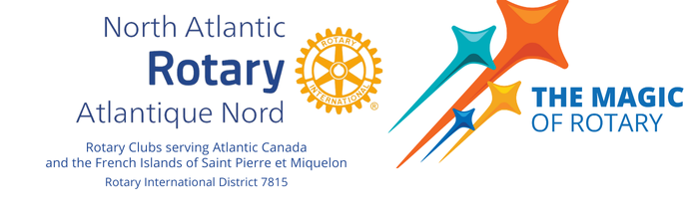   
 

**North Atlantic Rotary PELS and SELS 2025**   
**The Magic of Rotary**

**Friday, May 30th, 2025**

Thursday, May 29th

The Westin Nova Scotia

1181 Hollis St, Halifax, NS B3H 2P6

|  |  |  |
| --- | --- | --- |
| Time: | Location: | Activity: |
| 3-6pm | Westin Lobby | Registration desk open for PELS & SELS |

Friday, May 30th

The Westin Nova Scotia

1181 Hollis St, Halifax, NS B3H 2P6

|  |  |  |
| --- | --- | --- |
| Time: | Location: | Activity: |
| 7:30-8:30am | Commonwealth Ballroom | Continental Breakfast for PELS, SELS and AGS |
| 8:30-9:00am | Atlantic Ballroom  PELS,SELS, AG’s | Welcome and ice breaker |
| 9:00-10:30am | Atlantic Ballroom  PELS, SELS, AG’s | From ideas to Action to Growth:  With Doug Logan and Louisa Horne |
| 10:30-10:45am |  | Health Break |
| 10:45-Noon | Atlantic Ballroom  PELS, SELS, AG’s | From ideas to Action to Growth:  With Doug Logan and Louisa Horne |
| Noon-1:00pm | Atlantic Ballroom | Lunch |
| 1:00-3:00pm | Atlantic Ballroom  PELS & AG’s | Empowering Membership Growth through Club Creation:  With Patrick Longano |
| 1:00-3:00pm | Bedford Room  SELS | Secretary Toolbox:  With Brian Smith |
| 3:00-4:00pm | Atlantic Ballroom | District Governor Elect Q&A:  With Marcel Gervais |
| CLOSING REMARKS | | |