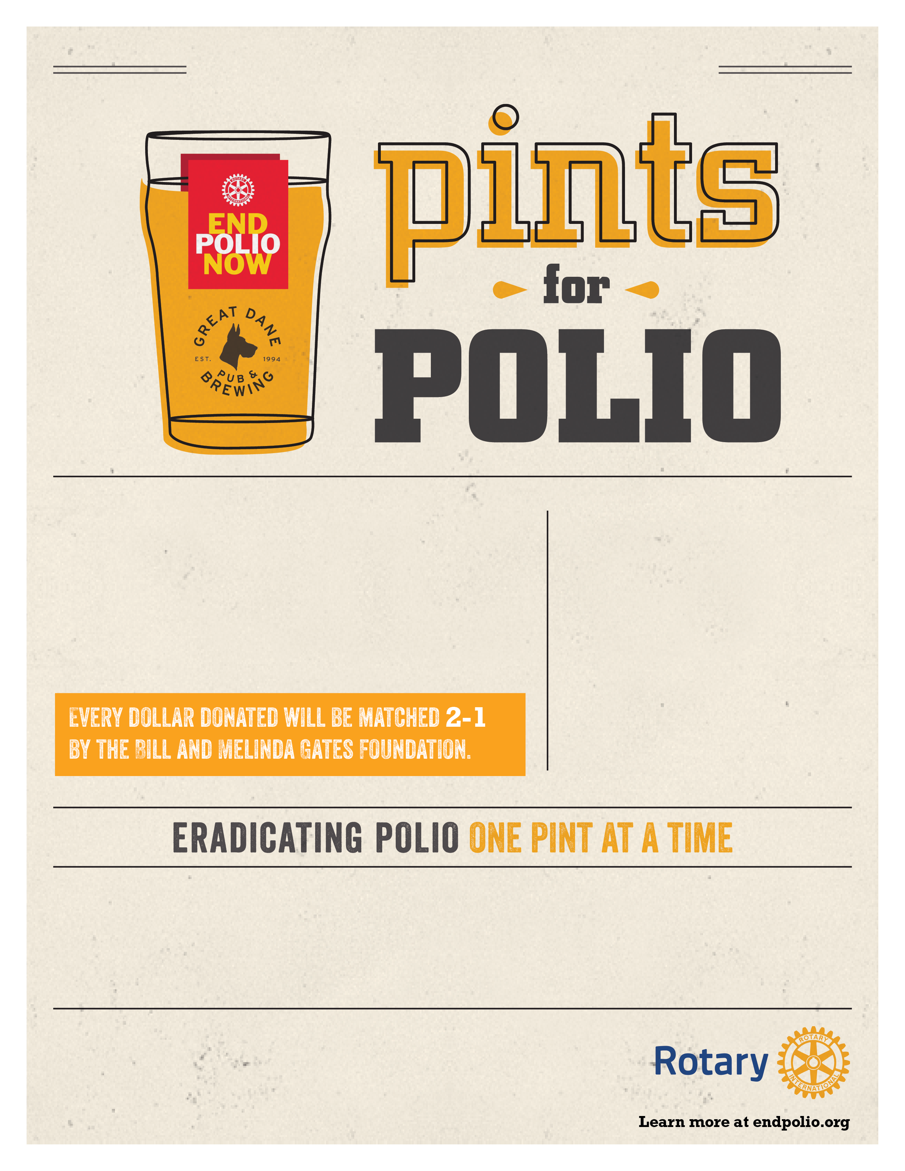

*Special mention your rotary club here or any further info you need to express.*

*(Your Rotary Club Name) Invites you to join us for:*

*Put any information about your event here (Location, time, directions etc.)*

*Date/Time information here!*

*Put an explanation of your event or End Polio Now’s mission here!*