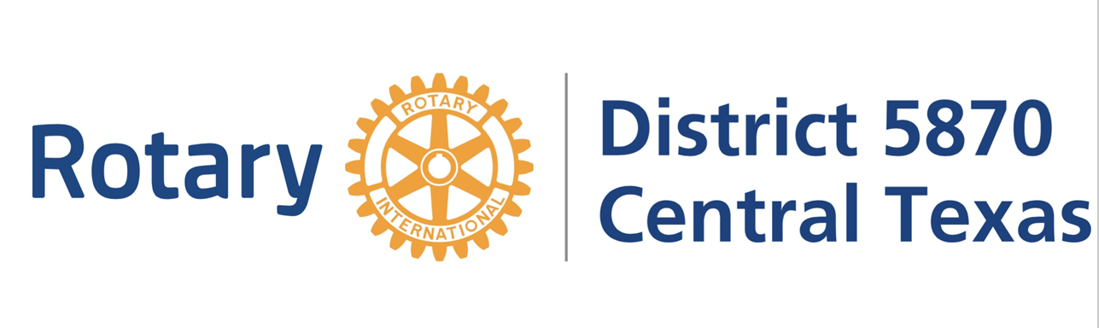
Contact “Your Name”  Telephone [Company Phone]  Cell [Cell Phone]  Email [Company E-mail]  Website [Website] | FOR IMMEDIATE RELEASE  [Date]

ROTARY SEEKS PARTICIPANTS IN YOUTH AWARDS PROGRAM
(City, state, and date) High School young men or women interested in developing their leadership skills, and having a great time doing so, are invited to fill out an application for the Rotary Youth Leadership Awards (RYLA) program. RYLA is a leadership training and education program for youth who are currently in 10th or 11th grade.
Sponsored by the Rotary Club of_____________, those selected to participate in RYLA will spend JUNE 30 TH -5TH, 2024 at Twin Lakes Family YMCA, in Cedar Park, TX where they will take part in fun group activities and hear interesting presentations with other young people sponsored by Rotary clubs throughout central Texas.
RYLA participants receive training from successful professionals, with special emphasis on leadership and the importance of ethics and community service. They often are or become leaders in their schools and communities and in their professional pursuits.
Those interested in applying should contact (name) at (number) for more information and an application form.
The Rotary Club of ______________ is part of Rotary International’s global network of more than 46,000+ clubs in over 200 countries. Rotary International consists of 1.4 million professionals who volunteer to improve the quality of life in their home and world communities. Through service efforts, Rotary club members help promote understanding and peace throughout the world. Rotary clubs support programs that address today’s most critical issues, including hunger, health care, the environment, illiteracy, and youth development and youth development.

# # #
If you would like more information about this topic, please contact ““Your Name” at [Company Phone] or email at [Company E-mail].

