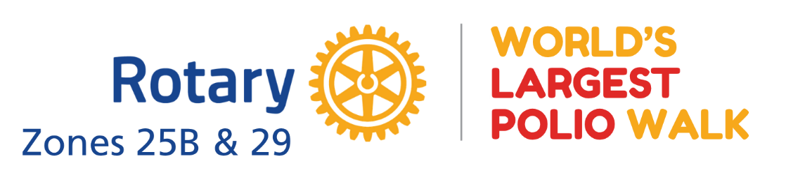
World’s Largest Polio Walk – Planning Ideas
Event Goals
- Raise awareness about polio eradication
- Encourage community and family participation
- Create a fun, low-cost, easy-to-join event
- Provide Rotary visibility and fundraising opportunities
- Focus on participation over distance or fundraising totals
Location Needs
- Parking and gathering space
- Restrooms and electricity access
- Safe walking route (indoors or outdoors)
- Rain backup option if possible
Event Features
- Welcome speakers and short polio education segment
- Registration/check-in to count participants
- Purple Pinkie station
- Donation station (cash, card, Venmo/Zelle)
- Educational displays and photo opportunities
- Face painting, signs, and themed activities
- T-shirts and participant badges/lanyards
- Concessions/snacks and water stations
Walk Setup
- Clearly marked start and finish
- Optional milestone/history signs along route
- Participant giveaway at finish line
Volunteer Needs
- Setup and cleanup crews
- Registration and food volunteers
- Photographers
- Speakers and community leaders
- Medical/polio awareness representatives
Budget & Fundraising
Expenses
- Venue and signage
- Decorations and supplies
- Food/drinks
- T-shirts and badges/lanyards
Revenue Ideas
- Registration fees
- Donations and sponsorships
- 50/50 raffle
- Vendor logo sponsorships on shirts/signage
Timeline
- Setup: 7:00 AM
- Walk Starts: 10:00 AM
- Cleanup Complete: 1:00 PM

