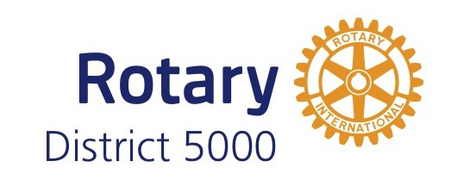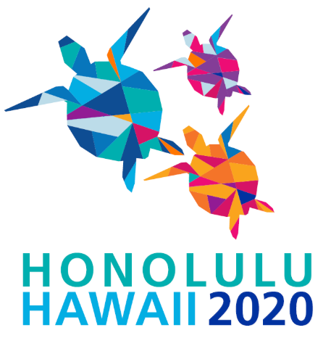

February 16, 2019

Dear District 5000 Presidents-Elect,

The Rotary International Convention is only 15 months away. It takes the entire D5000 membership to produce such an event of this magnitude and to be involved in one way or another. District 5000 will be center stage, and we must show the 25,000+ Rotarians from around the world that Hawaii Rotarians are capable, organized and have prepared well for their visit.

That said, the Host Organizing Committee needs $240,000 to produce our part of this international convention. We have a sponsorship team led by Sonya Mendez, Ron Tsukamaki and Dick May, and we are looking to expand this team.

Please join us if you want to help make IC2020 a success!

We are asking each Rotary club member to go out into the community and ask business associates for a Mahalo Level contribution. While it is not mandatory that clubs contribute, it will certainly be helpful. While anyone may contribute any amount up to $4999 at this time, potential donors at the $5000 and higher levels will need to be vetted by Rotary International. You may submit the donor information to our Sponsorship Team leaders first to begin the vetting process.

Inserted into each Sponsorship Brochure is a breakdown of the “Mahalo Level Supporters,” which range from $500 to $2500. High level donor information will be e-mailed to you upon request. We need your help!

Mahalo in advance from PDG Del Green, the Host Organizing Committee, and the Sponsorship Team leaders.

Ron Tsukamaki (808) 561-8846; rtsukamaki@aol.com

Rotary Club of Honolulu

Sonya Mendez (808) 228-4499; sonyamendezrotary808@gmail.com

Rotary Club of West Pearl Harbor

Dick May (808) 375-2439; rmayhi02@hotmail.com

Rotary Club of Kapolei

