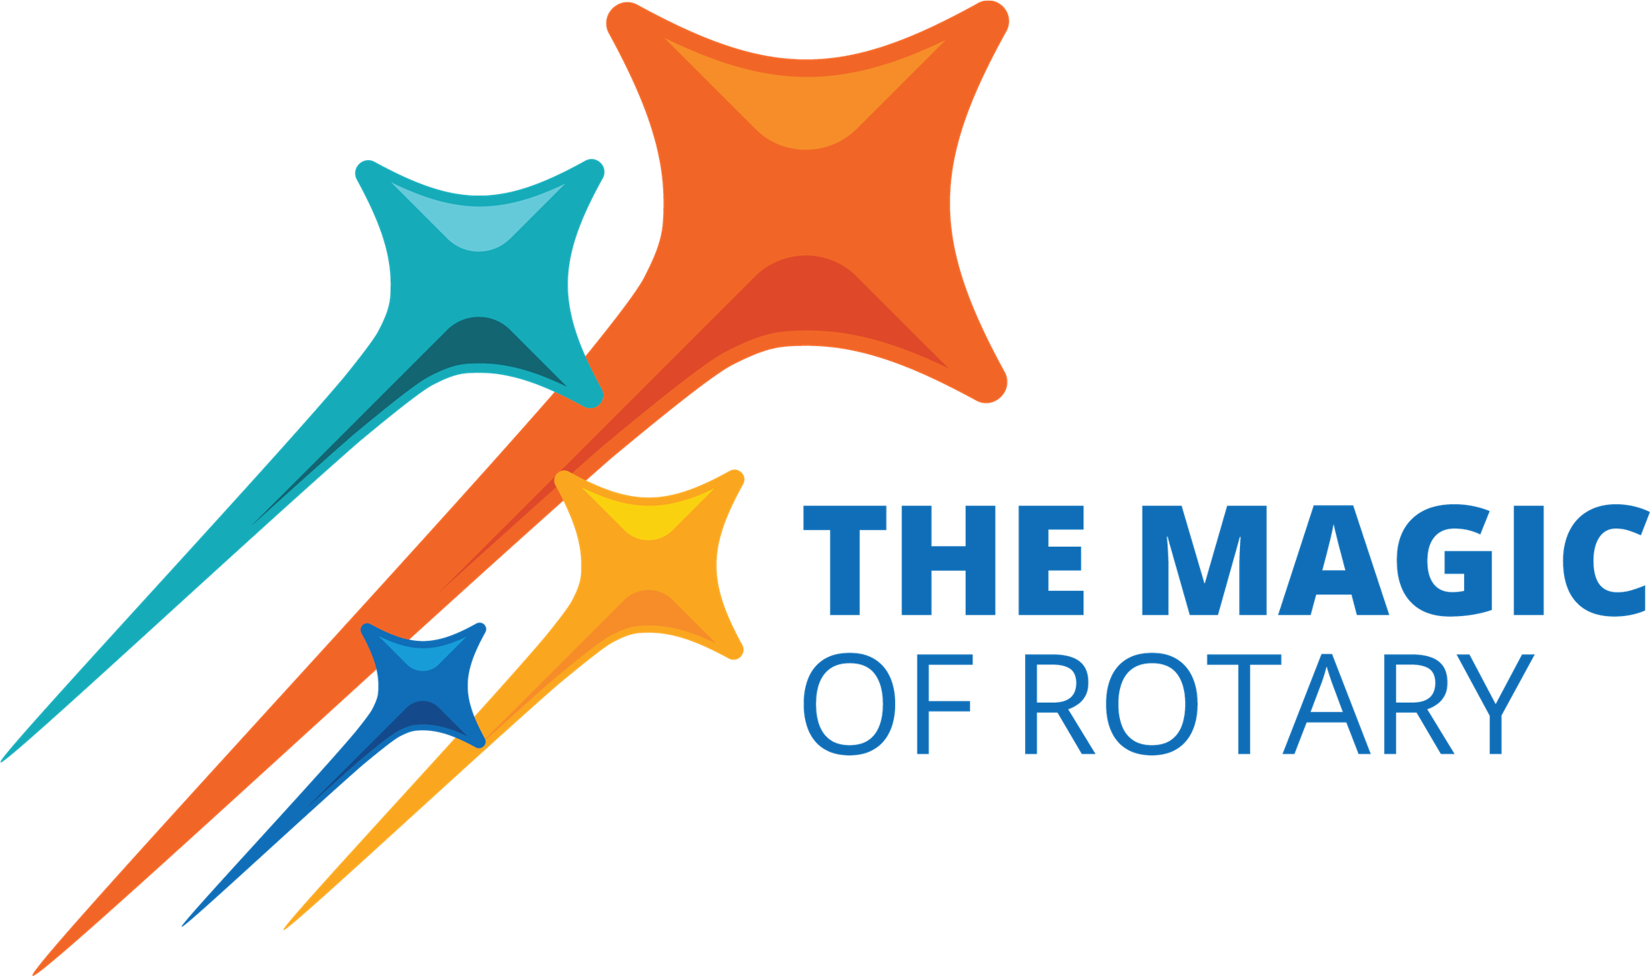
District 5000 Judging Awards for Rotary Year 2024-2025
Instructions to Presidents: You (or someone else in your club whom you designate) will be judging Clubs that are not in your Division. Small Clubs will judge the Medium clubs. The Medium Clubs judge the Large clubs. The Large Clubs judge the Small Clubs.

The judging is voluntary, but clubs will receive 5 bonus points for participating in the judging.
Clubs are divided into three size divisions. Awards will be given out to the 1st and 2nd place clubs in each division (for most of the award categories). Club size is based on the July 1, 2024 RI Invoice; not on membership numbers from later in the year.

SMALL Clubs JUDGE Medium  (17 or less members):  Diamond Head/Kaimuki  Eco Maui  Hawaii Kai  Hickam Pearl Harbor  Honolulu Pau Hana  Kahala Sunrise  Kapaa  Kapolei  Kona Mauka  Lahaina  Maui  Pahoa Sunset  Upcountry Maui  Wahiawa-Waialua  Wailuku, Maui  West Kauai  West Pearl Harbor  Windward Oahu (Lanikai)  Windward Oahu Sunrise  International Peace, WE Rotary | MEDIUM Clubs JUDGE Large  (18-29 members)  E-Club of Hawaii  East Honolulu  Ewa Beach  Kahului, Maui  Kaneohe  Kauai  Kona Sunrise (Kailua-Kona)  Lahaina Sunrise  Lahaina, Maui  Mililani Sunrise  North Hawaii  Pearl Harbor  Pearlridge, Oahu  Poipu Beach  South Hilo  Volcano  Waianae Coast | LARGE Clubs JUDGE Small  (30 and above members)  Ala Moana  Downtown Honolulu  Hanalei Bay  Hilo  Hilo Bay  Honolulu Sunrise  Honolulu Sunset  Honolulu  Kaka'ako Eco  Kihei- Wailea  Kona  Lahaina Sunset  Metropolitan Honolulu  Waikiki  West Honolulu
For each category, please choose the top FIVE Clubs based on submissions by the clubs seeking awards. It is very important to select FIVE Clubs. Write the Club's name in order of preference:
(#5 is the best, #4 is next best, etc. (5 points awarded to the top club, 4 points to the next, etc.)
You will be judging the following categories:
- Membership
- The Rotary Foundation Programs
- Public Image
- Club Administration
- Community Service
- International Service
- Vocational Service
- Youth Service
You will find the submissions on the District website (www.rotaryd5000.org) - “Club Awards and Citations”. Be sure to judge only the submissions in the divisions you are assigned - refer to the Instructions. Click here to go to the Awards page. Send your judging sheet via email: d5000awards@gmail.com by June 27.
Please email or contact Beth Hoban at (808) 306-4241 with any questions.

2024-2025 District Awards Judging Sheet

Ballot submitted by Rotary Club of

President: Phone:

Size Category being judged on this form: [ ] Small [ ] Medium [ ] Large

MEMBERSHIP AWARD: This award involves many activities revolving around recruiting new members, keeping members engaged and the operations of your club. These items would include club programs, social functions, meeting culture and diversifying membership.

5. Rotary Club of Click here to enter text. (Best)
4. Rotary Club of Click here to enter text.
3. Rotary Club of Click here to enter text.
2. Rotary Club of Click here to enter text.
1. Rotary Club of Click here to enter text.

FOUNDATION PROGRAMS AWARD: The mission of The Rotary Foundation of Rotary International is to enable Rotarians to advance world understanding, goodwill, and peace through the improvement of health, the support of education, and the alleviation of poverty. How well did the club promote TRF programs and giving?

5. Rotary Club of Click here to enter text. (Best)
4. Rotary Club of Click here to enter text.
3. Rotary Club of Click here to enter text.
2. Rotary Club of Click here to enter text.
1. Rotary Club of Click here to enter text.

PUBLIC IMAGE AWARD: While Rotary’s Public Image is usually directed at an external audience, raising awareness of Rotary is equally valuable within the Club and the Rotary community.

5. Rotary Club Name Click here to enter text. (Best)
4. Rotary Club Name Click here to enter text.
3. Rotary Club Name Click here to enter text.
2. Rotary Club Name Click here to enter text.
1. Rotary Club Name Click here to enter text.

CLUB SERVICE AWARD: The club administration committee helps the club function smoothly and plays an important part in creating positive experiences for members. This can include different responsibilities, such as planning meetings, handling communication and more.

5. Rotary Club of Click here to enter text. (Best)
4. Rotary Club of Click here to enter text.
3. Rotary Club of Click here to enter text.
2. Rotary Club of Click here to enter text.
1. Rotary Club of Click here to enter text.

COMMUNITY SERVICE AWARD: Service defines Rotary's character; whether local or international, it promotes Rotary's appeal and visibility in the community, and is the reason Rotary continues to grow. Community service responds to the needs of a local community. Rotary clubs should determine top priorities for service projects by first learning about a community's needs and assets and then developing a response that addresses them.

5. Rotary Club of Click here to enter text. (Best)
4. Rotary Club of Click here to enter text.
3. Rotary Club of Click here to enter text.
2. Rotary Club of Click here to enter text.
1. Rotary Club of Click here to enter text.

INTERNATIONAL SERVICE AWARD: This award involves projects that take place outside of the United States. International projects should identify a specific need that will improve the quality of life and benefit others within that intended area. Grants and projects can be done by one or more Clubs. Other international projects involve the establishment of Sister Clubs, sponsoring a Rotary Peace Scholar, Rotary Youth Exchange, or other projects that promote cultural awareness & world understanding.

5. Rotary Club of Click here to enter text. (Best)
4. Rotary Club of Click here to enter text.
3. Rotary Club of Click here to enter text.
2. Rotary Club of Click here to enter text.
1. Rotary Club of Click here to enter text.

VOCATIONAL SERVICE AWARD: As business leaders, Rotarians share their skills and expertise through vocational service. Your vocational service efforts can play a vital role in improving the quality of life for those hardworking members of the community. A Vocational project can be mentoring, career days, vocational awards, business assistance, or even talking about your job at a club meeting.

5. Rotary Club of Click here to enter text. (Best)
4. Rotary Club of Click here to enter text.
3. Rotary Club of Click here to enter text.
2. Rotary Club of Click here to enter text.
1. Rotary Club of Click here to enter text.

YOUTH SERVICE AWARD: This award is based on programs that benefit children and young adults. Working with schools, literacy projects, Interact & Rotaract Clubs are just some of the examples of Youth Service projects.

5. Rotary Club of Click here to enter text. (Best)
4. Rotary Club of Click here to enter text.
3. Rotary Club of Click here to enter text.
2. Rotary Club of Click here to enter text.
1. Rotary Club of Click here to enter text.

