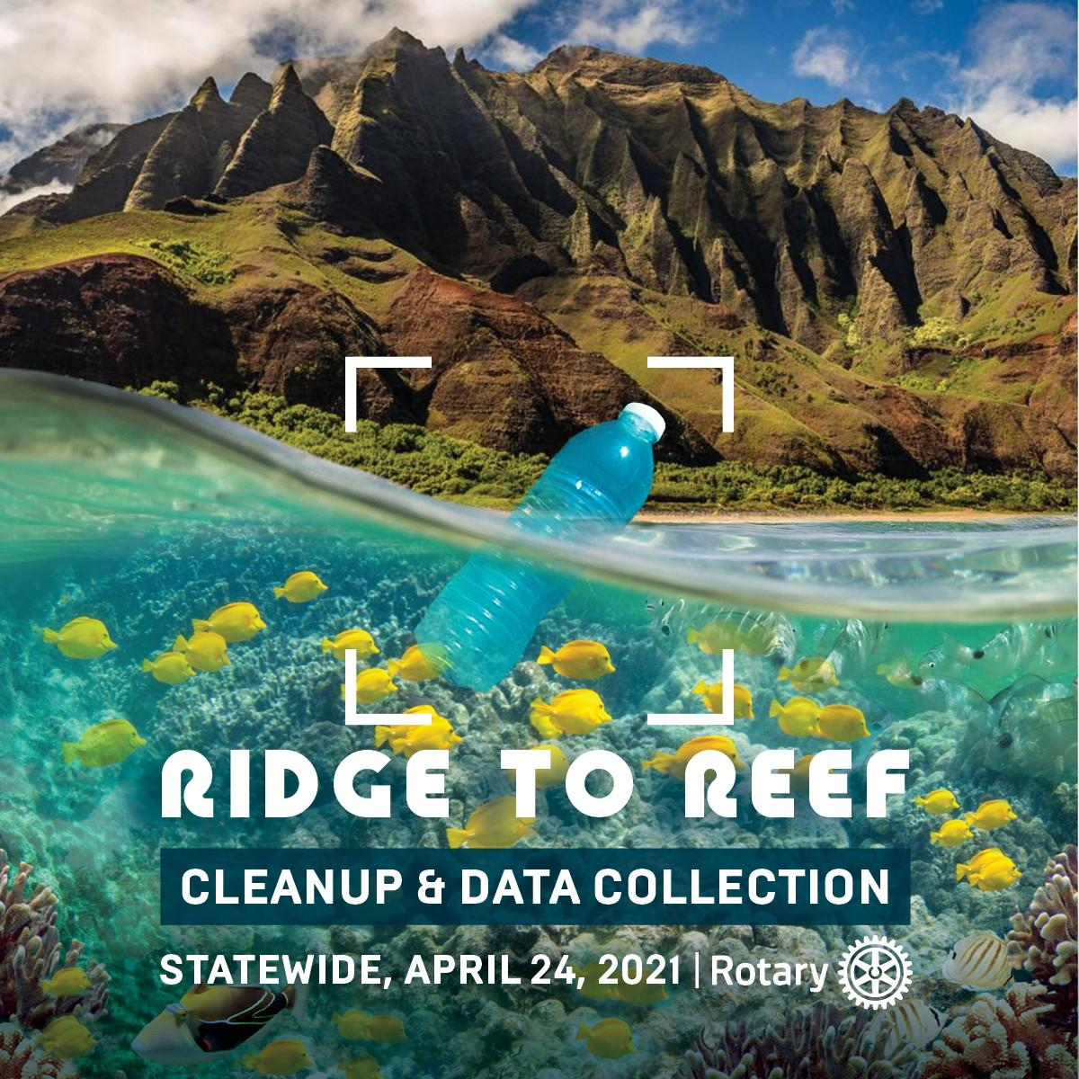

Rotarians At Work Day - Ridge to Reef Cleanup & DataCollection

The plastics and micro-plastics piling up on our beaches, parks, trails and reefs are more than just unsightly, they’re often a safety hazard and a real health concern to both humans and animals alike. Plastics threaten Hawaii's water quality and vulnerable marine ecosystems are even accumulating in our bodies.
Join us on Rotarians at Work Day 2021 for a statewide Ridge to Reef trash cleanup and audit. With a small group of Rotarians, you can spend one day to help make our communities safer, care for the ocean, protect Hawaii's natural beauty, marine animals, and our own health from the damages of this plastic pollution.
The good news is, we still have a chance to fix these problems from persisting. In the weeks following, we will explore ways to reduce or replace the plastic from our everyday lives that are otherwise ending up in the ocean. As an added benefit, the data we collect can help local advocates launch successful campaigns against plastic pollution, targeting long-term solutions.
Date/Time: April 24, 2021 — Rotarians at Work Day - 8:00am - 12 noon followed by BBQ
Location: Meet at Aweoweo Beach Park, 68-197 Au St., Waialua.
POC: Kate: 808-358-0640 BBQ at Mac’s House: 68-325 Kikou Street

