TREES, PART OF THE ANSWER TO FIGHT CLIMATE CHANGE.

Climate change is a real issue and CO2 is the trigger. To add more context, lets define CO2 first:

“Carbon Dioxide: Acts as a sort of greenhouse, preventing heat introduced by the Sun from escaping back as thermal radiation into space—the “greenhouse effect.” The heat trapped by carbon dioxide warms our oceans and atmosphere. This effect is what enables life on this planet, keeping Earth at a livable global temperature. But changes in the concentrations of these gases change the amount of heat that remains here.”1

Many of the activities we do on a daily basis generate C02. And there are many ways we can reduce that amount of CO2: bike to work, eat less meat, turn down your thermostat. All of which are great.

But there’s an even better way to reduce our emissions — planting trees! Here are a couple ways in which trees are vital to reducing carbon emissions and so much more.

Natural Carbon Eaters

Every living thing on Earth is made up of four basic elements - carbon, hydrogen, oxygen, and nitrogen. Those four elements make up about 96 percent of your body, and most of a tree's roots, trunk, branches, and leaves.

While we humans get most of our carbon through eating, trees breathe it in the way that we breathe in oxygen. When a tree breathes, it inhales carbon dioxide and exhales oxygen - the exact opposite of humans. As a tree matures, it can consume 48 pounds of carbon dioxide per year (among other greenhouse gases like ozone), and releases enough oxygen for you to breathe for two years!

Removing carbon dioxide from the atmosphere and releasing oxygen in its stead also helps limit global warming, providing for a cleaner, healthier climate. So, by planting trees, you can help clean the air and fight climate change!

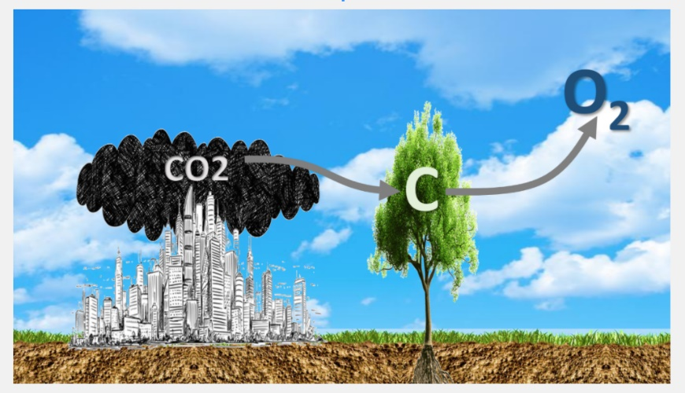

Trees provide more benefits beyond just eating CO2. When shade is cast on an office building or home, internal temperatures can drop 8–10°F, and save on electricity needed to cool the building. This reduction in energy use goes a long way when it comes to shrinking your carbon footprint, because more than a third of U.S. carbon emissions are caused by the production of electricity.

Trees also make your property and community more beautiful, improve your water quality, and provide numerous economic and social benefits.

Plant a Tree Today!

If you're looking to reduce your carbon footprint and give back to the planet, trees are one of the most effective and personally beneficial ways to do it. Let’s build a nicer home and a better environment.

Join the Eco Rotary Club of Kaka’ako Eco and Hawaii Legacy Hardwoods in our reforestation efforts. We plant native/endemic Hawaii trees. To plant a tree with us and support our goal, go to the following link https://legacyforest.org/rotary

Sources:
https://blogs.ei.columbia.edu/2017/03/10/the-science-of-carbon-dioxide-and-climate/#:~:text=The%20conclusion%20rests%20on%20basic,%E2%80%9Cgreenhouse%20effect.%E2%80%9D%20The%20heat

https://onetreeplanted.org/blogs/stories/planting-trees-reduce-carbon-footprint

http://www.soc.hawaii.edu/mora/Tree%20carbon%20storage%20potential.html

Article facilitated by Pili Valderrama, President 2020-2021 Eco Rotary Club of Kaka’ako.

