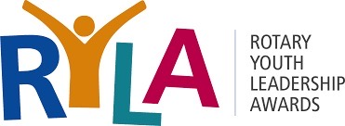
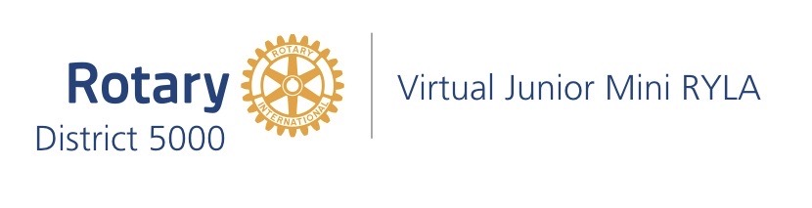

FACILITATORS NEEDED!
Virtual Junior Mini RYLA
Saturday, September 10, 2022
10:00 am – 12:15 pm

WHAT IS VIRTUAL JUNIOR MINI RYLA?

Imagine bringing together middle school students from across Hawai`i for a two-hour workshop focused on creating connections, providing inspiration, and encouraging action. This 3RD annual workshop is designed for students to get inspired to “jump start” their leadership skills for the school year. This date was selected by the middle school activity coordinators as the “best” for maximum participation.

WHAT HAPPENS DURING VIRTUAL JUNIOR MINI RYLA?

The two hours will feature a combination of both short “keynote” presentations and time to connect students from across islands through the “Zoom Room” breakouts sessions. Our keynote presenter, Rochelle Whellams, will inspire students to take action on the 3 C’s: Their Character, Connections, and Contributions. Participants from schools across the islands will be guided in their “Zoom Rooms” by adult facilitators (YOU!!!) to meet new friends, make connections, and make a difference by applying the principles of Rotary and the 4-Way Test.

FACILITATORS ROLE:

Participate via Zoom on WEDNESDAY EVENING, SEPTEMBER 7, 2022 from 7:00-8:00 PM (Hawaii time) for Facilitator Training. Participate as a Small Group “Zoom Room” leader at the event on SATURDAY SEPTEMBER 10. You will need to commit to be available from 9:30am-12:30 p.m.

To sign up to serve as a leader and role model for this unique experience for middle school students go to this link and scroll down to the bottom for the Facilitators link:
https://rotaryd5000.org/sitepage/junior-ryla

12-15 Facilitators are needed! For questions contact Joanne Laird at: mamalrd01@gmail.com

