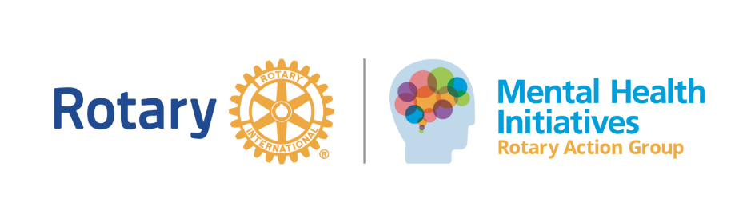
District 5000 Monthly Meetings
Last Friday of every month
5:00p.m.-6:00p.m.
Join Zoom Meeting
https://us06web.zoom.us/j/88116375154?pwd=vJRcIITWT08Tk8ae8TqOUa9rhSb9M6.1
Meeting ID: 881 1637 5154
Passcode: 877534

At the recent D5000 district conference the Mental Health Initiatives RAG met and extended for 3 more years! District Governor Nancy Cabral is dedicated to mental health and is excited to support the RAG because the RAG supports a wide range of activities. First and foremost, the RAG is an open forum for Rotarians to meet regularly and check in with each other. RAG membership is open to anyone that cares about mental health and is devoted to spreading the message that “Mental Health Matters.” The RAG promotes initiatives large and small. The District RAG is a member of the larger international RAG, more information on www.ragonmentalhealth.org
Please join the monthly zoom meeting to find out more. Bring ideas and get ideas. There is no need to be a mental health professional or have any experience in the field. The RAG encourages anyone that has an interest in mental health to join.
For additional information, please contact the RAG Chair, Kathleen Merriam at K.merriam@live.com or 808-561-4806.

