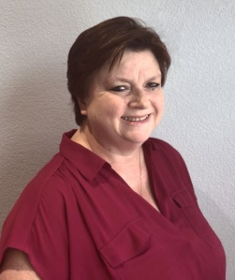
Words from our President
I hope everyone enjoyed their 4th! I will have to watch 2 or 3 fireworks displays during this time. If I am unable to see fireworks, it’s just not Independence Day for me!
Thanks to all the committees getting together and planning their year of events. Let’s get excited about all the possibilities of things to do.
Award applications have been submitted to District Nine for the following project awards:
Mamie L. Bass – Service
Dr. Nina Fay Calhoun – International
Edith DeBusk – President
Communications and Directory

Special thank you to Stephanie Noland for helping with these applications. And thanks to members for sharing pictures to include with these applications.
At our upcoming meeting on July 8, we will be discussing upcoming events, approving budgets and sharing ideas. I hope to see everyone.
NEW THING: WE NEED YOUR OLD STUFF!
It is time for our club to create an archive of the history of our club. I am asking our members for any hard copies of President scrapbooks, directories prior to 2015, photos and any other historical item you may have stored in a box somewhere. All items would be returned (per your request) after digitizing. Also, I am looking for a volunteer to help organize and digitize this history. If you are interested in helping with this project, please let me know.
We will be taking new member pictures in July for the directory. If you want a new picture, let’s get it taken at this time.
Again, I want to thank everyone planning our new year and keeping the Caring, Commitment and Community theme.
Fondly, Betty Sainz
The Communication Committee is
responsible for leading the
Pledge/Collect/Benediction/Altrusa Accent
for the July Meeting
GARLAND ALTRUSA IMPORTANT ADDRESSES
Email: garlandaltrusa@gmail.com
Facebook: garlandaltrusa
Website: districtnine.altrusa.org/garland/
District Nine Website: www.altrusadistrictnine.org




JULY EVENTS
Jul 4 Independence Day -
Jul 8 6p Membership/Business meeting at Holiday Inn at Bush Tollway and N Garland
Jul 15 6p Board Meeting – note date change
Jul 28-31 Altrusa Int’l Convention in Charlotte NC
Jul 29 Fifth Thursday – more later
Aug 12 5p Board Meeting – with District Nine visitor - note date change
Aug 12 6p Membership/Business meeting - District Nine visitor will bring program
Sep 8 Literacy Day
Sep 23 North Texas Giving Day

NEW MEMBER
Altrusa Garland welcomes Kimberly Kierce as a dual member to our club. Kimberly and a friend attended our President’s Banquet in May and she decided to make it “official” and become a part of us – Garland Altrusa! We look forward to getting to know her better. Welcome to Kimberly.
Karla Langston submitted her membership materials recently and her initiation is scheduled for our August meeting. Look for information on welcoming these 2 new members to our group.
WE’RE READY FOR THE RUN IN ’21,
LET’S HAVE SOME FUN AND GIVE!
We need member participation in the fundraiser of course, but we also need volunteers for the following (choose one, or both):
- Write a short, 3-4 sentence testimonial about what Altrusa means to you. This can be how Altrusa benefits your life, our community, how/why you enjoy Altrusa, etc.
- FUNdraising pages – this is each member’s personal fundraising page that will be posted on their own NTGD log-in and/or on our club page. We can also share these pages on our social media sites. The committee will set a time and place for the video and we will even help with the script.
The committee will contact each member asking for participation so please be thinking about your testimonial or video. Also be thinking about your contacts and who may be willing to support us. We need corporate sponsors as well as outside donors.
We’re looking forward to a VERY successful fundraising event.

ALTRUSA WAVES – JULY

COMMITTEE REPORTS:
Communication Committee – If you want a new photo in our new club yearbook, pictures for that will be taken at the July meeting. So, put on your favorite outfit and come prepared. The club is preparing to create an archive and Betty is asking for hard copies of various scrapbooks, club directories and other club items prior to 2015. This may be the time to pull out those boxes in your garage and look for this type information.
Community Service – Tina Rhodes and Marlee Nickerson are looking for volunteers to help with the fund raising set-up (see article on first page). Give one of them a call if you can help. We need every one of our members to participate in this project, of course, to make it as successful as it was last year and such that we only will need one such project to fund our service projects for this new year.
Fundraising – The committee met last week and are excited to kick off our 2021 fund raiser with North Texas Giving Day scheduled for 23 September, which will be here too soon. Our theme this year is “We’re ready for the run in “21! Let’s have some fun and GIVE!” Our goal for 2021 is $10,000. Based on the phenomenal success we had last year, this is completely achievable.
Membership – We have 2 new members, Karla Langston and Kimberly Kierce. Be sure to visit and get acquainted with them at our July meeting.
Program – Discussion of upcoming events and sharing ideas will be the program at our upcoming meeting on July 8, as well as budgets approval.
Social – July 29th is a 5th Thursday and we will get information from our Social Committee later in the month for that event.
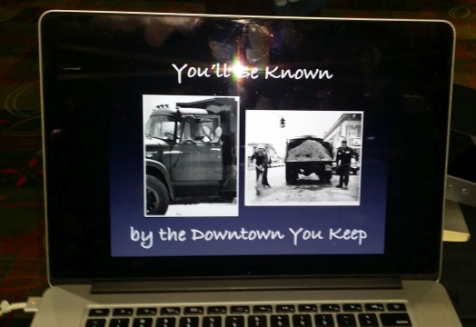

Downtown Garland Square from many, many years ago – This picture was from a long-time resident of Garland, Robert Smith.

COMMITTEE CHAIRS AND MEMBERS
COMMUNICATIONS: Christina Contreras*; Carol Hanson**
Tina Rhodes, Sue Floyd, Barbara Boyden-Newsletter
FUNDRAISING: Tina Rhodes*; Marlee Nickerson**
Mary Henderson, Shirley Raymer
MEMBERSHIP: Stephanie Noland*; Patty Lucas**
Mary Powlen, Helen Partain, Rosalyn Blackshear,
Barbara Boyden
PROGRAM: Rita Johnson*; Jan McCorstin**
Stephanie Noland, Deb Henson
SERVICE: Elizabeth Fuentes*; Mary Dyer**
Janet Black, Helen Partain, Barbara Powers, Shirley Raymer,
Deb Henson, Tammy Caruso, Donna Raymer, Mary Powlen,
Rosalyn Blackshear
SOCIAL: Marlee Nickerson*; Janet Black**
Tammy Caruso, Mable Usrey, Mary Helen Vollmer
SPECIAL DISTRICT NINE 2023 CONFERENCE
Betty Sainz*
Barbara Powers – Treasurer, Carol Hanson, Alice Mae Britt,
Patty Lucas,
Code: 1 * = Chair; 2 ** = Co-Chair

I am reprinting this list of Committee Chairs so you know who they are when you want to talk with them – save it!

Page 2
JULY BIRTHDAYS
16 July Barbara Powers
22 July Shirley Raymer
22 July Elizabeth Fuentes
1 Aug Kimberly Kierce 3 Aug Mary Powlen

JULY BOOK CLUB

The book selected for our July Book Club meeting is New York Times bestselling authors Marie Benedict’s and acclaimed author Victoria Christopher Murray’s novel, The Personal Librarian. This remarkable, little-known story of Belle da Costa Greene, JPMorgan’s personal librarian, who became one of the most powerful women in New York despite the dangerous secret she kept in order to make her dreams come true, Mark your calendars for July 20th, at 6 pm. More information will be coming for our meeting place during the monthly business meeting.
GETTING TO KNOW YOU
The Altrusa Member Spotlight shines this month on two members:
Betty Sainz – Betty is a Hoosier by birth and a Texan by choice and does not plan on moving away! We all knew she was one smart cookie, right? Betty enjoys doing very large jigsaw puzzles – ask her about the last one she completed. She looks forward to when her husband, Jose, travels to Hawaii for business as she is able to join him there. Perhaps you didn’t know but, as a kid, Betty picked blueberries for 9 cents per pound and cleaned cattails for those dried flower arrangements that were popular in the 70’s.
Rita Johnson – Rita is a patron of the arts and helped usher and run the concessions in the early years of the Garland Performing Arts Center (PAC). Later, she served as the President of the PAC Guild. She likes to write poetry and enjoys several outdoor hobbies, including hiking, traveling, cruising and camping. Her camping venue of choice these days is their Airstream trailer! If you think Rita seems poised when she presents to the club, it’s because she is a veteran speaker, beginning with being the commencement speaker at her high school graduation.
PICTURES FROM 2016 NEWSLETTER
HOPE CLINIC GRANT PROJECT
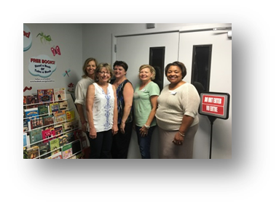
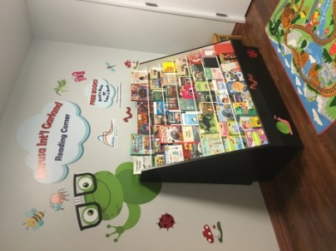
Pictures from the past -- one of our very successful grant projects from 5 years ago.

