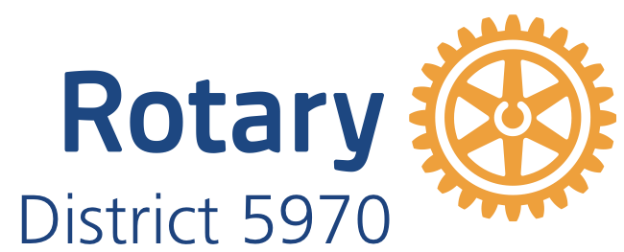

District 5970 Public Image Grant 2023-2024

District 5970 has allocated Public Image Grant funds to help clubs improve public awareness and understanding of what Rotary does within their local communities. Increasing awareness of Rotary within a community attracts the interest of potential members and inspires existing Rotarians. A club may apply for a grant of up to $250. Five grants will be awarded.

Public Image (PI) Grant Qualifications
  - Only clubs in good standing in District 5970 are eligible to apply.
  - Clubs who have not previously received a public image grant will be given priority If funding remains, other applications will be considered.
  - Six district matching PI grants of up to $250 will be available to a club. The grant deadline is December 31, 2023.
  - Clubs must contribute at least $1 for every $1 requested of District 5970. The District will match club contributions dollar for dollar up to a cap of $250.
  - Potential PI Projects could include rebranded websites, club brochures, print ads, billboards, TV/cable public service announcements, radio public service announcements, social media-based campaigns, yard signs, etc. Creativity is encouraged.
  - Projects must have a longer life span (e.g., membership brochures, reusable banners, etc.) One-time, special event-related Projects are not eligible (e.g., banners for a club fundraiser.)
  - PI Projects that are already completed or in process are not eligible for funding.
  - Clubs are encouraged to obtain in-kind donations from local/specific vendors, such as free or discounted print space, billboards, or television/radio time. In-kind contributions, however, do not qualify as club contributions toward the match requirement.
  - The proposed project must use the current RI logo / branding. Create / customize a club logo for download on Rotary’s Brand Center: https://brandcenter.rotary.org or find customizable templates for RI’s People of Action PI campaign.
  - Clubs submitting an PI Grant Application must have a Public Image rep identified.
  - Clubs must have their goals in Rotary Central and this must help them attain one of those goals. Clubs must have enough goals entered to qualify for the Rotary Citation (13).

Application Components
Clubs applying for a District 5970 PI Grant must submit an application. The application should include the following elements:
  - Detailed description of the PI project and how this project will meet a club goal that has been entered into Rotary Club Central.
  - Detailed explanation or visual illustration of the proposed PI materials indicating use of correct branding materials.
  - Description of how the current RI logo will be used in the project.
  - Estimates of intended audience and number of people reached by proposed PI project.
  - Project price quote(s).
  - PI Grant amount requested and amount of direct club contribution.
  - Club President’s and club member responsible for Public Image signatures on the application.

Application Deadlines
December 31, 2023: Last date to submit grant applications and required components (unless District PI Grant funds have already been depleted)
June 1, 2024: Club PI projects must be completed and all reimbursement requests submitted to District 5970

More information
Suellen Kolbet, District Executive Secretary
PO Box 445
New Hampton, IA 50659
641-330-3118
des@district5970.org

Public Relations
Grant Application
2022-2023

Rotary Club: Contact Name: Phone Number: Email Address: Application Date:

Project Description

- Describe your club’s proposed public image project in detail and what club goal it will help your club reach.

- Who is your intended audience for this project?

- Estimated number of people that will be reached by this PI project?

- Grant amount requested (maximum grant: $250)? $

- What is the total project budget? $

- Describe how the new Rotary logo will be used in the project.

- Please provide a visual illustration or rendering of the proposed project if available.

Certifying Signatures

Date:

Club Name:

Club Public Image Rep name & email:

Mailing address to send awarded grant:

Signatures:

Club President Public Image rep

By signing this report, I confirm that to the best of my knowledge the District Public Image Matching Grant funds will be spent only for eligible expenses and that all of the information contained herein is true and accurate.

Please scan and submit the grant application to District Secretary, Suellen Kolbet - des@district5970.org
or send to:
Suellen Kolbet
Rotary District 5970
P.O. Box 445
New Hampton, IA 50659

DISTRICT 5970 PI COMMITTEE USE ONLY
Date Application Received: Date Application Approved: Date Decision Sent to Club:
Date Receipt(s) Provided by Club: Date Payment Submitted:

