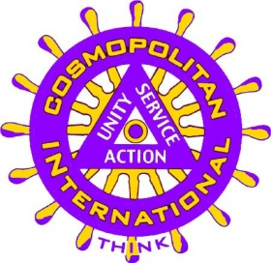
COSMOPOLITAN INTERNATIONAL
The Club that Fights Diabetes
P.O. Box 524, Boystown, NE 68010
Phone (717) 295-7142
www.cosmopolitan.org headquarters@cosmopolitan.org

