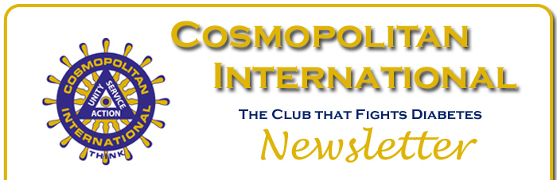
March 2017 Newsletter
2017 Federation Conventions and their official International representatives are as follows:
Cornbelt – Grand Island, NE – April 21-22 – John Krysak
Capital – Roanoke, VA – May 19-20 – John Keeley
Midstates – North Aurora, IL – May 20 – John Hubert
Mo-Kan – Topeka, KS – April 21-23 – Bob White
North Central – Rapid City, SD – April 28-29 – Rick Swansbro
Western Canada – St. Albert, AB – May 26-28 – David House
 | The 2017 updated Leaders Manual is here! International President-Elect John Hubert and ED Tracy have completed updates to this manual, which now is available on the website at www.cosmopolitan.org > Resources > Membership Documents. The updated manual features new information for leaders across all levels of Cosmopolitan, including club officer job descriptions. Check it out!
 | Many of us have, at one time or another, made purchases from Amazon.com. But did you know that Amazon offers a way that your purchase can benefit the Cosmopolitan Diabetes Foundation (CDF)? Simply log onto smile.amazon.com and select Cosmopolitan Diabetes Foundation as the charity of your choice. When you do, Amazon will donate a portion of your purchase price to the CDF. There is no cost to participate. This is a very simple way for Cosmos to show their support for the CDF. Log on and sign up today!
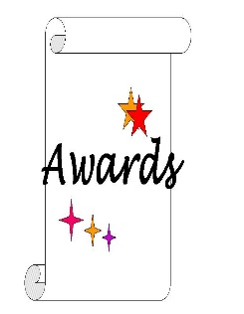 | The Awards Committee has been hard at work improving the entry forms for individual awards. The new forms may be found on the website at www.cosmopolitan.org > Resources > Award Entry Forms. All federations should use these forms when submitting nominations to International for judging. Also, the Awards Brochures has been improved aesthetically with consistent due dates and appears on the website with the entry forms. Important: There are NO changes to any award criteria this awards year.
 | If you have not already checked out the new online store, do so today at www.cosmopolitan.org > Shop! The new store features Cosmopolitan attire along with great gift ideas for club speakers and guests, such as mugs, pens, tote bags, and much more! The online store also is our new resource for name badges and club plaques. All club secretaries are encouraged to order members’ name badges through the store. Contact ED Tracy for any assistance with your online store purchase.
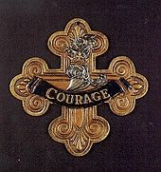 | The 2016-2017 International President’s Award has been announced! David House will award the “Courage” bannerette to all clubs who achieve the following during the current Cosmo year. Winning clubs must:  - Achieve a net club membership increase over 2015-2016;  - Be registered for and represented at International Convention;  - Achieve the Big C Award;  - Hold a minimum of one membership event; and  - Submit at least one article to COSMOTopics.  Make sure your club earns this prestigious award. All it takes is a little “Courage!”
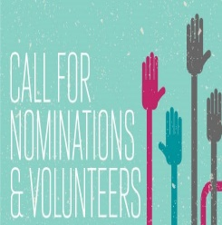 | Chairman of the Nominating Committee, Immediate Past International President Richard Gordon, has called for nominations for Executive Committee offices for 2017-2018. If you are considering volunteering your time and talents on the Executive Committee for next year, contact ED Tracy at headquarters@cosmopolitan.org to submit your name for a position or for information on qualifications.
And finally,

“A government big enough to give you everything you want is strong enough to take everything you have.”

--Thomas Jefferson

