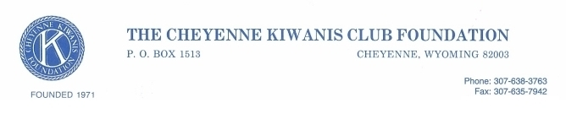

FOUNDATION BONHAM POLICY

The Foundation’s Bonham Fellowship was established to honor Dwight Bonham. A long-time member, past Club President, and Rocky Mountain District Governor. After Dwight’s passing donations to the Foundation from his family and friends led to the establishment of the Foundation’s Bonham Fellow Program.
The Foundation awards Bonham Fellowships to individuals who contribute $1,000.00 to the Foundation. The contribution can be in one lump sum or in up to 10 installments. The installments must be at least $100.00 and received in the same calendar year.
Bonham Fellows will be recognized by a plaque and their name will be placed on the Bonham Board in the Treber Warehouse. Members with multiple Bonham Awards may opt not to receive an additional plaque, but their contribution will be acknowledged, with an additional asterisk placed on their name plate on the Bonham Board. If there isn’t room for an additional asterisk an additional name plate will be placed on the Board.
This Policy supersedes any previous policy or guidance and was approved by the Foundation Board at their regularly scheduled meeting November 21, 2022.

James W. Coomes
Foundation President

