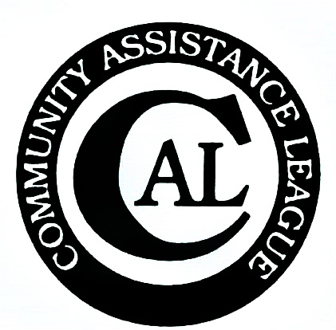

Dear Applicant

Thank you for your interest in the Community Assistance League grant application process for 2021. Our organization strives to make our community a better place to live and work through our philanthropic programs, scholarships and grants to local non-profit organizations.

Our focus will be on those projects that provide direct benefit to Bonner County residents. We want to understand your organization, the project for which you are requesting support and how it will benefit the community. Please include information on other funding sources involved in seeing your project through to completion. We only fund specific projects and not general operating expenses such as administration, rent or utilities.

Please complete the attached application and return to CAL, with a postmark no later than March 31, 2021. Your request will be reviewed and a decision will be communicated to you at the address listed on the application by May 15, 2021. Please review the application instructions for further details.

If you have received a previous CAL grant, a requirement for receiving a 2021 grant award is submitting a one time final report for the previous award. Once your report has been submitted, you are eligible for the current grant cycle. Final reports for grants given in 2020 (or any other year where a final report was not filed) must be submitted by March 31, 2021.

The final report should describe your project, how it impacted the community, and details how the funds were appropriated, including invoices for materials, labor, and purchases of items specifically funded. Photos of completed projects/purchases are requested and where appropriate, before and after photos of the project to provide clear documentation of completion. The report should be mailed to: CAL, PO Box 1361, Sandpoint, ID 83864, ATTN: Grants Chair, postmarked by March 31, 2021.

The application form and instructions can also be downloaded from the CAL website, calsandpoint.org.

If you have any questions regarding the application or process, contact me at calsandpointgrants@gmail.com or by phone at (208)290-5752.

Tracy Gibson, CAL Grants Chair

Grant application criteria upon which decisions are based:
- Is the project innovative?
- Is this a complete project or a phase of the project that can be completed within the grant year?
- Do you have confidence of project completion within the grant year?
- Does the project address important issues?
- Does this project have a significant impact on the community?

Projects must apply to Bonner County residents. Applicant must be a non-profit organization. It is helpful, but not required to have an IRS status of 501c3. You may include attachments for further clarifications, detailed budget spreadsheets, etc.

CAL grants cannot be used for:
- Funding general administrative expenses, such as salaries, stipends, wages, honorariums, rent, and overhead expense.
- Capital campaigns
- Sectarian religious programs that do not serve the entire community
- Social events
- Political organizations

The application must:
- Stand on its own. We will not return the application for further clarification.
- Be completed by the applicant or authorized designee for the organization.
- Be type written or legibly written.
- Use the approved CAL 3-page Grant Application Form, with data entry fields.
5. Include the budget information needed to evaluate the project.

Submission Options:
1. Mail to CAL. P.O. Box 1361, Sandpoint, ID 83864, and postmarked no later than March 31, 2021
2. Deliver to Bizarre Bazaar, 502 Church Street, Sandpoint no later than close of business March 31, 2021 (4:00 pm)
3. Or Email to calsandpointgrants@gmail.com no later than 4 pm on March 31, 2021

Community Assistance League
2021 Grant Application

Organization Name & Address: Date Submitted:
Organization Name:
Address:

City/State/Zip:
Person to Contact/Grant Requestor:
Primary Phone Number: Office Cell Home
Alternate Phone: Office Cell Home
Email Address:

Description of the Organization:
- Membership/Size:

- IRS Status:

- Date Established:

- Mission or Purpose:

- Annual Budget (can attach):

- Brief Description of Current Programs:

Describe the Project to be funded:
- Project Description, Implementation Plan & Time Line

Budget for project (may be attached):

Number of people directly and indirectly impacted:

Fund Amount Requested:

Will this request fund the entire project? If other organizations are involved in the funding please identify. You may attach an annual report and/or pertinent brochures.

How will you measure your success in reaching project goals?

Please mail the completed application with any attachments postmarked no later than March 31, 2021 to:
Grants Committee
Community Assistance League
P.O. Box 1361
Sandpoint, ID 83864

Application may be submitted electronically via email to calsandpointgrants@gmail.com

