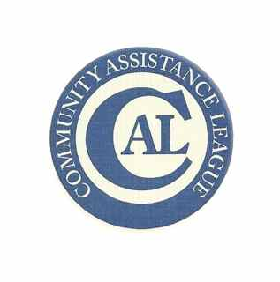
March 2024
Dear Applicant,
Thank you for your interest in the Community Assistance League grants program. CAL is dedicated to improving the quality of life in Bonner County through philanthropy—mostly in scholarships and grants.
Our grant program supports local non-profits which provide a direct benefit to Bonner County residents. If you believe your organization does that, we want to know more. Please complete the attached application and return no later than 3:00 p.m. March 30, 2024. We will not accept late applications and all applications must be complete, accurate, and legible. (The application form and instructions may also be downloaded from our website: www.calsandpoint.org)

Do not email completed applications – they must be delivered to the Bizarre Bazaar at 502 Church Street, Sandpoint Idaho 83864 or mailed to Community Assistance League, P.O. Box 1361 Sandpoint, ID 83864.
CAL grants cannot be used for:
- Administrative wages, rent, insurance, or utilities for your group;
- Political organizations;
- Religious or other organizations that do not serve the community as a whole; or
- Capital campaigns

Your application must: 1) be legibly written if not typed; 2) use the CAL Grant Application form in total; 3) include budget details for the project or program you wish funded; and 4) stand on its own—meaning no other explanation or paperwork is needed. We will not contact you for clarification.

Once reviewed by our committee, you will be notified by mail at the address you list on your application. That notification will be postmarked no later than May 15, 2024. Notifications are sent to all applicants either informing you of acceptance of your project for funding or letting you know it will not be funded.

If you do receive a CAL grant, we will require a final report that documents completion of the project for which the funds are intended. Grant recipients who do not send a final report will not be eligible for future grants.

For questions about this process, please email me at CALSandpointgrants@gmail.com. Good luck!

Ann Nichols, Grants Committee Chair

Community Assistance League 2024 Grant Application
This form must be used for all applications for CAL grant funding. And it must be completed in full, answering each question and providing all requested information. Incomplete applications will be disqualified from consideration.
Organization name: IRS status (incl TIN#)
Mailing address:
Person to contact: Phone: Email:

Amount you’re requesting from CAL:

All of the following ten questions must be answered in full.
- What does your organization do? Who do you serve? (mission/purpose)

- Current budget: (attach if you prefer)

- Describe your current programs or projects:

- What specifically are you asking us to fund?

- Project description:

- Plan for implementation, including expected timeline:

- Project budget—itemize, please. If appropriate, include written estimates for materials and/or labor (may be attached)

- Who will benefit and how is this a benefit?

- How will you measure success? Be specific—give us data, if possible.

- If the CAL grant will not fund the entire project, please explain how you will complete funding.

Submitting your application:
- Do not email completed applications.
- Mailed applications must be postmarked no later than March 30. Mail to CAL Grants, PO Box 1361, Sandpoint, ID 83862.
- Applications may be delivered to Bizarre Bazaar at 502 Church St. no later than 3 p.m. on March 30.

