ECFC CLIFF HILL TRAINING GROUND

**3G RULES**

Please see below the rules and regulations that we have put in place for the use of our all-weather artificial surface.

Thank you in advance for your co-operation and we look forward to welcoming you to the Cliff Hill Training Ground.

* Moulds only – **MUST** be clean.

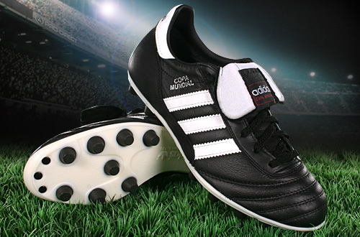

* No studs – players will not be allowed on the 3G if wearing metal studs.

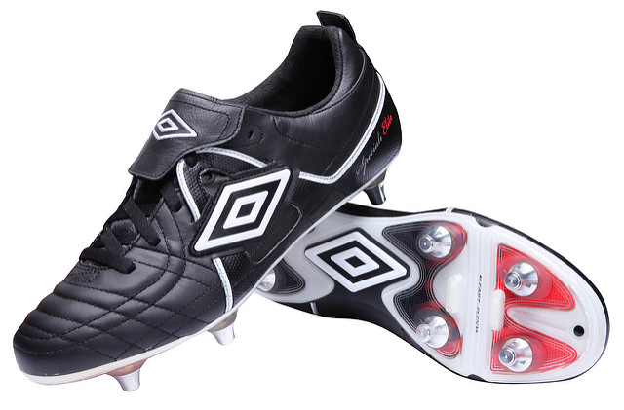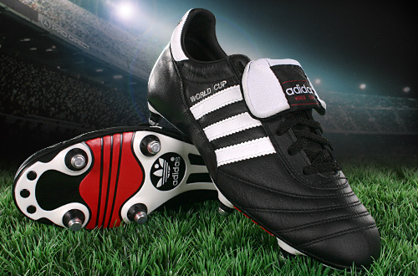



* No trainers on the 3G – **including** staff and officials.

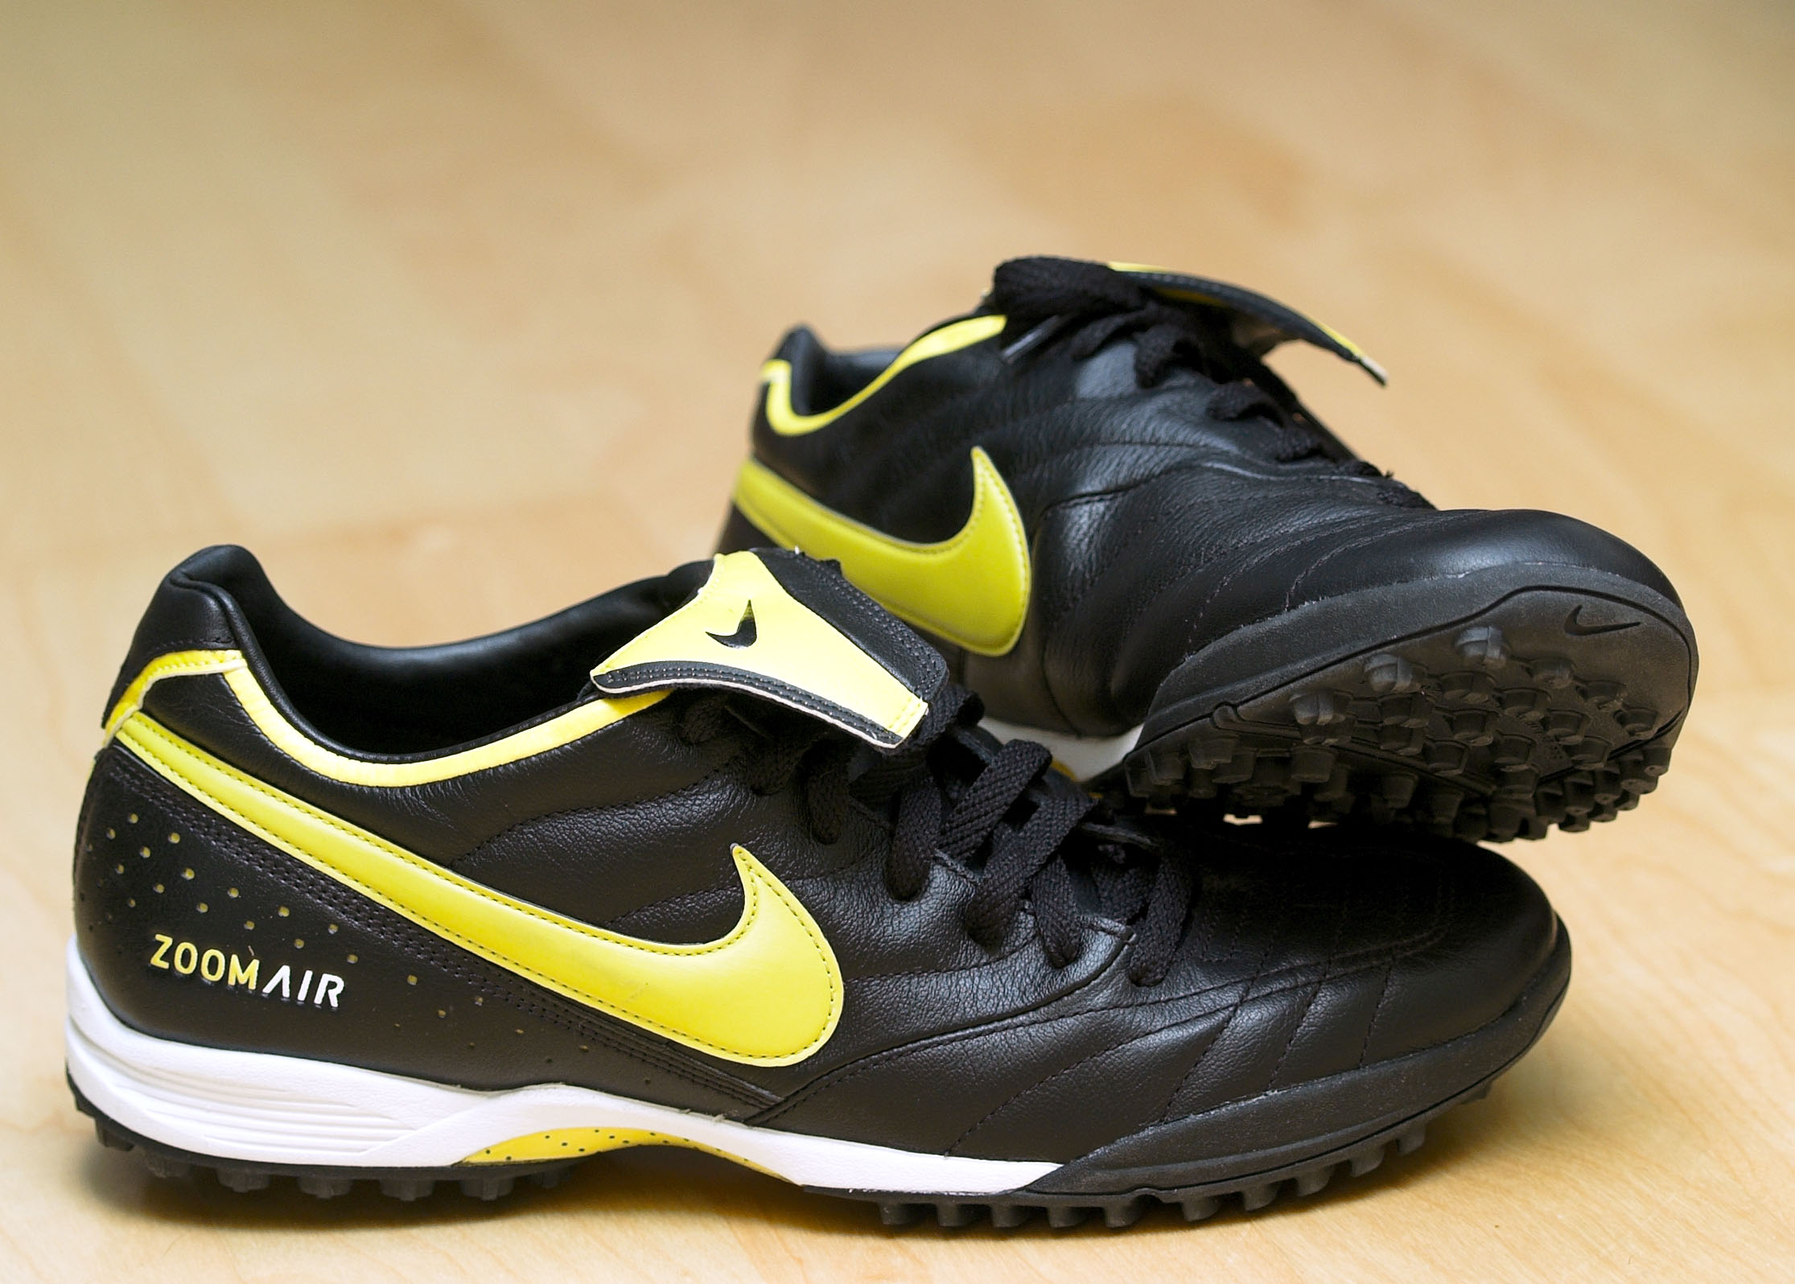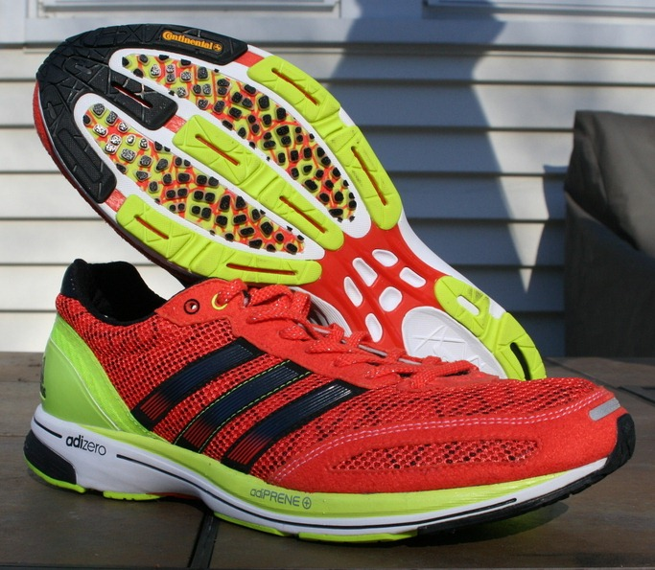

* Change of footwear needed to walk from the changing rooms to the pitch.

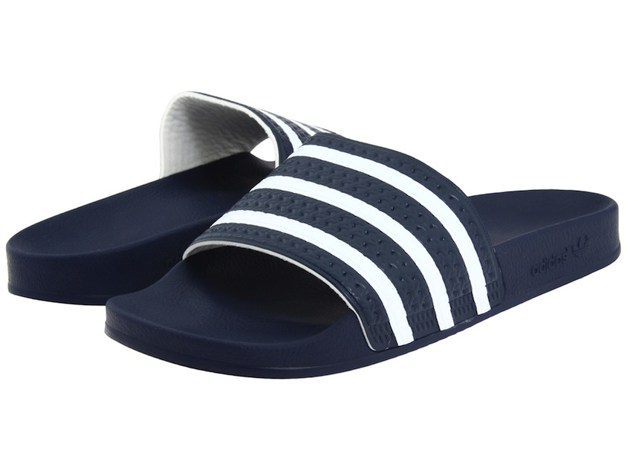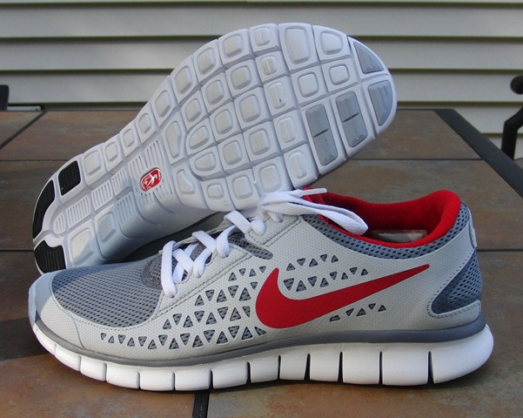



* No juice/isotonic drinks on the 3G surface.

[](https://www.google.co.uk/url?sa=i&rct=j&q=&esrc=s&source=images&cd=&cad=rja&uact=8&ved=0ahUKEwjIqOLVpbXRAhVMaxQKHTCYABYQjRwIBw&url=https://twitter.com/lucozadesport/status/603531141094645762&psig=AFQjCNEJECed7ZsKC5BjNqDVeCH9L-MEgA&ust=1484059228809886)



* ONLY water to be taken onto the 3G surface.

