Royal Rosarians
Historical Photographic Retrospective: 1912 - 1946
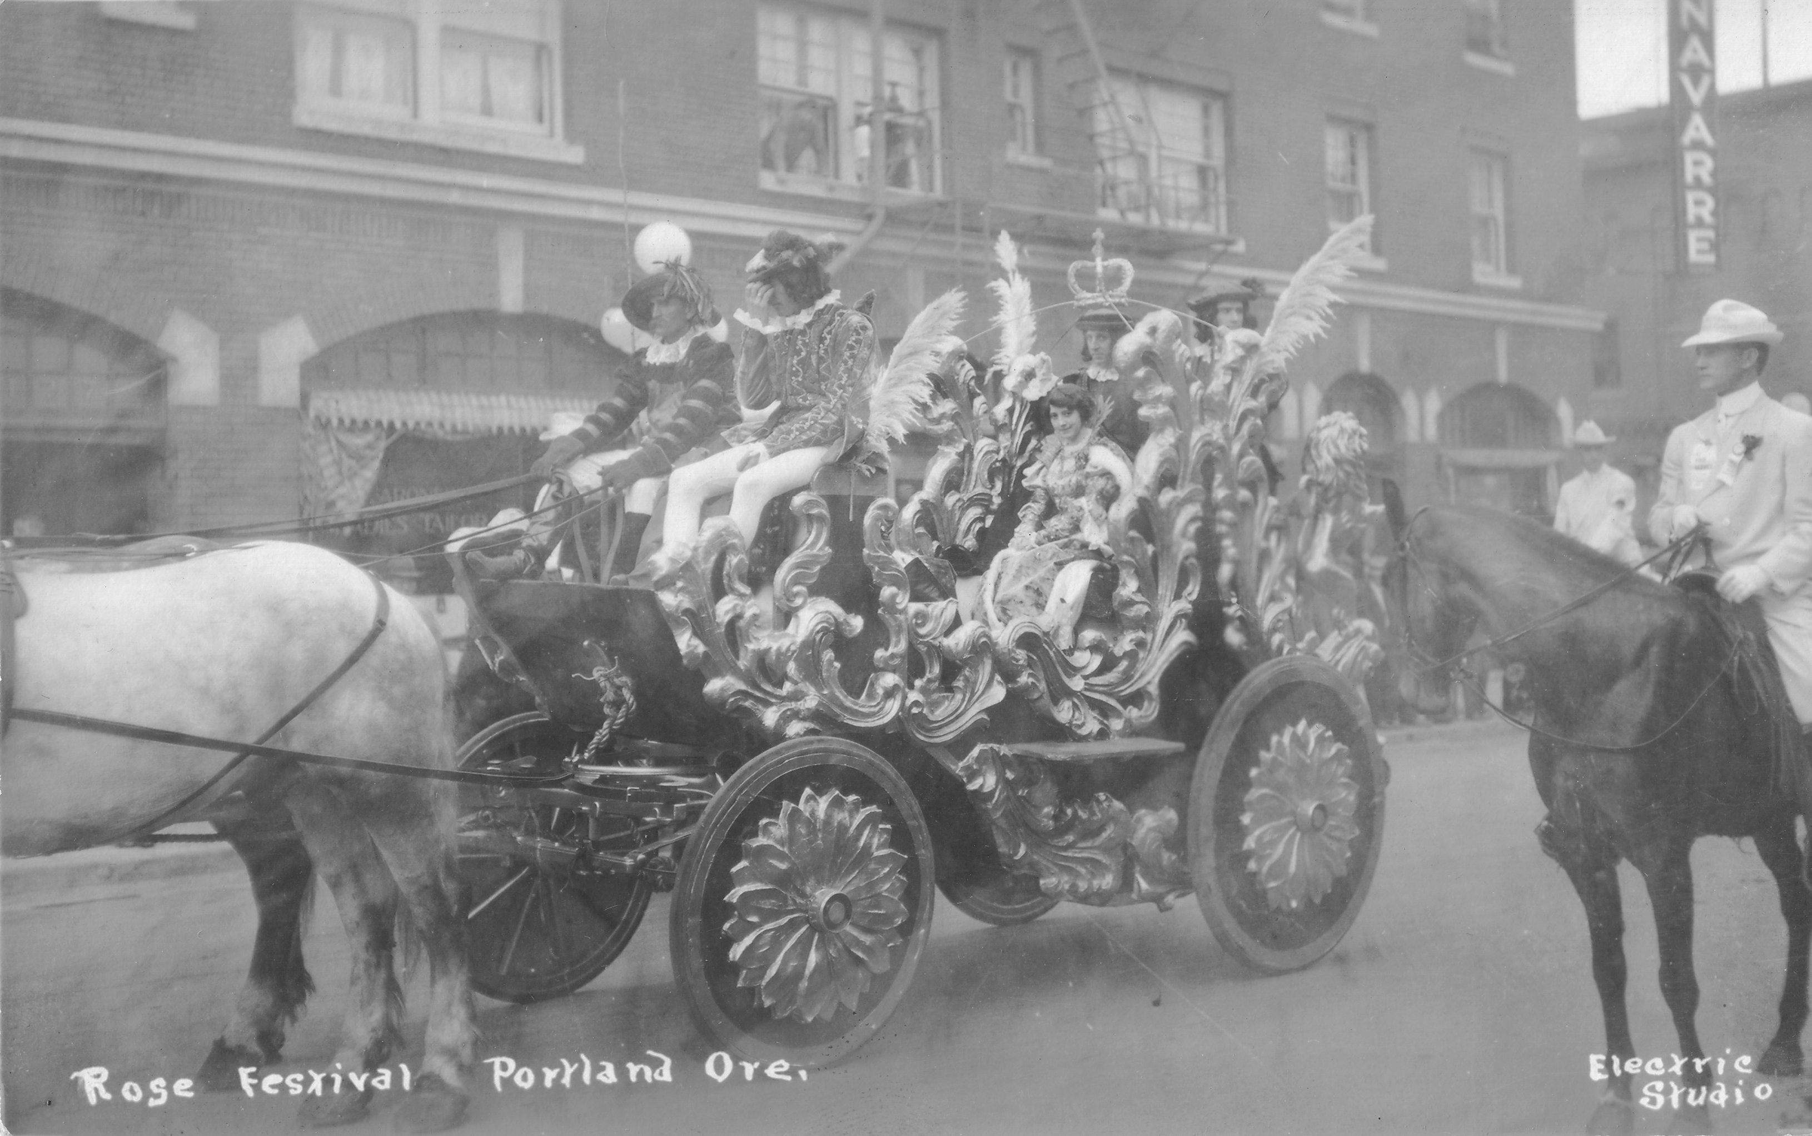
1914
Queen Thelma’s Coach, Grand Floral Parade. Escorted by Royal Rosarians on Horseback.

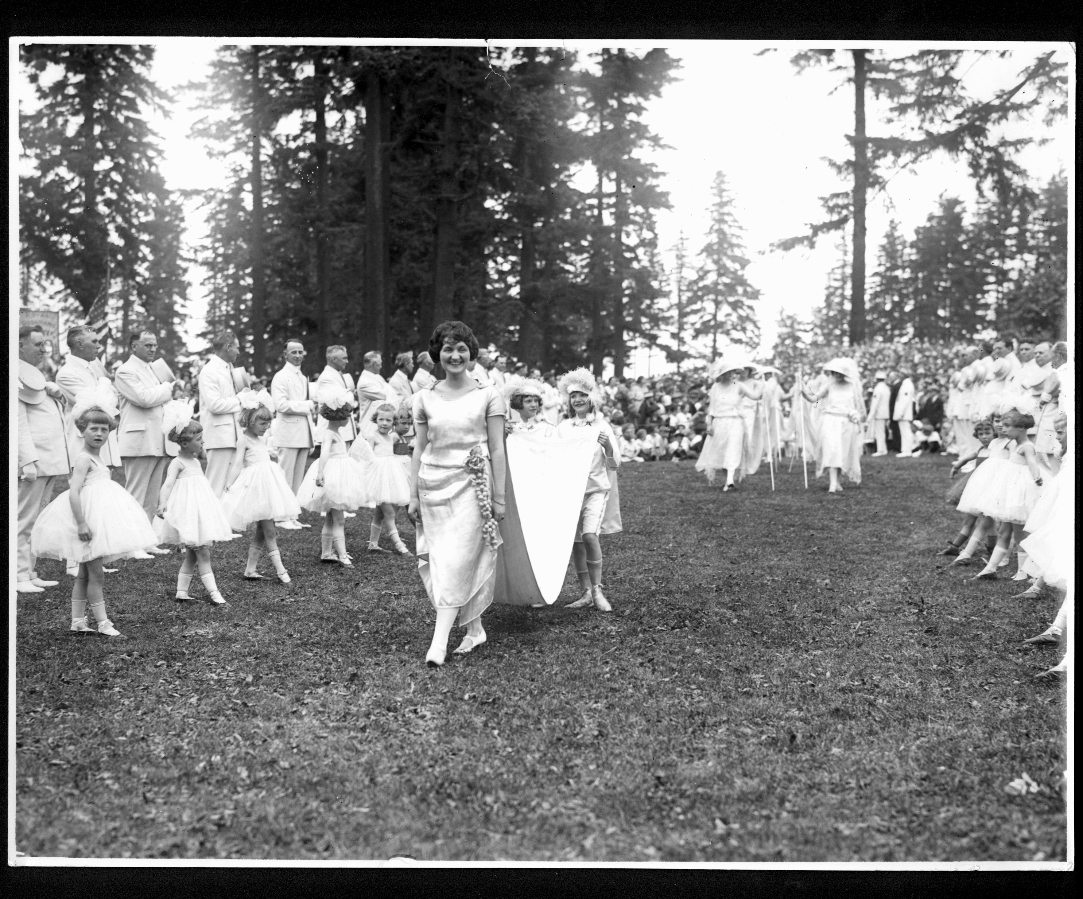
1922
1922 Queen Harriet Griffith Coronation. This was the first time the “Crown” was worn.
The Prime Minister was John Dundore. Photo Courtesy of the Oregonian.
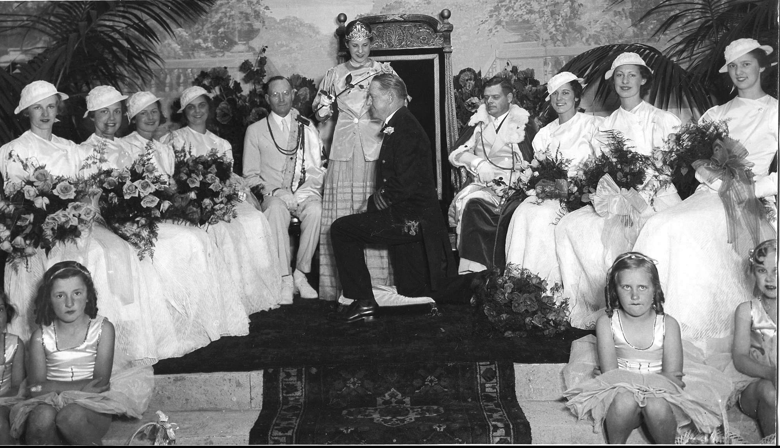
1933
Queen Jan knights Commander Gulliner at Honorary Knighting Ceremony.
Prime Minister Oscar Smith, Prince Regent Roy K. Terry.

