Royal Rosarians
Historical Photographic Retrospective: 1947 – 2012
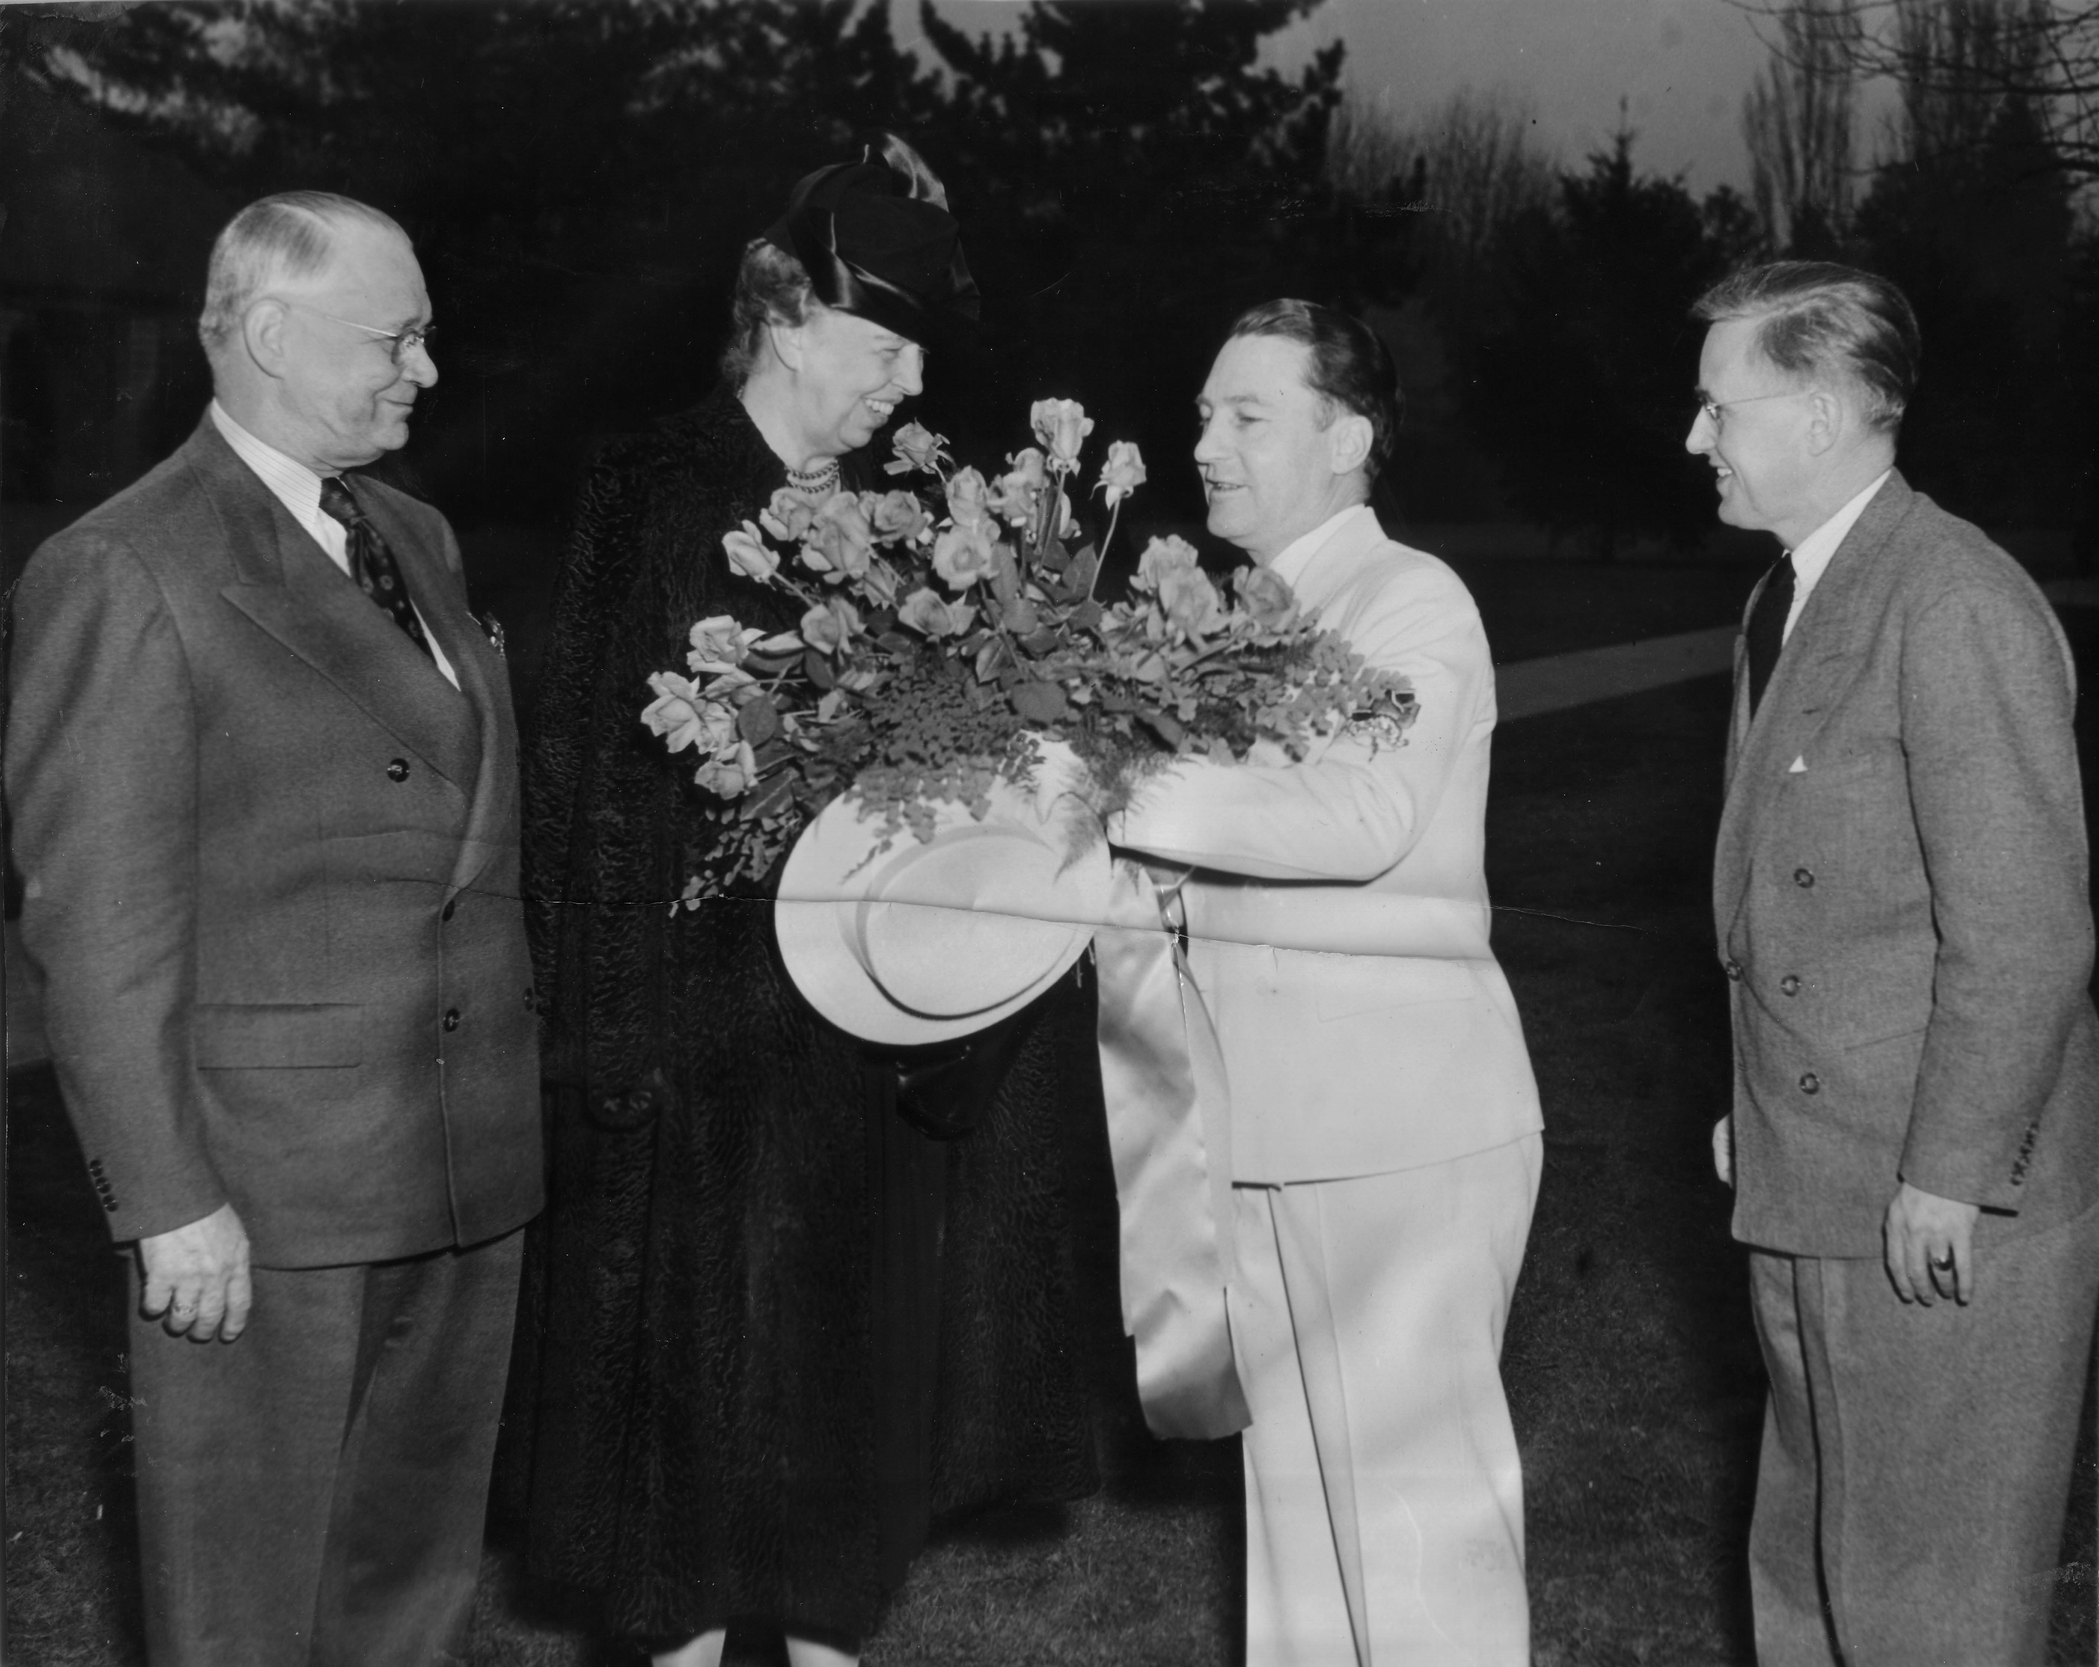
1947
Rosarians Greet First Lady Eleanor Roosevelt. Leeland Hess presents her with a bouquet of roses.
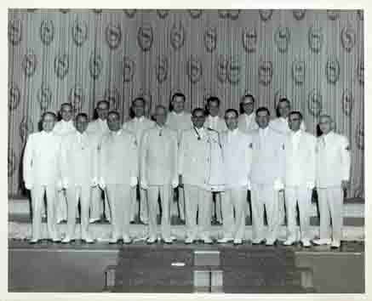
1961
Inauguration of Council at Sheraton Hotel.
Prime Minister Cecil Brown, Prince Regent Ed Eggen.

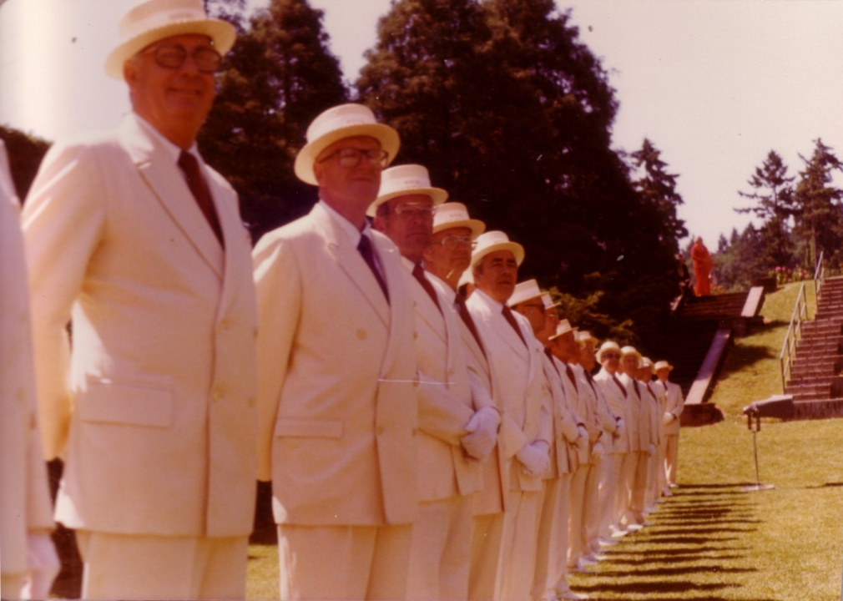
1979
Rosarian pageantry at Washington Park Knighting.
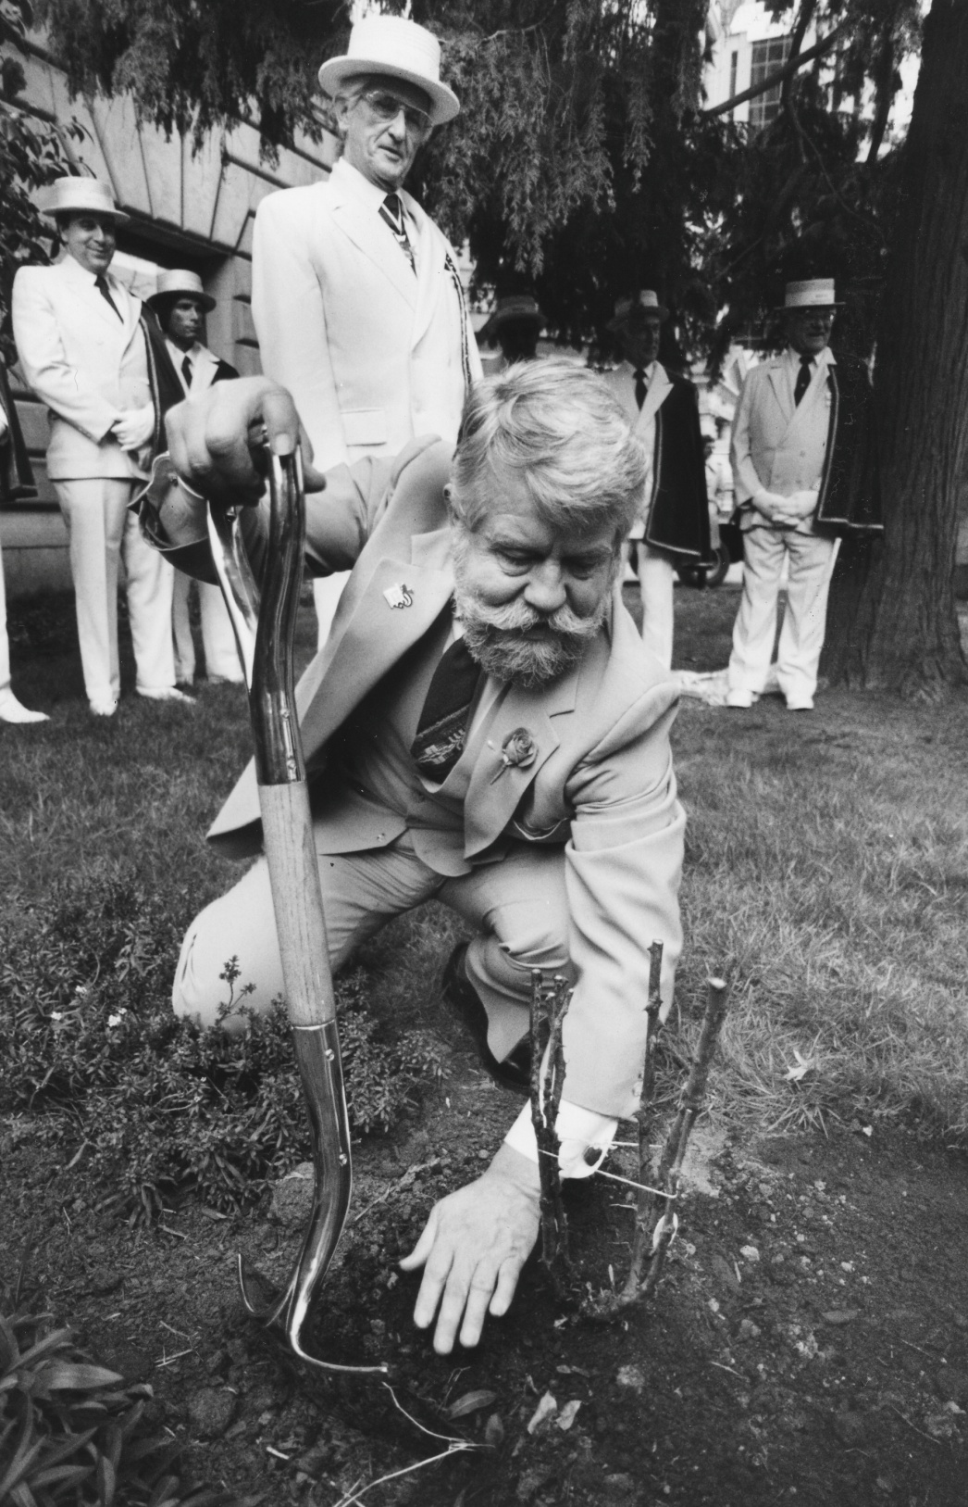
1988
Mayor Bud Clark plants rose as PM Victor Greb looks on. Photo Courtesy of the Oregonian.

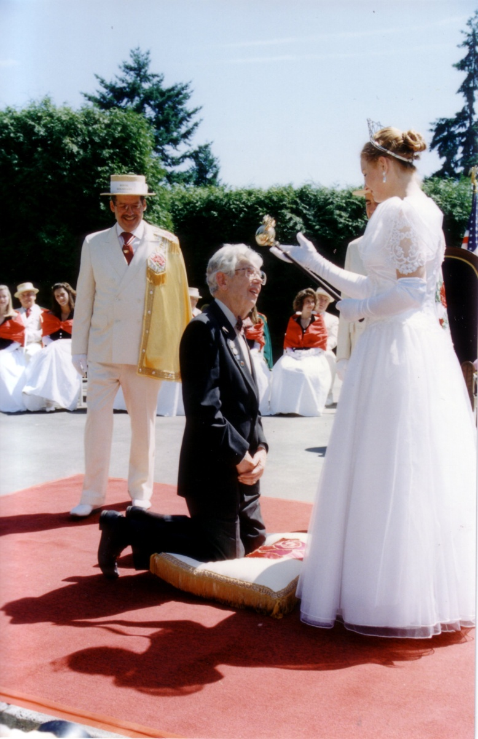
1994
Queen Joy knights Orville Redenbacher.
Prime Minister Ed Honeycutt and Prince Regent Bob Bishop look on.
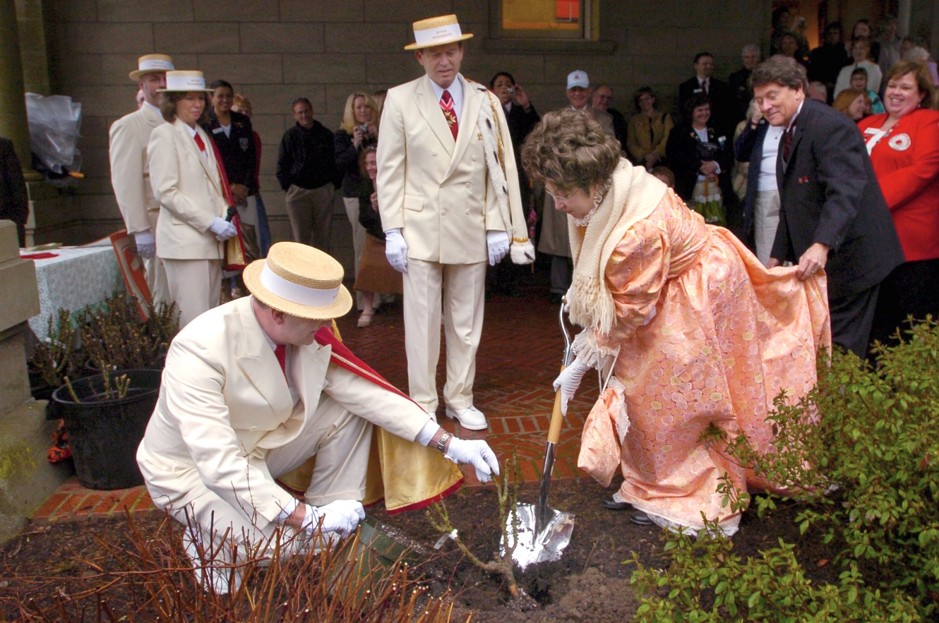
2007
Mayor Harry Lane (1907 Mayor) and Georgiana Pittock plant rose at the Pittock Mansion in honor of the Rose Festival 100th year. Also shown: Prime Minister Bob Strader, Royal Gardner Aivars Saukants and Royal Scribe, Gayle Whitehurst. Photo courtesy of the Oregonian.

