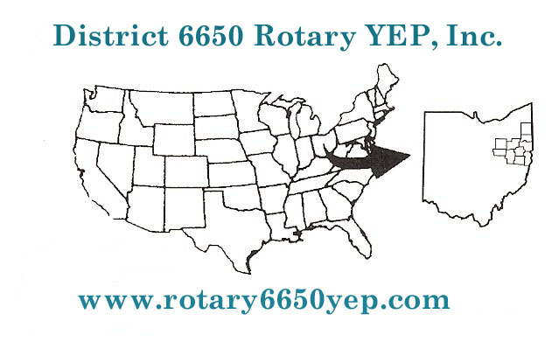

203 Cleveland Avenue NW
Canton, OH 44702 USA
Phone: 330 452 2882
Fax: 330452 8614
email: info@cantonrotary.org

Local Coordinator Name: _______________________________

Student:__________________________________

By signing this form, I confirm that have received and reviewed the Local Coordinator Training Materials provided by Rotary District 6650. I also confirm that we have been informed about the resources available on the District 6650 Rotary Youth Exchange Webpage - www.rotary6650yep.com and about my ability to contact Youth Exchange Resources in the event I have questions about the training content.

Signature: _______________________________

Date: _________________________________

