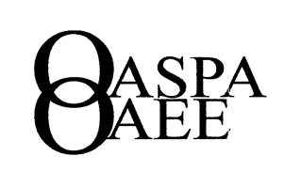
OASPA Boot Camp
September 7, 2018
DoubleTree by Hilton, Worthington, Ohio

Friday, September 7, 2018
Time | Schedule
08:00–08:30 | Registration and Continental Breakfast
08:30-08:45 | Opening Remarks | Michael Rarick
08:45-09:45 | HR Calendar | Marion Stout
09:45-10:00 | Break
10:00-11:45 | The Basics of Staff Management,  Employee Discipline and Investigations | Ennis Britton
11:45-12:45 | Lunch
12:45-14:00 | Trial by Fire – Surviving Real Life School HR  Scenarios Panel Discussion | Marion Stout-Facilitator  Sam Gifford  Greg Hester  Patrick Hoy  Ennis Britton
14:00-14:15 | Break
14:15-15:30 | Case Study Dialogue  Panel Discussion | Marion Stout-Facilitator  Sam Gifford  Greg Hester  Patrick Hoy  Ennis Britton
15:30 | Closing, Evaluations, and Feedback | Mark Barhorst

