“Rights of Students with Disabilities in Public Charter Schools” (12/28/16)
The sixty minute webinar, is a presentation and brief Q&A of the guidance package developed by the U.S. Department of Education’s Office for Civil Rights (OCR) and Office of Special Education and Rehabilitative Services (OSERS.) The jointly-issued Dear Colleague Letter and Frequently Asked Questions (FAQs) documents on Section 504 of the Rehabilitation Act (Section 504) and on the Individuals with Disabilities Education Act (IDEA), along with a Know Your Rights document, help update educators, parents, students, and other stakeholders to better understand the rights of students with disabilities in public charter schools under Section 504 and IDEA.
A Transition Guide (January 2017)
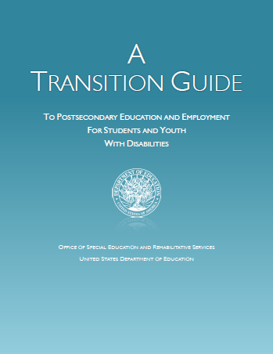

OSEP: Dear Colleague Letter related to Preschool Least Restrictive Environments (LRE) (1/9/17)
Equity in Special Education
- OCR: Dear Colleague Letter: Preventing Racial Discrimination in Special Education (12/12/16)
- IDEA: Significant Disproportionality: Final Regulations (December 2016)

Ohio’s Draft ESSA State Plan (Open for Public Comment through March 6)
Memo #2017-1:
Responsibility of a School District of Residence to Ensure Free Appropriate Public Education (FAPE) to its Students with Disabilities in Separate Public or Private Facilities (January 13, 2017)

