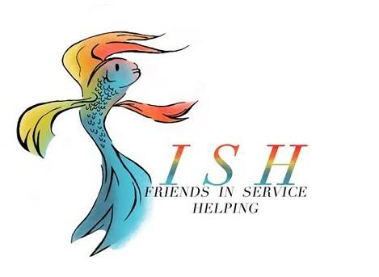
Business Meeting Minutes
September 10, 2019

- Meeting called to order at 12:07 pm by President Carol White followed by Altrusa grace and the pledge of allegiance.

- Jennifer Adams introduced two guests in attendance.

- Kelli Alsup presented the Accent on National Senior Day, celebrated on September 8, which was started by President Ronald Reagan to recognize senior citizens and their quality of life. Kelli encouraged club members to participate in the many senior projects we support.

- The following new members were installed by Jennifer Adams
  - Cathy Sage
  - Jennifer Loftin
  - Luanne Popelka

- Old Business
Minutes from the August 13 business meeting and August 27 program meeting were presented and approved as written.

- New Business
  - Debra Hicks presented the Treasurer’s Report reflecting an administrative account balance of $11,357.04 and a project budget balance of $19,228.91 ($691.83 allocated for To The Moon and Back).
  - Marsha Oliver presented the Correspondence Report for the month of August. Report will be filed.
  - Traci Squarcette presented a check in the amount of $900 to Ralph Wilson Youth Club to support Rock N Readers and the reorganization of their library. Beverly Leudke urged members to sign up as readers for RWYC.
  - The following new project proposals, approved by the Board on September 3, were presented by Carol White and approved by club membership.
    - Hostesses for the Bra Brunch, sponsored by the American Cancer Society, October 1, 2019. 25 hours and $0.
    - Caring Ball, benefitting the Temple Community Clinic, February 8, 2020. $0 and 300-400 hours.
    - Make A Difference Day to provide food, consumable items and activities for low income and/or disabled senior residents at the Kyle, Golden Haven and Frances Graham Hall. Saturday October 26, 2019. $1,400 and 40-60 hours.
    - Children’s Library and Toy Chest, McLane Children’s Medical Center to purchase books for bibliotherapy, which helps patients understand key medical topics, and to organize the storage unit (Toy Chest). $2,500 (donated by an anonymous donor through the Foundation account) and 60 hours. Donna Wright informed that the funds need to be formally requested from the Foundation.

  - The following project proposal, which was not presented or approved by the board, was presented to the club membership.
Sirena Fest, October 5, 2019 to support the All-Abilities playground project for Central Texas (Salado). Monies raised at the festival will go directly to the playground. $1,000 and 72 hours. Motion by Carol Fleck and seconded by Debbie Mabry. Approved.

- Committee Reports
  - Debbie Mabry announced that the Membership Committee will host a new member social on Wednesday, September 18, 5:30 pm at Sona Wine Bar.
  - Donna Wright announced that Taste of the Holidays invitations will be mailed on September 11 and online registration will open on September 16.
  - Amanda Pierce, Taste Of the Holidays Raffle Committee Chair, announced she has two new co-chairs: Cindy Black and Traci Squarcette.

- Brags

- Following the benediction, the meeting was adjourned by President Carol White at 12:59 pm.
Minutes submitted by Lori Luppino, 2019-2020 Recording Secretary.

