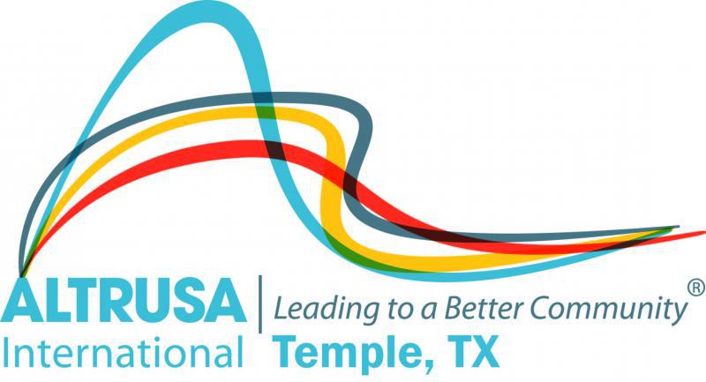
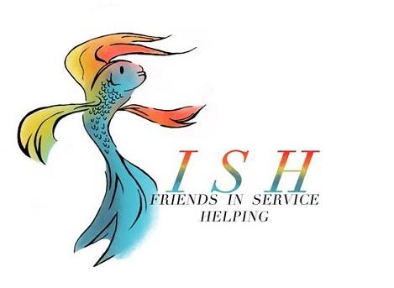Program Meeting Minutes
September 24, 2019

- Meeting called to order at 12:01 by President Carol White followed by Altrusa grace and Pledge of Allegiance.

- Guests were presented by Jessica Kirkland.

- Susan Cory presented the Accent on World Food Day celebrated on October 16, 2019. The Temple Club supports many initiatives to alleviate food insecurity including Feed My Sheep, Helping Hands Ministries and Kids Against Hunger. Altrusans are encouraged to participate in these initiatives.

- Taste of the Holidays Chair, Co-chair and Committee Chairs presented the program which was a funny and informative skit on the 2019 Taste. Committee Chairs, or their representative, provided updates and requests for volunteers as needed.

  - Decorations Committee needs a minimum of four volunteers on Wednesday, November 20 to finish putting stems on pumpkins.
  - Invitations – Over 1,000 invitations were mailed and only 35 returned. Donna Wright and Taryn Cox will email Altrusans with the list to update or delete.
  - Entertainment – Sylvia Winker shared exciting information on the entertainment. Volunteers are needed for November 21 to walk around with a photo frame and take pictures of guests.
  - Facilities – All requests at the Mayborn must be made via Regina Phinney or Marie O’Neal.
  - Fashion – Beverly Leudke. Fittings complete. Promos scheduled.
  - Graphics – Brenda Hill and Tara Manly. Program and PowerPoint are in progress.
  - Hospitality – Sherry Woodard. Breakfast and snacks will be provided to volunteers on Wednesday. Wrap up party at the CAC on Thursday after cleanup is complete.
  - Logistics – New committee for 2019 chaired by Debbie Fendrick and Teresa Bowen-Bechtel. Purpose is to coordinate moving supplies from storage to Mayborn and return.
  - Menu – Celeste Kaylor and Debbie Gordon. No report.
  - Publicity – Melissa Tyroch, Chair. Temple Daily Telegram had a very nice article earlier in the week. TV promos and news stories are planned as well as Facebook posts.
  - Raffle – Amanda Pierce, Cindy Black and Traci Squarcette. Requested help in securing items for themed baskets. Need 8 volunteers the day of the event.
  - Reservations – Marsha Oliver and Kelli Alsup. Need volunteers day of event to greet guests and escort them to their tables.
  - Underwriting – Sharon Walzell and Michelle DiGaetano. $4,100 received to date.

- Committee Announcements
  - Membership: Jessica Kirkland announced that new member pins are available. New member orientation is scheduled for October 3, 6:00 pm at Patsy Sulak’s home.
  - Jessica Kirkland – Toy Chest clean up and organization day at McLane Children’s scheduled for November 2.
  - Jessica Kirkland: Encouraged Altrusans to volunteer for Sirenafest on October 5 in Salado. All proceeds will benefit the All Abilities Playground. Wear your Altrusa shirt.
  - Make A Difference Day: Carol White announced that a planning meeting is scheduled for Thursday, September 26, 5:30 pm at Kolache Kitchen #2.
  - Service Committee: Michelle DiGaetano announced meeting today, September 24, at 5:30 at Temple Community Clinic.

- Brags

- Meeting was adjourned at 12:55 following the benediction.
Minutes submitted by Lori Luppino, 2019-2020 Recording Secretary.

