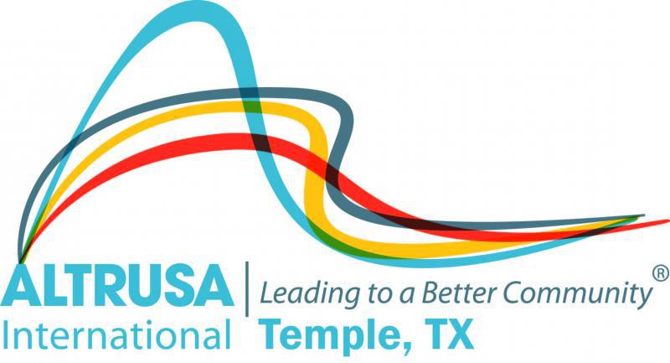

Program Meeting October 22, 2019 Agenda

- Welcome and call meeting to order.
- Altrusa Grace
For this food before us spread,
For thy steps in safety led,
For thy favor on our way,
Lord accept our thanks today
- Pledge of Allegiance
- Accent – Jana Janes, The Do’s and Don’ts of Social Media
- Program Meeting – Flying Vikings
- Committee Announcements:
- Membership
- Communication
- Taste of the Holidays
- ASTRA
- Brags
- Benediction and Adjourn Meeting:
May we go forth with high ideals to greet our fellow man. Be true to all Altrusa aims until we

