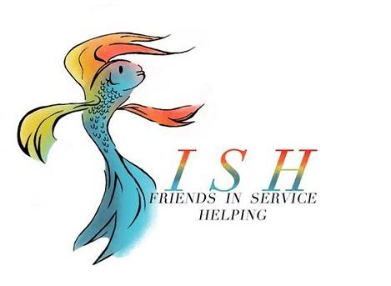
Business Meeting Minutes
October 8, 2019

- Meeting called to order at 12:00 pm by President Carol White followed by Altrusa grace and the pledge of allegiance.

- Jennifer Adams introduced two guests in attendance.

- Kathy Folley presented the Accent on Make a Difference Day, celebrated on the 4th Saturday in October, which will benefit “At-Risk Seniors” in Temple at the Hal Rose Building on 9th St. Altrusa members will provide a breakfast, bingo and prizes, along with a goodie bag to each senior present. This project was previously approved for $1,400 and 40-60 hours.

- The following new members were installed by Jennifer Adams
  - Pamela Abernathy
  - Brittany Wentz
  - Ashley Ruiz (via phone call)

- Old Business
Minutes from the September 10th business meeting and September 24th program meetings were presented and approved as written.

- New Business
  - Debra Hicks presented the Treasurer’s Report reflecting an administrative account balance of $11,556.54 and a project budget balance of $15,184.83.91 ($691.83 allocated for To The Moon and Back).
  - Marsha Oliver presented the Correspondence Report for the month of September. Report will be filed.
  - The following new project proposals, approved by the Board on October 1, were presented by Carol White and approved by club membership.
    - ASTRA Finals Kits, $500.
    - Belton Senior Bingo & Meal, $300 and 35 hours.

- Committee Reports
  - Traci Squarcette - Make A Difference Day has a sign-up for breakfast casseroles and gifts; a workday is scheduled for October 14th at 5:30 at The Vine Church.
  - Traci Squarcette – ASTRA: there is a UMHB fundraiser scheduled for October 15th at MOD Pizza.
  - Teresa Bowen-Bechtel – ASTRA: announced a good turnout for Margarita Monday. Belton High is collecting items for veterans in Killeen. Also, there is an Altrusa Yoga Mixer scheduled for November 12th at 7:00 pm – Maximize your Potential, $20 fee.
  - Dorothy Granfor – Taste of Holidays decorations will need assistance on November 20th at 9:00 am with attaching stems to pumpkins.
  - Diana Zaremba – Taste of Holidays raffle tickets will be distributed by Amanda Pierce.
  - Cynthia Black – Ronald McDonald House dinner will need volunteers to help cook.
  - Debbie Fendrick – Altrusa t-shirts available for $10.

- Brags

- Following the benediction, the meeting was adjourned by President Carol White at 12:55 pm.
Minutes submitted by Marsha Oliver, 2019-2020 Corresponding Secretary.

