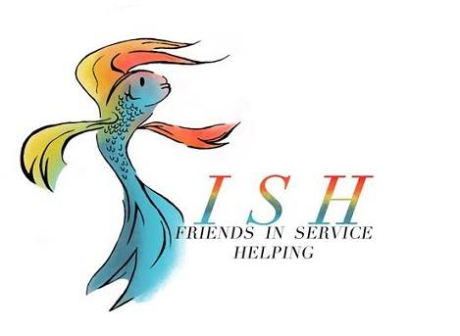Program Meeting Minutes
October 22, 2019

- Meeting called to order at 12:05 by President Carol White followed by Altrusa grace and Pledge of Allegiance.

- Guests were presented by Jennifer Adams.

- Janna Janes presented the Accent on “The Do’s and Don’ts of Social Media”.

- Michelle DiGaetano introduced Paul Hansen, Founder of the Flying Vikings. Flying Vikings is a not-for-profit organization which offers children ages 6 – 18 years old with a chronic illness or physical disability the opportunity to take control of an airplane and navigate the sky as they become pilots. Based in Belton, Texas, the Flying Vikings offers programs throughout the United States.

- Committee Announcements
  - President Carol White
    - Requested that no one add any additional events to Club Runner unless related to the Taste of the Holidays until after the Taste.
    - Ralph Wilson Youth Club is collecting new socks for children and veterans (Socktoberfest). Drop off items at RWYC.
    - Country Lane is holding their annual Christmas party on December 13 and volunteers are needed to shop for gifts.
  - Michelle DiGaetano: Service Committee meeting today, October 22, at 5:30 pm.
  - Julie Ruiz: Altrusa Christmas party, hosted by Julie Ruiz and Patsy Sulak, scheduled for December 9. It will be a progressive event, cost is $20 and BYOB.
  - Teresa Bowen-Bechtel: ASTRA is sponsoring five Belton High School teams for the HEB Turkey Run. Margarita Monday is November 4 at Little Mexico
  - Altrusa Yoga Mixer is November 12. See Club Runner for details and registration.
  - Traci Squarcette: Make a Difference Day is Saturday, October 26. Altrusans will be providing brunch, goody bags and hosting bingo for residents from Kyle, Golden Haven and Frances Graham Hall.
  - Cindy Black: TOH raffle tickets are available and the committee will deliver.
  - Susan Cory: Hope for the Hungry banquet November 14, 6:30 pm. We have eight seats available. Reminder - Election Day is November 5. League of Women Voters has a voter guide available.
  - Kelly Nix: Taste of the Holidays-If anyone needs a personal lunch ticket or apron, please see Diana Zaremba.
  - Michelle DiGaetano: McLane Children’s Toy Chest organization day is November 2 at 9:00 am. Volunteers are needed.
  - Debbie Fendrick: Has a limited number of Altrusa t-shirts available. Asked that the club consider purchasing additional sizes.

- Brags

- Meeting was adjourned at 12:59 following the benediction.
Minutes submitted by Lori Luppino, 2019-2020 Recording Secretary.

